

**Centre Name: ACE-HCMC-2-FPT.**

**Address: 590 Cach Mang Thang 8, District 3, Ho Chi Minh City, Viet Nam.**

[QuizTech]

(Quiz Management System)

| **Supervisor.** | Lê Mộng Thuý | |
| --- | --- | --- |
| **Batch.** | T1.2303.M0 | |
| **Group.** | Group 3 | |
| **Serial No.** | **Enrollment Number** | **Student Name** |
| 1. | Student1459123 | Lê Đức Minh |
| 2. | Student1459374 | Hạ Thế Doanh |
| 3. | Student1462828 | Lê Tấn Thành |

January 2024

**TABLE OF CONTENTS**

[**REVIEW 1 3**](https://docs.google.com/document/d/11ruFxKn_NeRn6EIJZf5QMV8YSvIAPvQW/edit#heading=h.1fob9te)

**❖ ACKNOWLEDGE 3**

**❖ INTRODUCTION 3**

**❖ SAMPLE PROGRAMING OUTLINE 4**

**❖ MAIN FEATURE 5**

**❖ TARGET 6**

**❖ EXPECTED BENEFITS 6**

**❖ HARDWARE/SOFTWARE REQUIREMENT** **7**

**❖ TASK SHEET REVIEW 1 8**

**REVIEW 2 9**

**❖ USE CASE’s QUIZTECH 9**

**❖ DATA FLOW DIAGRAM (DFD) 11**

**❖ ENTITY PROPERTIES 1****4**

**❖ ENTITY RELATIONSHIP DIAGRAM 1****7**

**❖ TABLE DESIGN 1****7**

**❖ TASK SHEET REVIEW 2 1****9**

**REVIEW 3 20**

**❖ APPLICATION MAP** **20**

**❖ QUIZTECH** **20**

**❖ TASK SHEET REVIEW 3** **56**

# REVIEW 1

## ACKNOWLEDGE

This report is an opportunity for us to express our deep gratitude to those who have contributed significantly to this QuizTech project. Among them, we especially want to mention the enthusiastic leadership of Ms. Le Mong Thuy and the team that made this project a success.

First, the team working on the QuizTech project has contributed continuously and professionally. Close cooperation, positive exchange of ideas and commitment of each member have created a complete and quality product. This is also our second project together, so team members not only contribute to technical development but also provide creative opinions on content and user experience. The diversity of each person's skills and visions made the project rich and engaging.

Furthermore, Ms. Le Mong Thuy, as a lecturer in our second semester, has been a constant source of encouragement for us during the project development process. Her dedication, in-depth knowledge and leadership not only helped us overcome challenges but also gave us clear direction. She made it possible for us to do things beyond our comfort level.

Finally, we would like to sincerely thank the contributions of Ms. Le Mong Thuy and our team for working together to complete the Quiz Management System project in the remaining time. We hope this project will continue to develop as fully as possible and that together we can face the remaining challenges.

## INTRODUCTION

Based on the ideas of our tests on the online varsity website. Using this intellectual question management system helps users improve their knowledge. In order to suffice the demand , we would like to introduce the Report on "Multiple choice question management system" - a smart and effective question management system about knowledge related to information technology. , especially designed to serve both main audiences: Admin and User.

## SAMPLE PROGRAMING OUTLINE

Our idea was built and sketched on the web figma about QuizTech  
<https://www.figma.com/file/nV3coXAoHWmZPMxrpbVlZp/Untitled?type=whiteboard&node-id=123%3A113&t=gGGIjoydXYuFYRh6-1>

**Admin/Player template:**

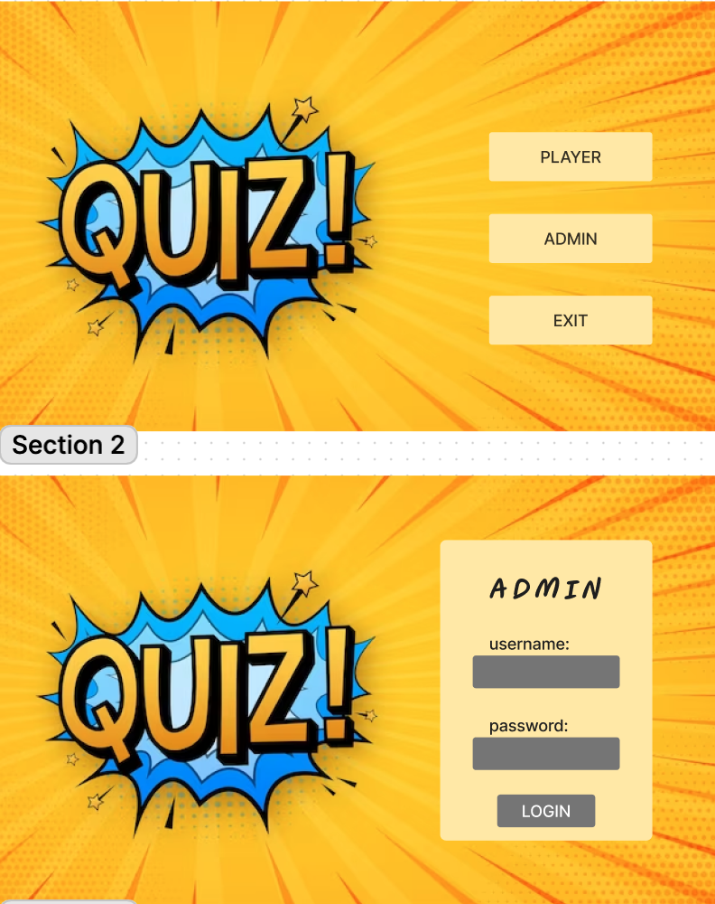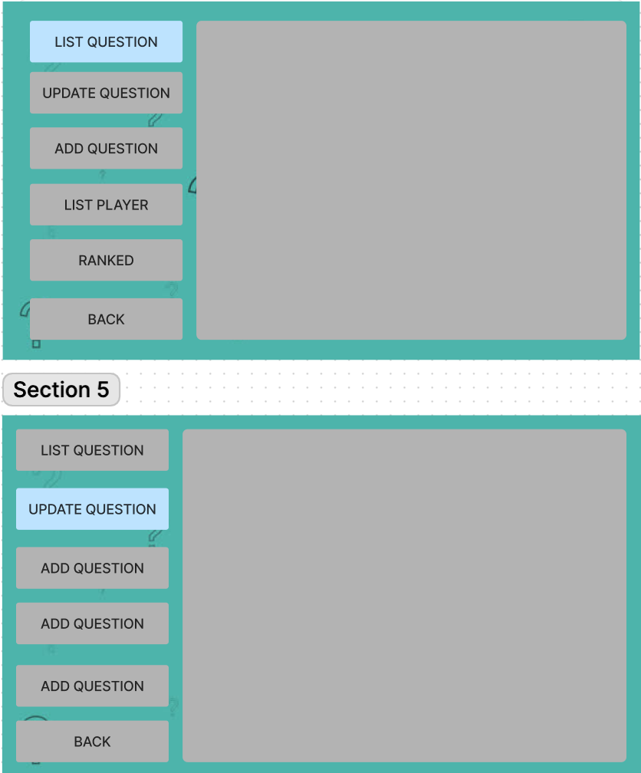

## 

## 

## 

## 

## 

## 

## 

## 

## 

## 

## 

## MAIN FEATURE

For Guest Users:

Participate in Quiz: Users have the ability to participate in quizzes on different topics, from education to entertainment.

Storing Results: The system helps users store and track the results of participating quizzes.

Challenges and Rankings: Users can challenge friends, view rankings, and track their progress within the player community.

For Admins:

Content Management: Admin has the ability to manage the content of quizzes, including adding, editing, and deleting questions.

Users and Permissions: Admin can manage users, set access rights.

Statistics and Reporting: The system provides statistical and reporting tools on quiz performance, helping Admin make smart and strategic decisions.

## TARGET

This report is built with analytical tools and showcases the possible item on how "Question Management System" meets the needs of both Administrators and Users, creating a multi-faceted brain game experience. shape and appeal.

| **INPUT OF THE SYSTEM** | | | | | |
| --- | --- | --- | --- | --- | --- |
| *Administrators of QuizTech need to provide:*   * Necessary information for creating accounts to access the administrative system. * Information will show in the app. * Essential information required for system creation. | | | *User of QuizTech*   * Personal information and details to register an account and use the program | | |

| **Processing Process** | | |
| --- | --- | --- |
| Handling Login Reasons and Permissions Updates:   * The authentication system receives credentials and checks user or administrator access.   Quiz and Content Management:   * Admin can add, edit and delete quizzes, questions and answers. Corresponds to system update data.   Take the quiz:   * The quiz user chooses the test, takes the questions, and the system records the detailed results of each player. | | |

| **OUTPUT OF THE SYSTEM** | | | | | |
| --- | --- | --- | --- | --- | --- |
| *Administrators of QuizTech will be able to*   * Log in/out of the administrative system. * Manage (add, view, update, disable) questions. * Manage (view, add, update, disable) users. * Manage(view) user rankings | | | *Users of QuizTech will be able to*   * Register/Log in/Log out user accounts. * Update some personal information * Play quizzes according to topics * View rank to challenge yourself | | |

## EXPECTED BENEFITS

For Administrators: Efficient in content management and activity tracking, optimizing the test organization process.

For Users: Experience diverse, exciting players and discover new knowledge through multi-topic tests.

We believe that the "QuizTech" will bring the best solution to manage and participate in intellectual games in a flexible and convenient way. Let us explore in detail the following sections of this report.

## 

## HARDWARE/ SOFTWARE REQUIREMENTS

| **HARDWARE REQUIREMENTS** | |
| --- | --- |
| ***Minimum*** | |
| **ADMIN/ USERS** | • Pentium 166 or better.  • 128 MB RAM. |
| ***Recommended*** | |
| **ADMIN/ USERS** | • Pentium Celeron 1.1Ghz or higher.  • 512 MB RAM or higher. |
| **SOFTWARE REQUIREMENTS** | |
| **ADMIN/USERS** | • Microsoft® Windows 7/8/10/ MacOS  • Microsoft® SQL server 2012  • JRE **7.0**  • Administrator rights. |

*For deploying:*

| **Hardware** | Processor | Intel Core I5 or higher |
| --- | --- | --- |
| Memory | 8 GB RAM or greater |
| Monitor | Super VGA (1366x768) or higher resolution |
| Modem/ADSL | Internet access is required |
| **Software** | Operation System | Window 10 or higher |
| Software | Simple logging facade |
| ControlsFX |
| SQLite tools |
| Development Software | * Microsoft Windows 10/MacOS * SQLite Studio/Azure Data Studio * NetBean * Scene Builder |
| Technology | * Java * JavaSwing * CSS * SQLite |

## TASK SHEET REVIEW 1

| **Project: QuizTech** | | **Project Name** | **Activity**  **Plan Prepared**  **By** | | **Date of Preparation of Activity Plan:** | | | |
| --- | --- | --- | --- | --- | --- | --- | --- | --- |
| **Sr./No.** | **Task** | **Actual Start Date** | **Actual Days** | **Team member name** | **Status** |
| 1 | Acknowledgment | QuizTech | Minh,  Thành,  Doanh | | 25/12/  2023 | 1 | - Minh  - Thành  - Doanh | Completed |
| 2 | Introduction | 25/12/  2023 | 1 | - Minh  - Thành  - Doanh | Completed |
| 3 | Main Features | 25/12/  2023 | 2 | - Minh  - Thành  - Doanh | Completed |
| 4 | Target | 25/12/  2023 | 2 | - Minh  - Thành  - Doanh | Completed |
| 5 | Expected Benefits | 25/12/  2023 | 1 | - Minh  - Thành  - Doanh | Completed |
| 6 | Hardware/Software Requirement | 29/12/  2023 | 1 | - Minh  - Thành  - Doanh | Completed |
| 7 | Sample Programing Outline | 29/12/  2023 | 2 | - Minh  - Thành  - Doanh | Completed |
| 8 | Task Sheet | 29/12/  2023 | 1 | -Minh  - Thành  - Doanh | Completed |
| **Date: 03 – January - 2024** | | | | | | | | |
| **Signature of Instructor:**  **Ms. LÊ MỘNG THÚY** | | | | **Signature of Team Leader:**  **Lê Đức Minh** | | | | |

# 

# 

# REVIEW 2

## USE CASE TechQuiz (Admin/User)

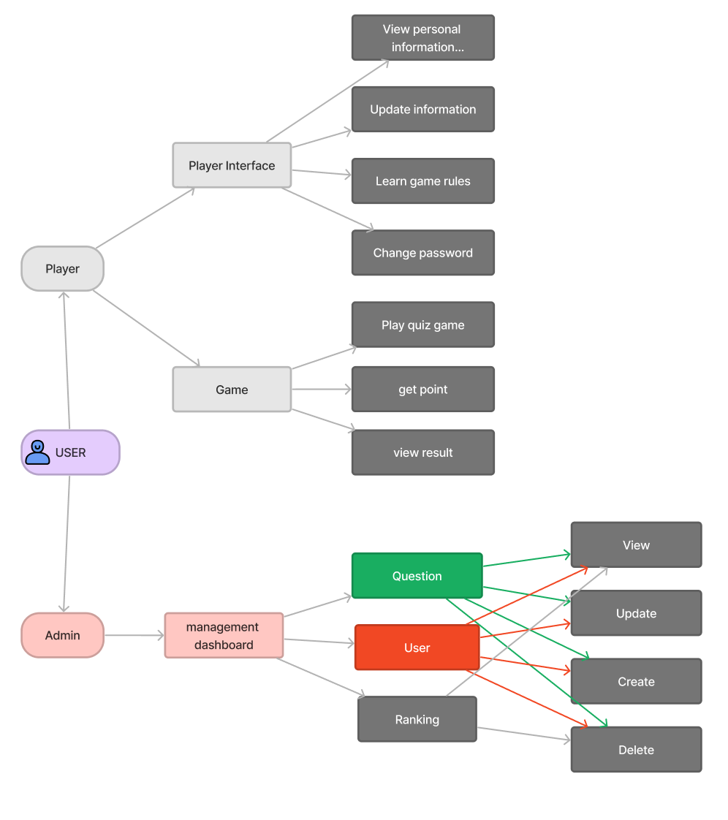

**Usecase's Admin:**

| **Admin** | **Login** | Admin need to log in for the system to confirm information and grant corresponding access rights. | | | |
| --- | --- | --- | --- | --- | --- |
| **Quiz Data Source** | Admin has the right to add, edit, and delete information quizzes. | | | |
| **User Data Source** | Admin has the right to add, edit, and delete information users. | | | |
| **Result** | view ranking | | | |

**Usecase's Player:**

| **Player** | **Login** | Users need to log in for the system to confirm information and grant corresponding access rights. | | | |
| --- | --- | --- | --- | --- | --- |
| **User Data Source** | Users will be able to view all personal information and only be able to update some basic information | | | |
| **Choose and Take Quiz** | * Choose the quiz topic and take the questions * The system accesses data from the database to display questions and check answers | | | |
| **Result** | view ranking | | | |

## 

## 

## Data Flow Diagrams

* **LEVEL 0**

## 

* **LEVEL 1**

## 

## 

## 

## 

* **LEVEL 2**

**Admin**

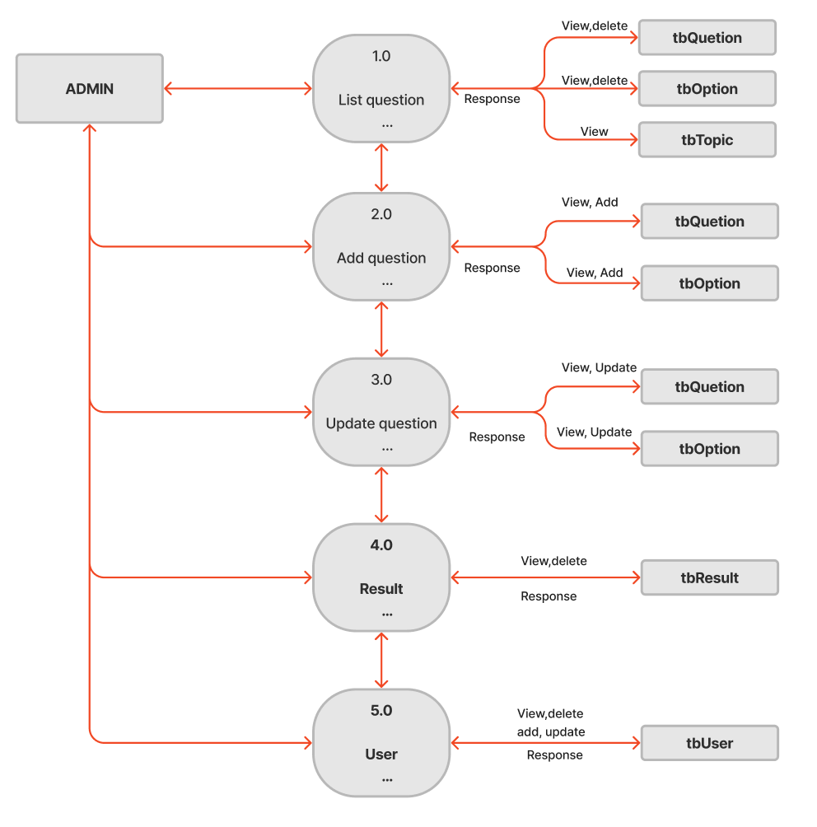

**Player**

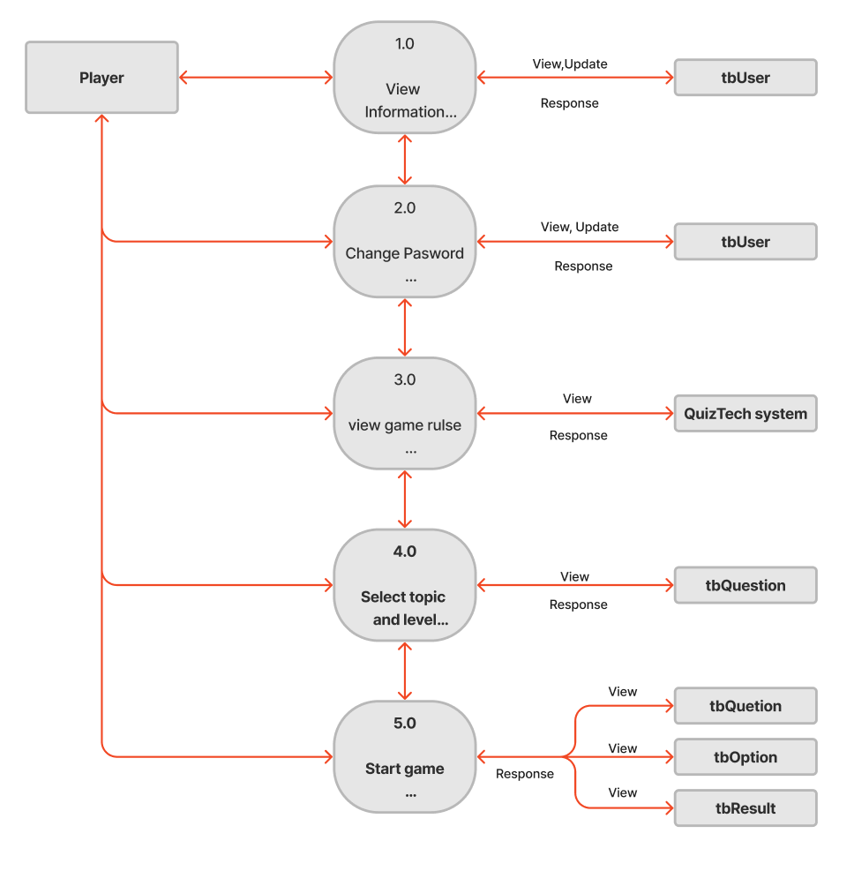

* **LEVEL 3**

**Player**

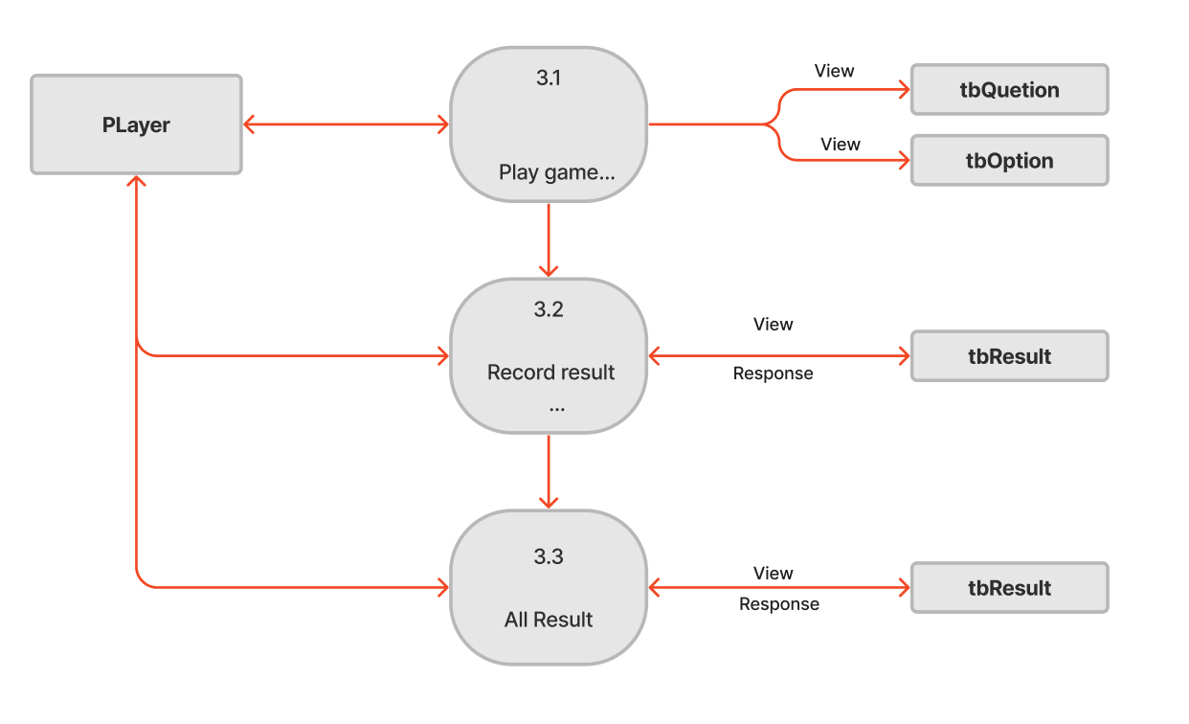

## ENTITY PROPERTIES

* **tbUser**

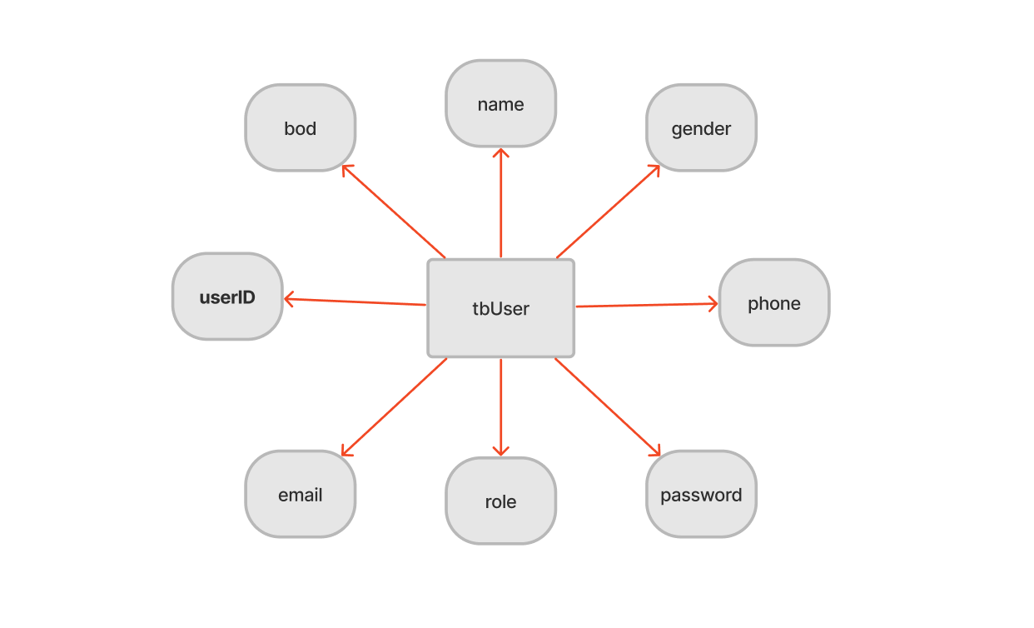

* **tbResult**

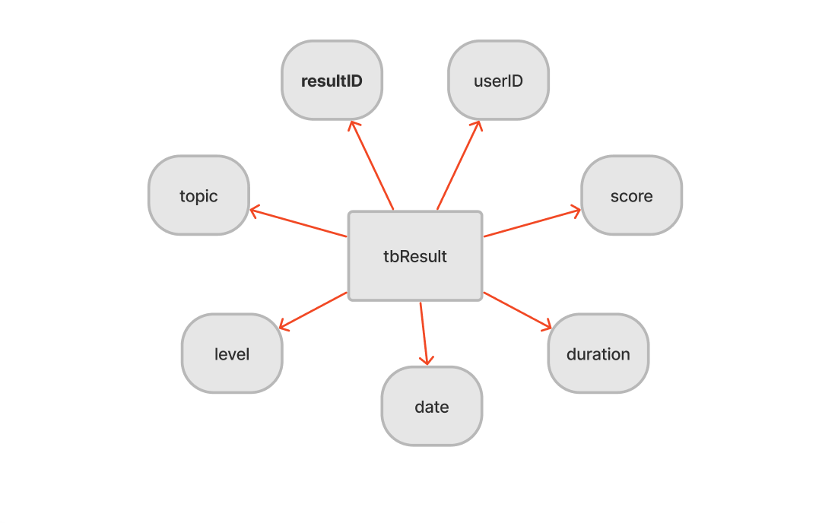

* **tbTopic**

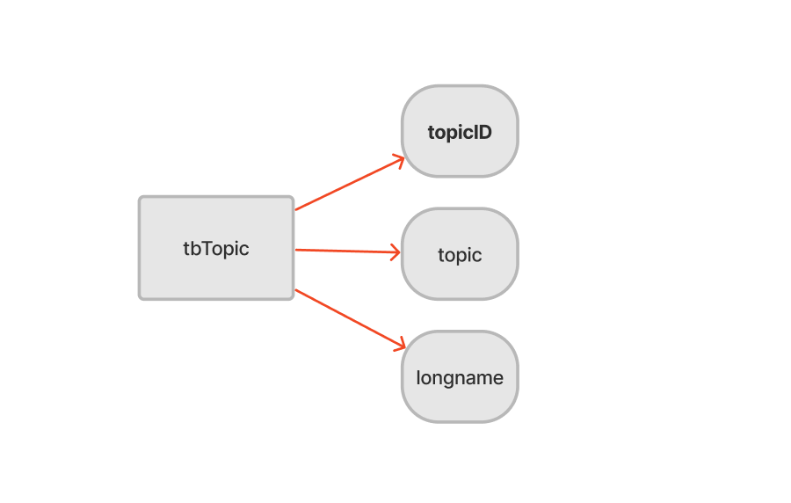

* **tbQuestion**

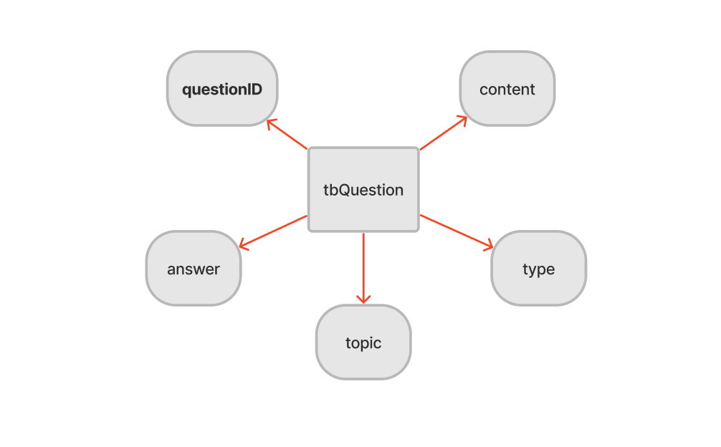

## 

* **tbOption**

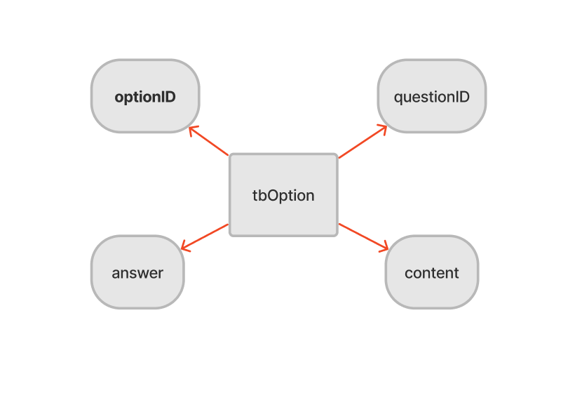

## ENTITY RELATIONSHIP DIAGRAM (ERD)

## TABLE DESIGN

**tbUser**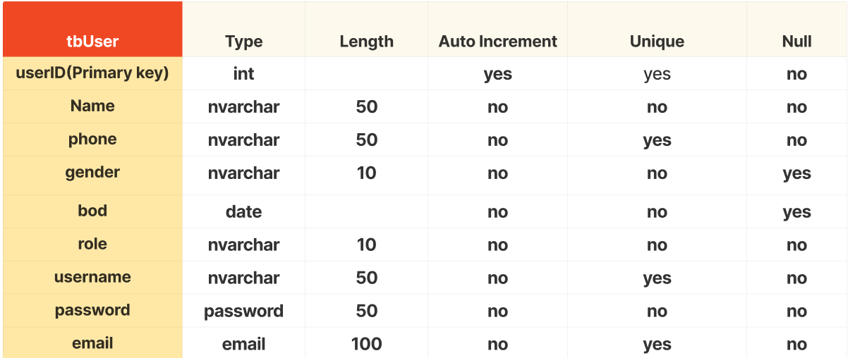

**tbTopic**

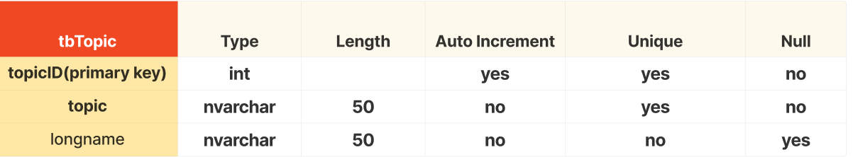

**tbQuestion**

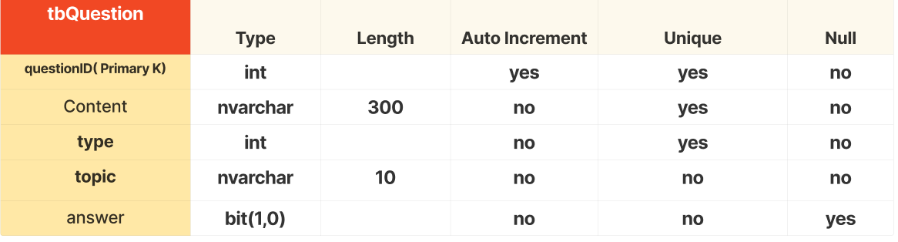

**tbOption**

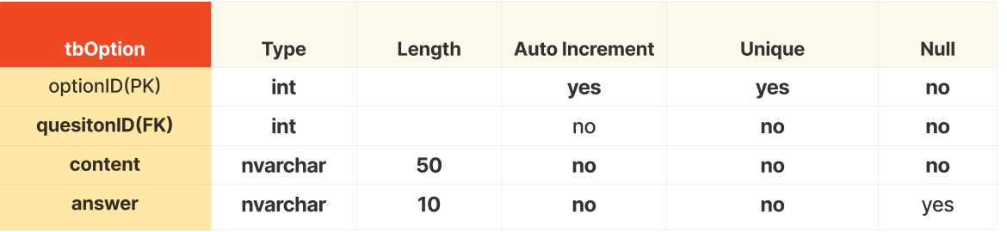

**tbTopic**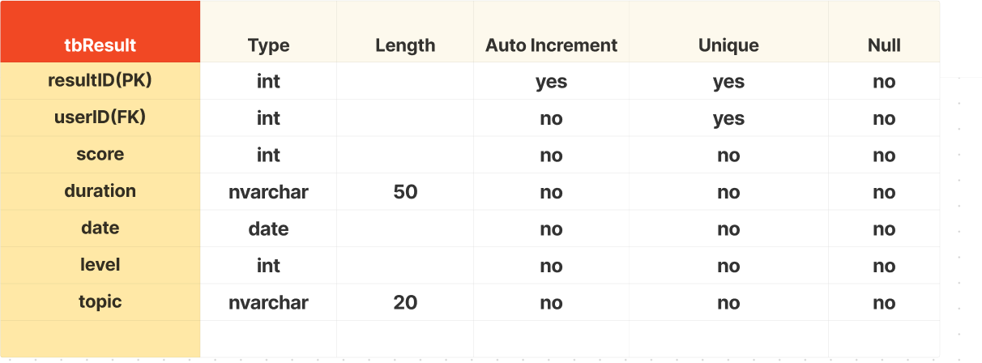

## TASK SHEET REVIEW 2

| **Project: QuizTech** | | **Project Name** | **Activity Plan Prepared By** | **Date of Preparation of Activity Plan:** | | | |
| --- | --- | --- | --- | --- | --- | --- | --- |
| **Sr./No.** | **Task** | **Actual Start Date** | **Actual Days** | **Team member name** | **Status** |
| **1** | **Use Case** | QuizTech | Minh,  Thành,  Doanh | 06/Jan/2024 | 2 | Minh,  Thành,  Doanh | Completed |
| **2** | **Sample QuizTech**  **Outline** | 03/Jan/2024 | 2 | Minh,  Thành,  Doanh | Completed |
| **3** | **Data Flow Diagram (DFD)** | 11/Jan/2024 | 3 | Minh,  Thành,  Doanh | Completed |
| **4** | **Entity Properties** | 13/Jan/2024 | 2 | Minh,  Thành,  Doanh | Completed |
| **5** | **Table Design** | 13/Jan/2024 | 2 | Minh,  Thành,  Doanh | Completed |
| **6** | **Table Design** | 14/Jan/2024 | 1 | Minh,  Thành,  Doanh | Completed |
| Date: 15 – January - 2024 | | | | | | | |
| Signature of Instructor:  Ms. LÊ MỘNG THÚY | | | | Signature of Team Leader:  Lê Đức Minh | | | |

## 

# REVIEW 3

## APPLICATION MAP

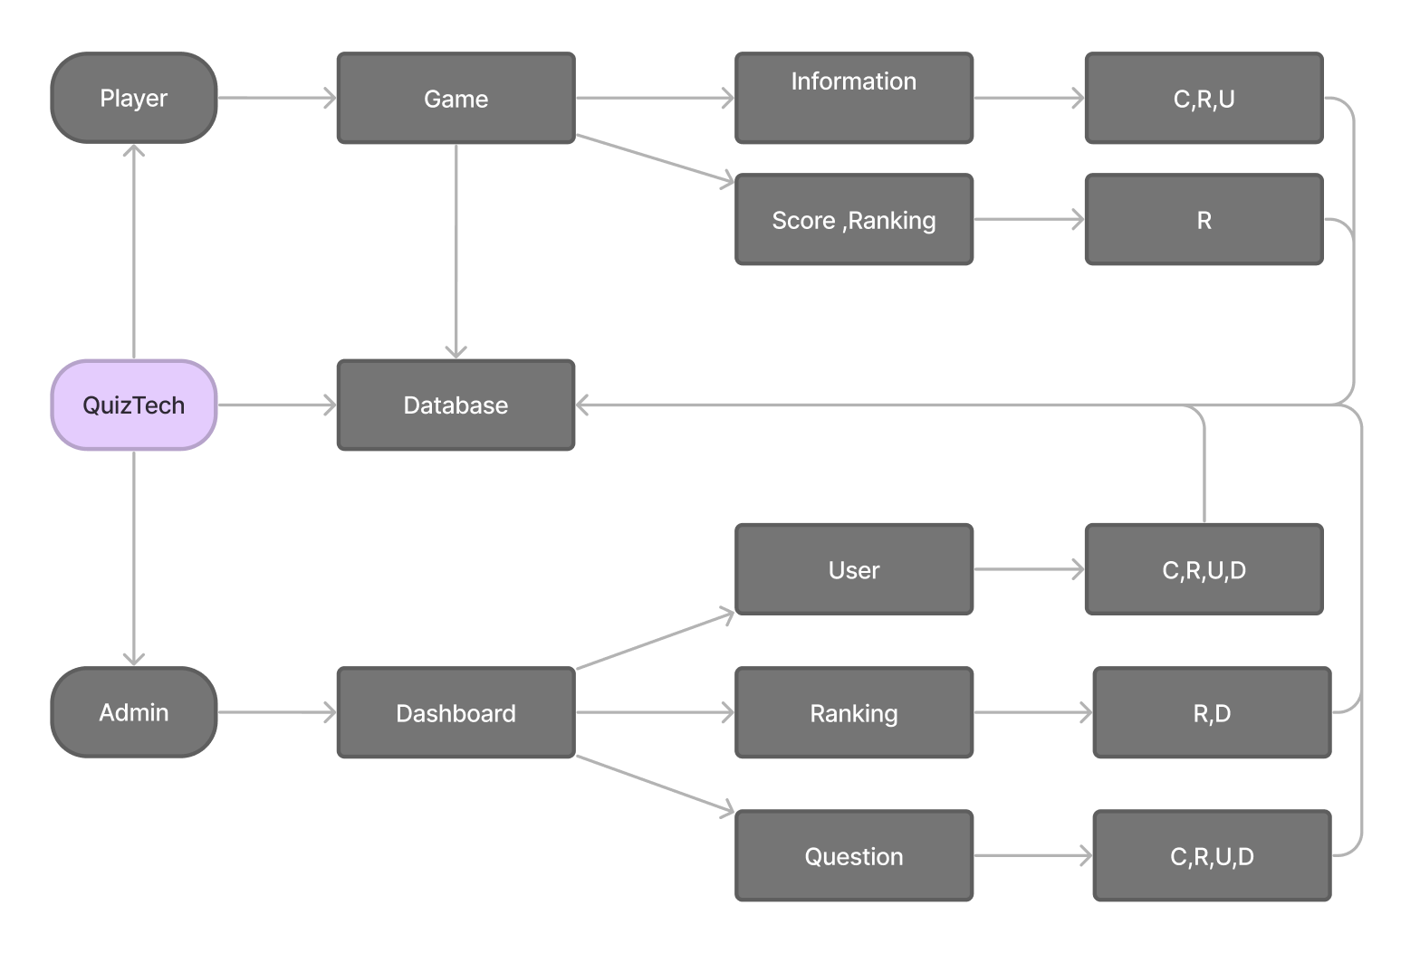

## QUIZ TECH

**QuizTech MAIN INTERFACE**

*a.Display:*

* Displays an interface that allows the user to choose between administrator and player.
* Clicking on the player will take you to the player interface and clicking on admin will take you to the admin login interface.

*b. Function:*

* Players can register for an account so they can log in to QuizTech to perform other functions.
* Admins are granted pre-existing rights and cannot register themselves.

*c. ScreenShot:*

*Figure 1: Quiztech's interface*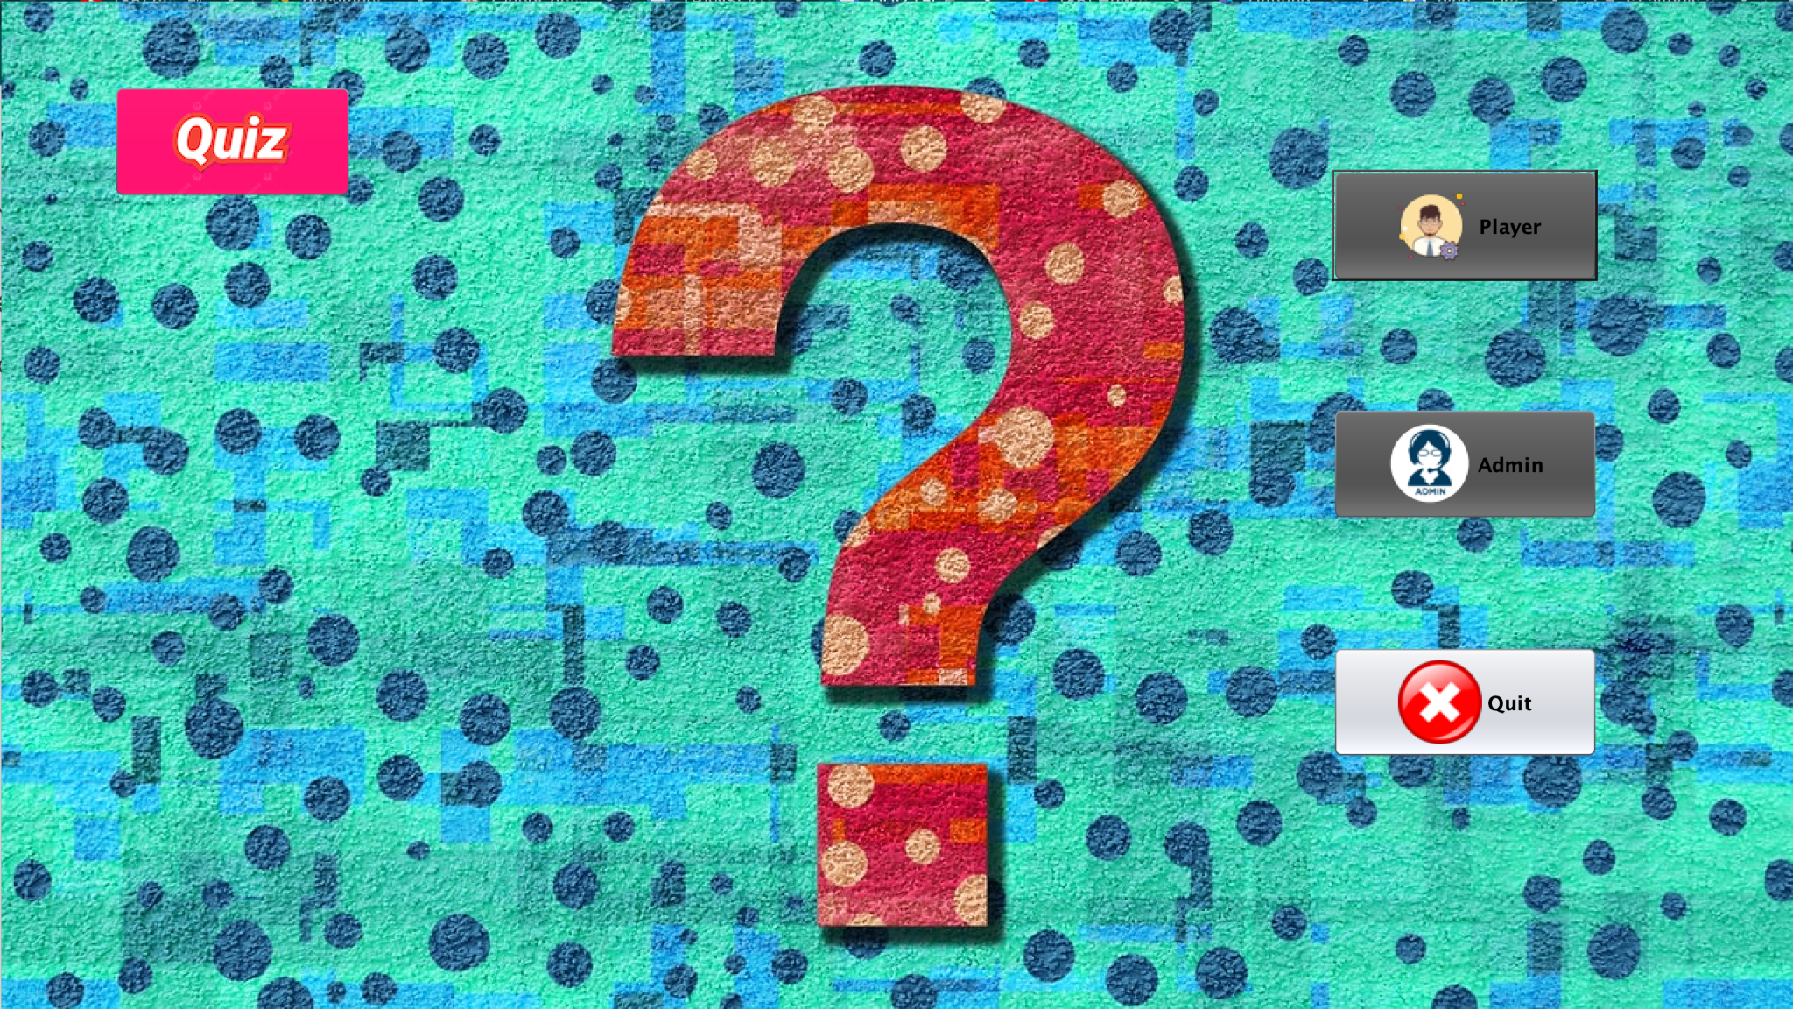

*Figure 2: Player's interface*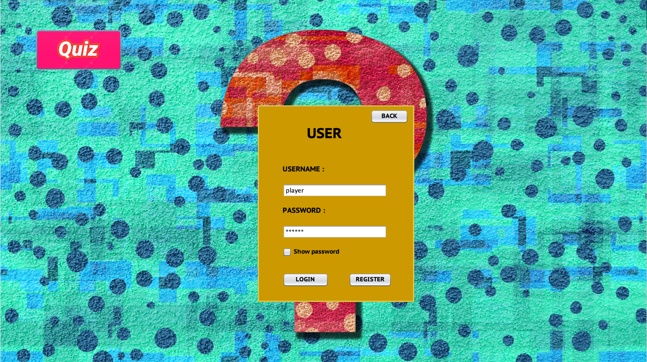

* When you click the register button, a form will appear to register the player

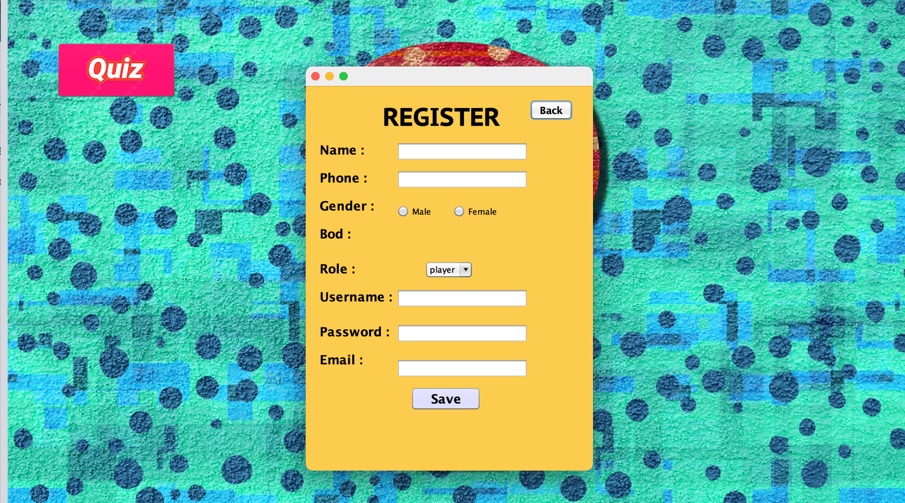

*Figure 3: Player registration*

* When created successfully, “ new player” notification will appear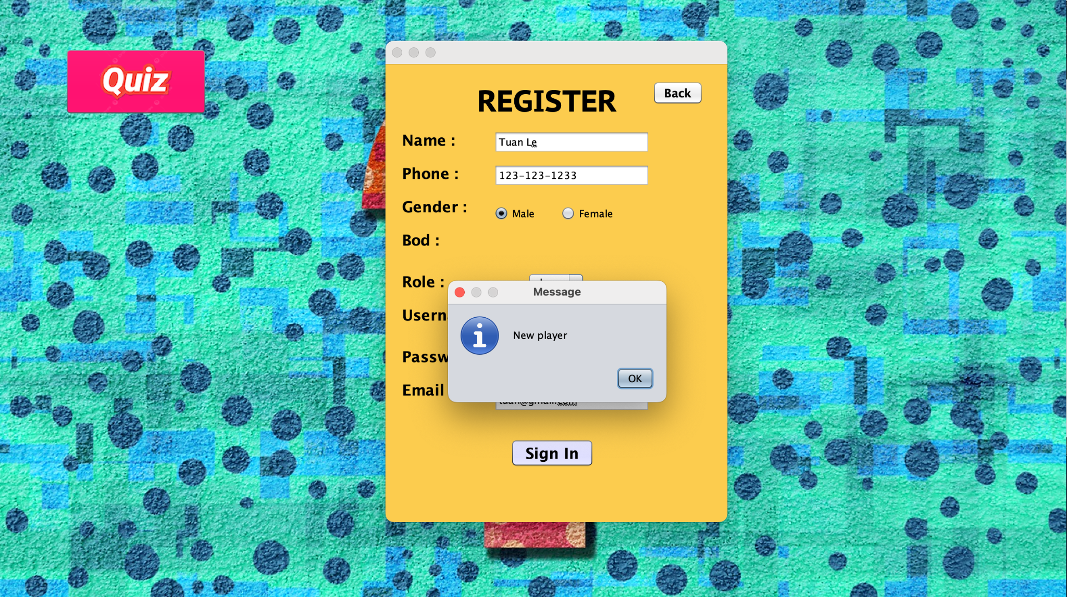

*Figure 4: Player registration*

* Successful login will notify you of successful login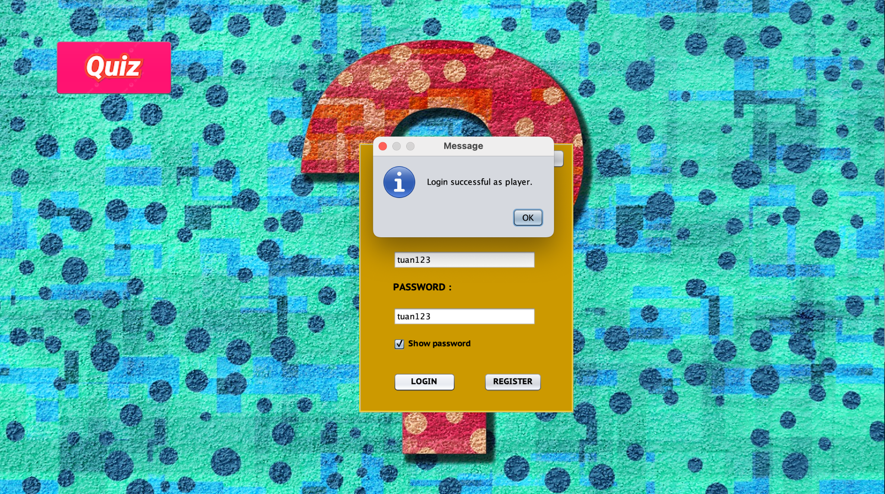

*Figure 5: Player login*

**PLAYER INTERFACE**

*a.Display:*

* The interface will display full player information, buttons to change password, and update information
* Show the rules of quiztech for new players.

*b. Function:*

* Players can change some personal information themselves.
* Players can change the password yourself.
* Players can learn the rules of the game themselves in the instruction sheet.
* Players can choose the topic and difficulty level of the game to start game play

*c. ScreenShot:*

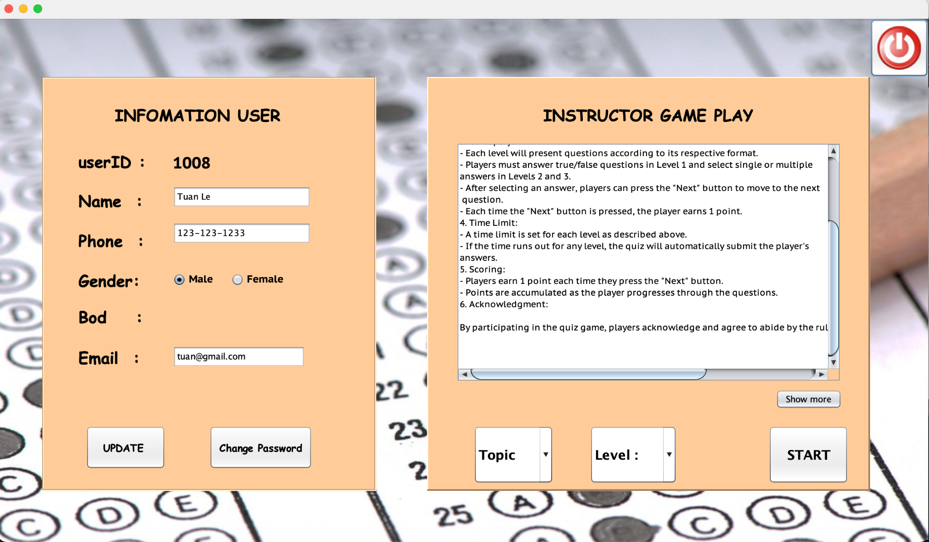

*Figure 1: Player interface*

-Players can edit some personal information and display a success message after pressing the update button

*Figure 2: Update personal information* 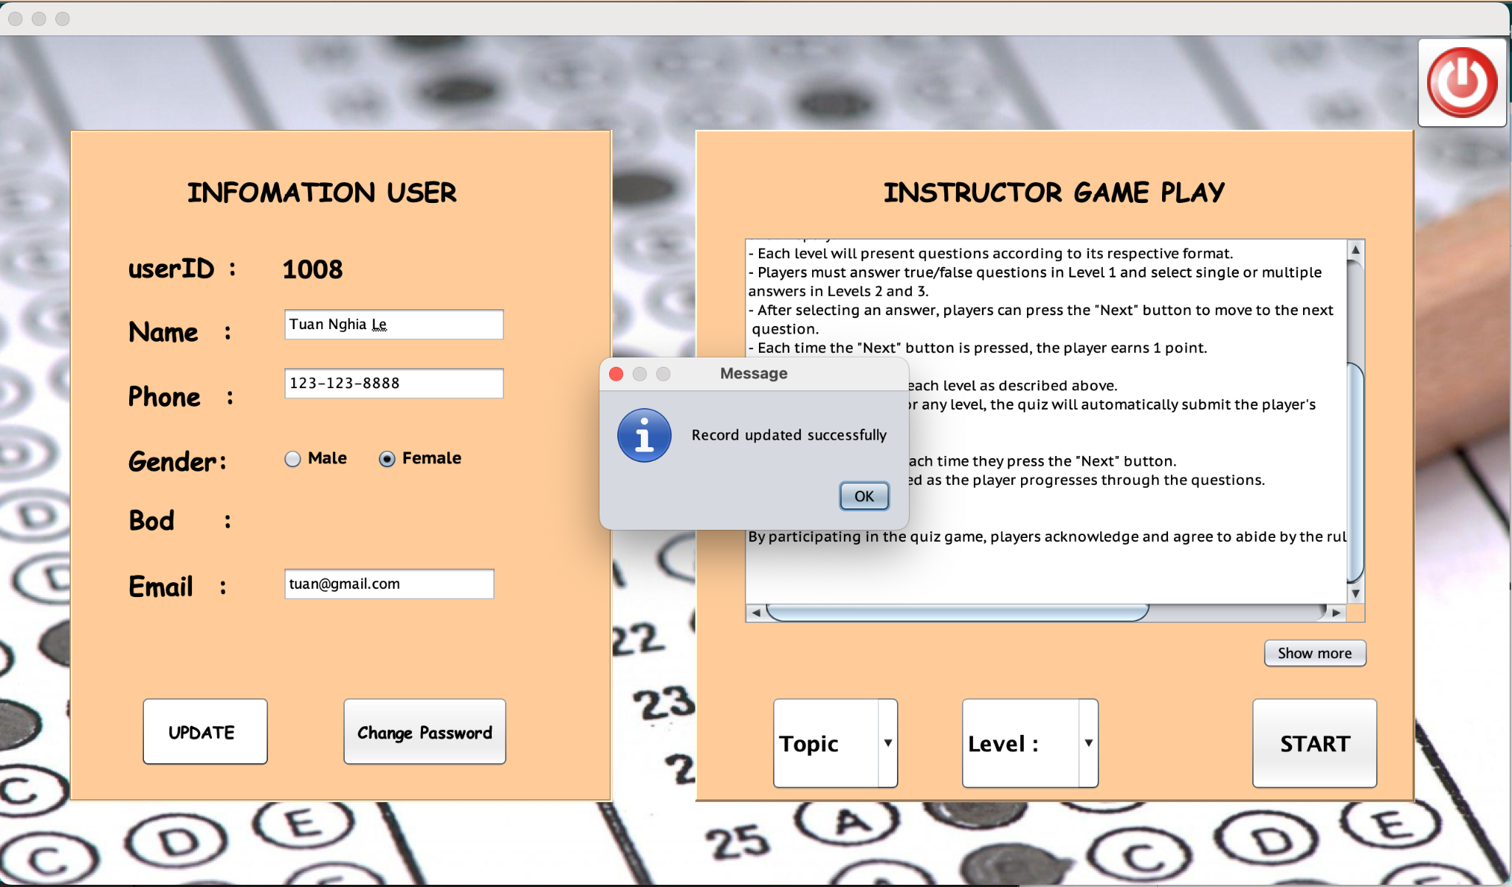

*Figure 3: After update* 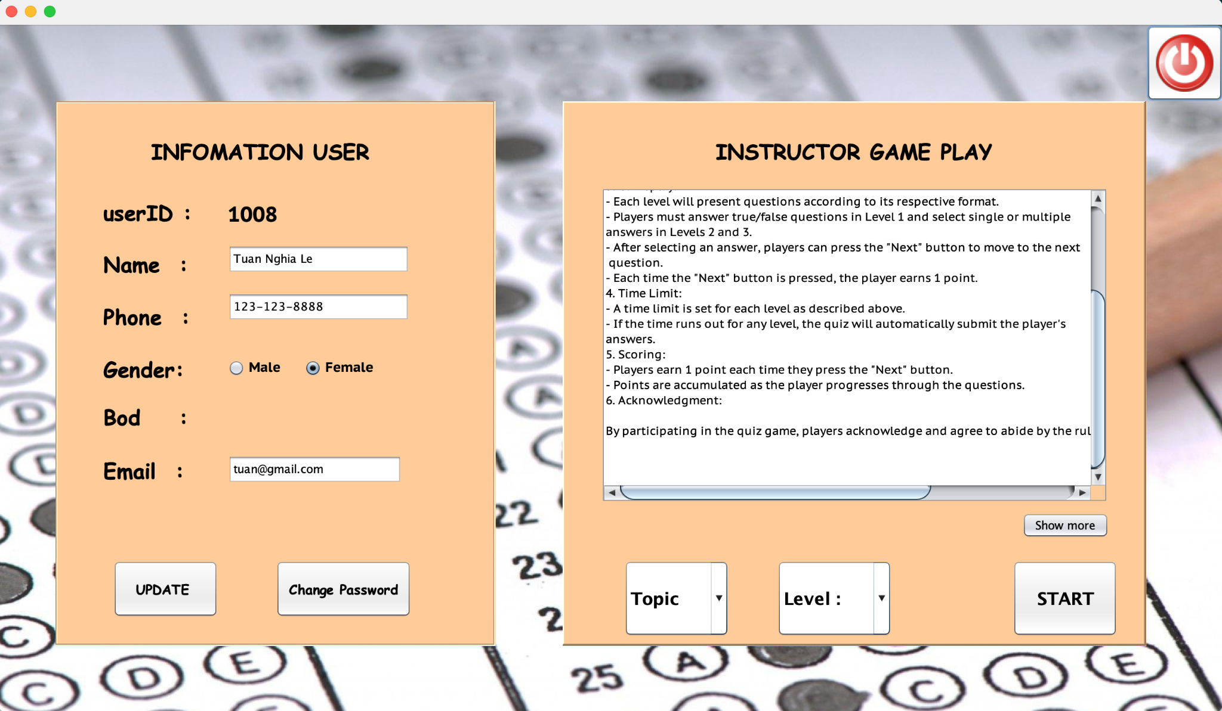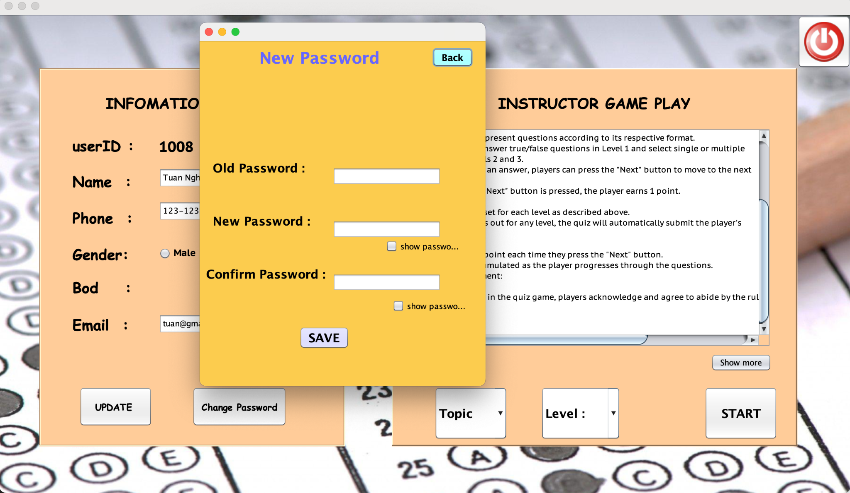

* In addition, users can also change the password when clicking the change password button

*Figure 4: Change Password*

*Figure 5: : Password changed successfully*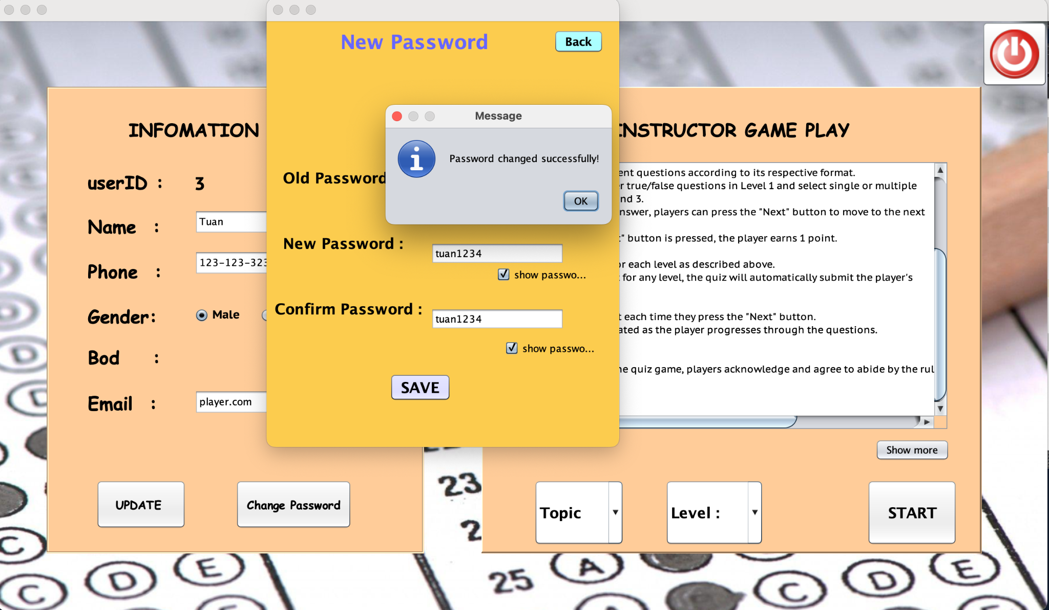

* After successfully changing the new password.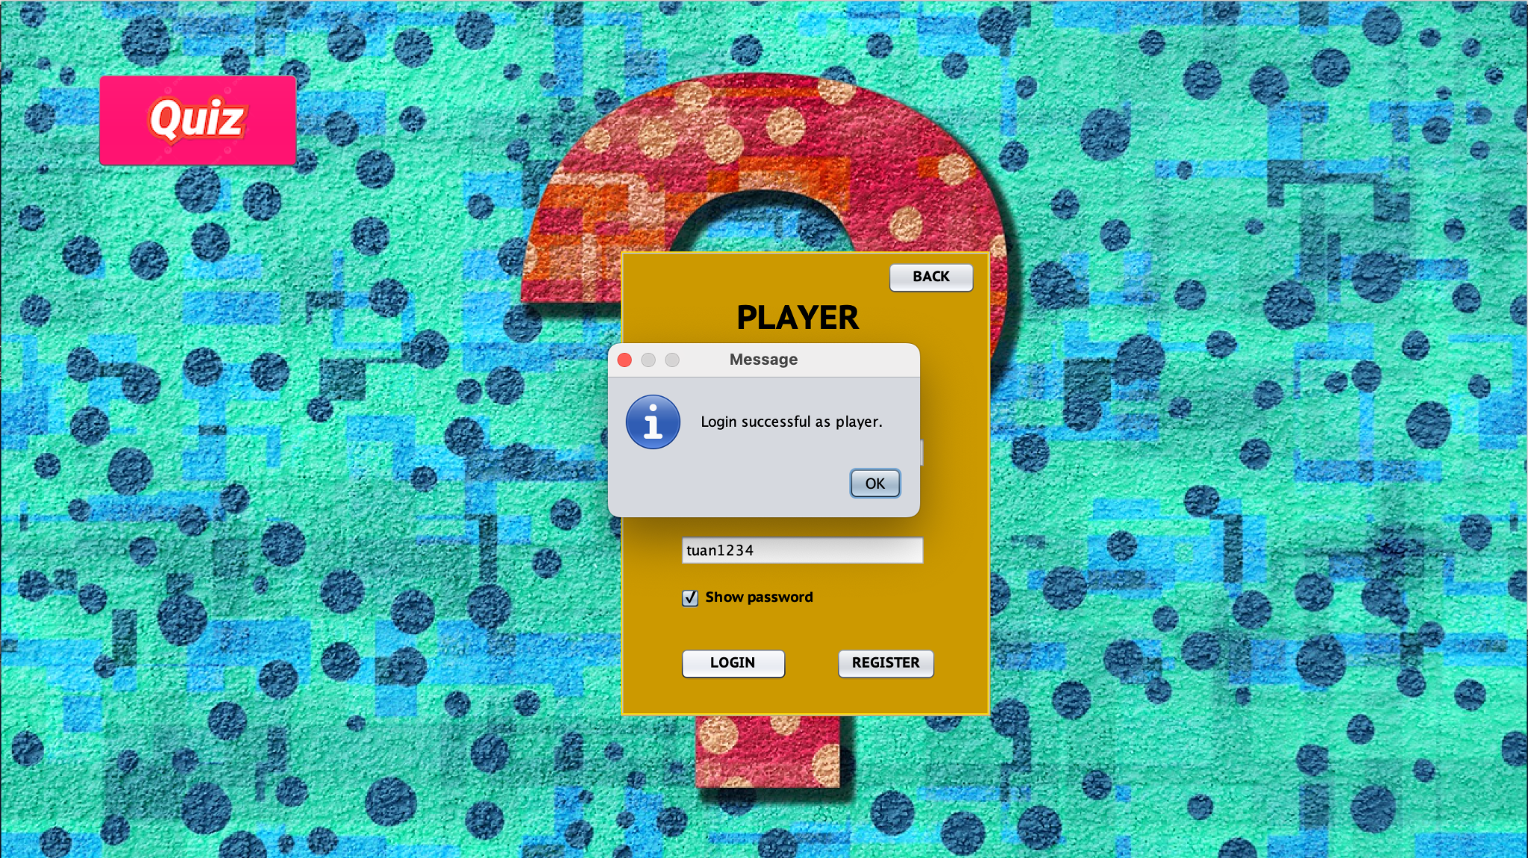

*Figure 6: : Password changed successfully*

* Players can learn the game rules on the right side of the screen.

*Figure 7: : Instructions on game rules*

* Players who want to see more details can click show more.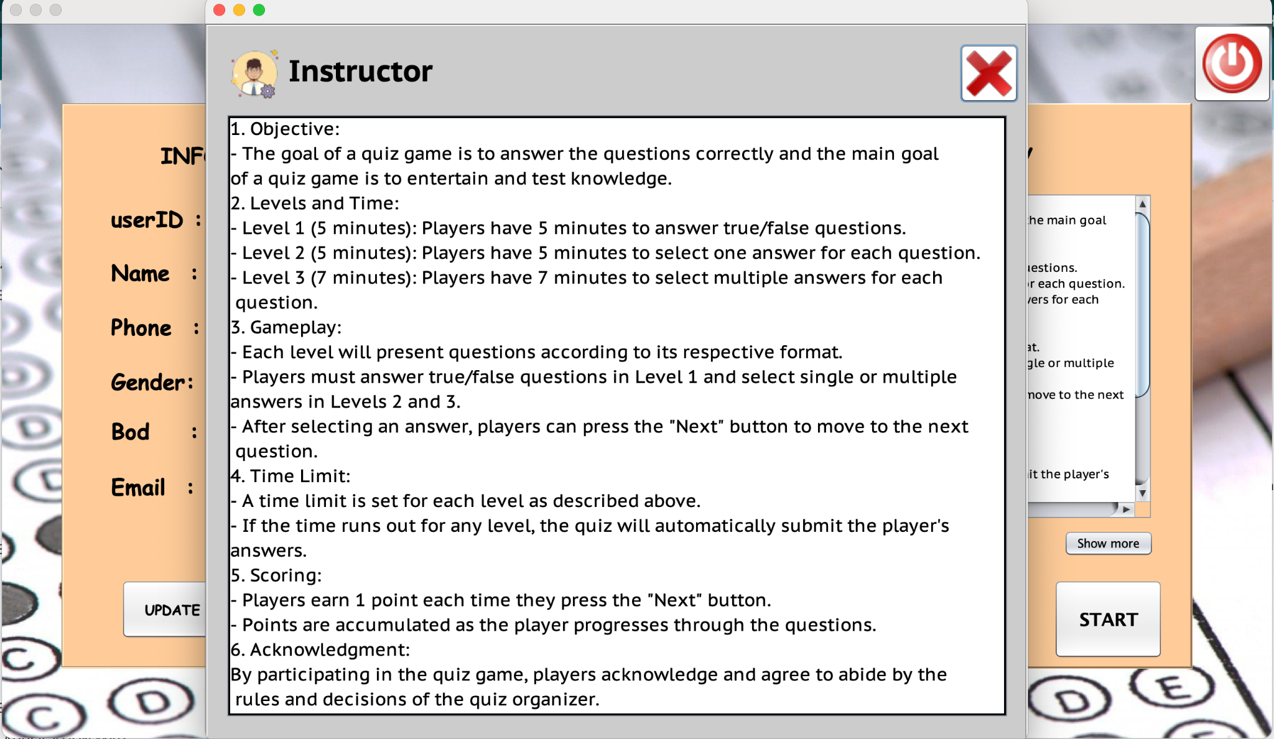

*Figure 8 : Instructions on game rules*

* To play the game, players need to choose a theme and difficulty level. Otherwise, the following message will appear.

*Figure 9 : Choose Topic*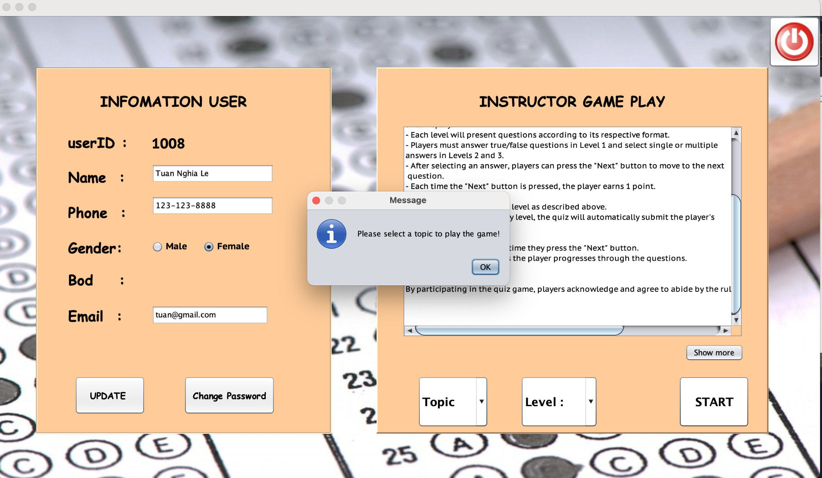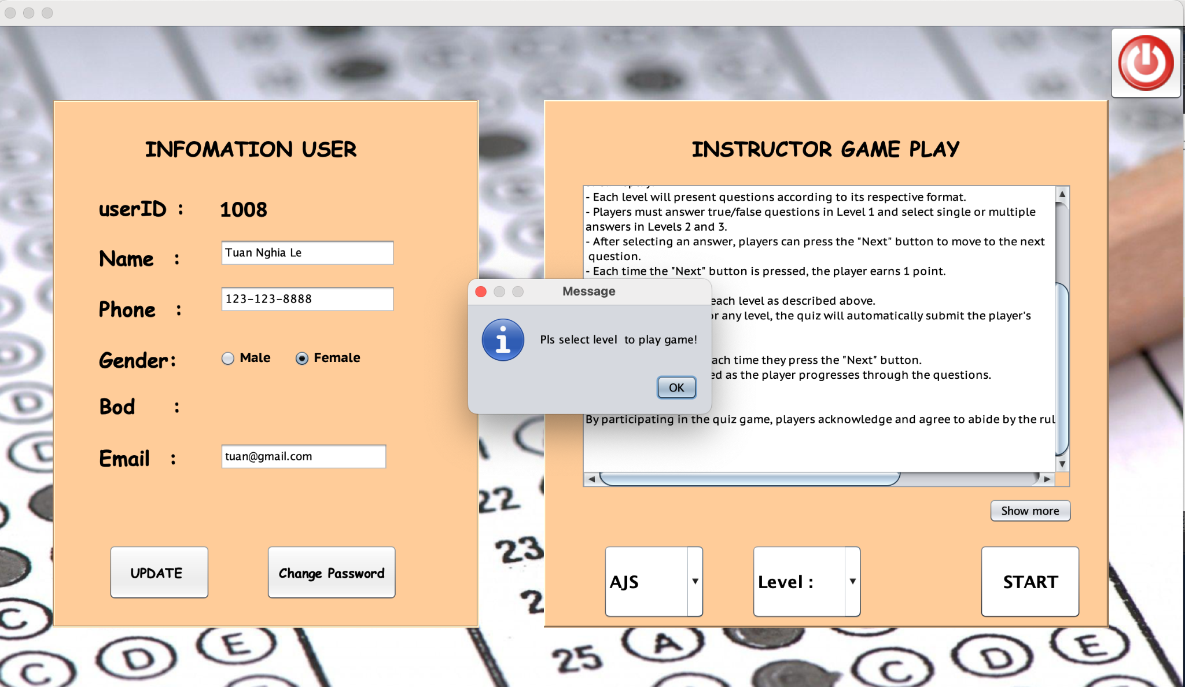

*Figure 10 : Choose Level*

**GAME PLAY**

*a.Display:*

* After the game is run for 5 minutes for easy(1) and medium(2), 7 minutes for hard(3).
* Show all random questions according to the selected topic and level in the database.
* Show player results after each test.
* Players will be able to view the top 10 scores or search by score

*b. Function:*

* Players can challenge themselves through difficulty levels and themes
* There are 3 levels: Easy level (1) are question with true or false answer

Medium(2) are questions with 4 answers and choose 1 correct answer.

Hard(3) are questions with 4 answers and multiple correct answers

* Click the next button to score each question, and players can submit their results when completed before time runs out.
* After the time ends, the results will automatically be submitted.

*c. ScreenShot:*



*Figure 1 : Easy level*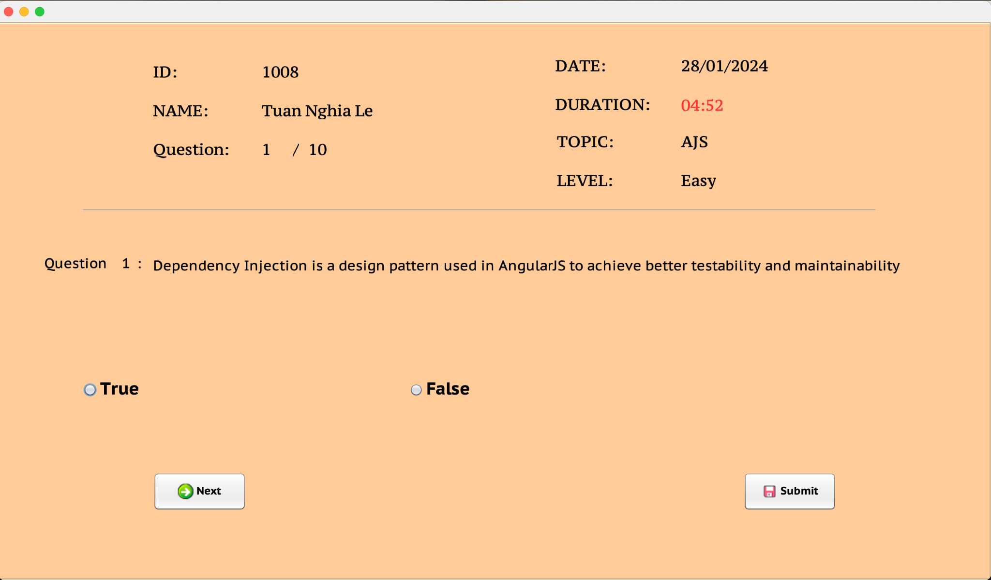

* A warning will appear when no answer is selected, to ensure players do not miss any questions

*Figure 2 : Warning message*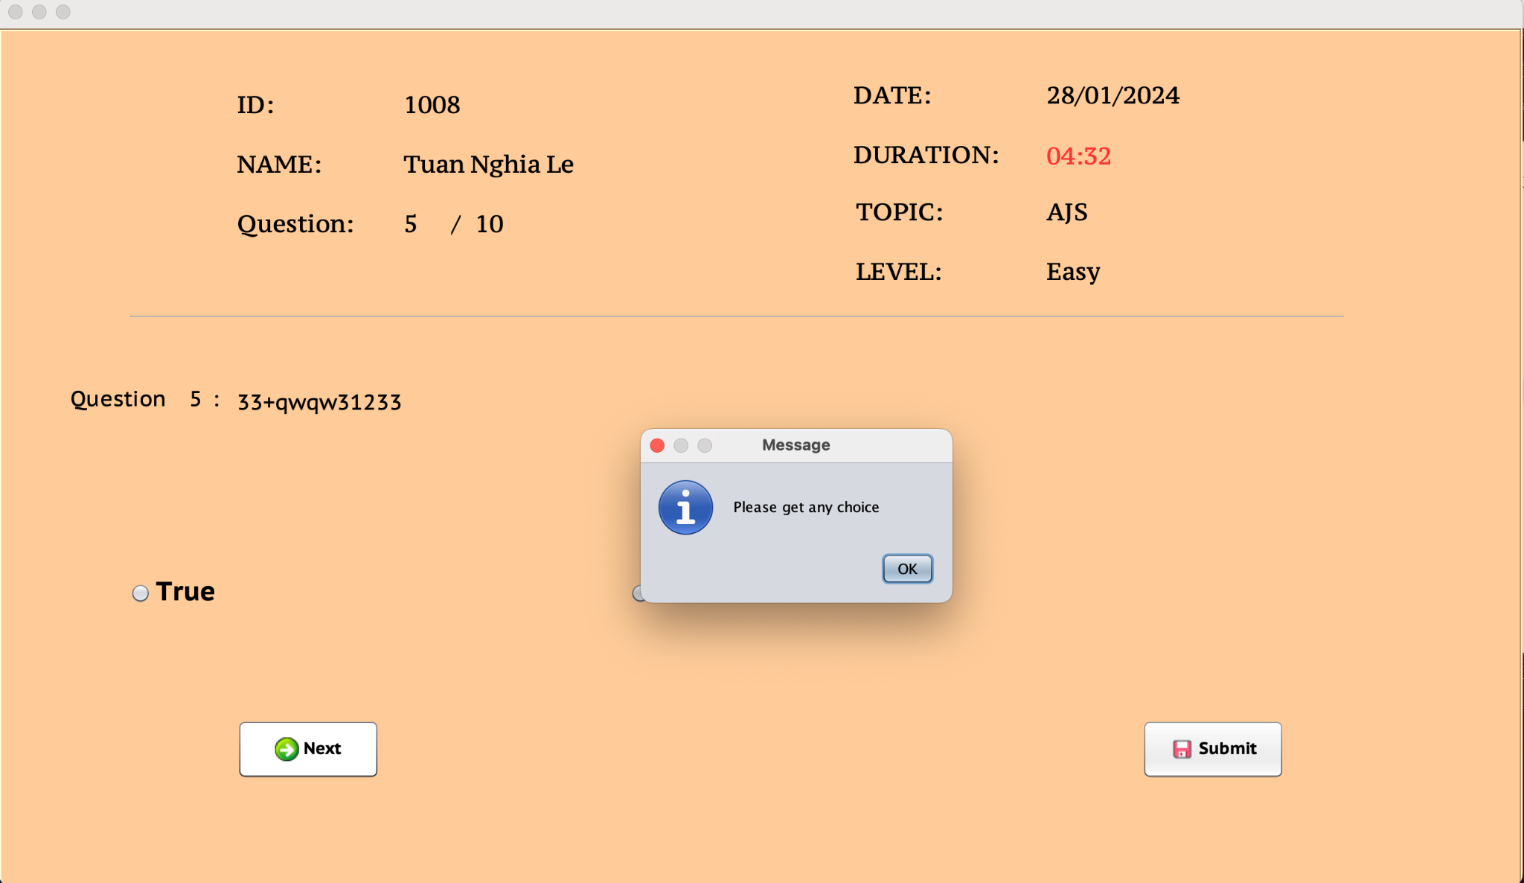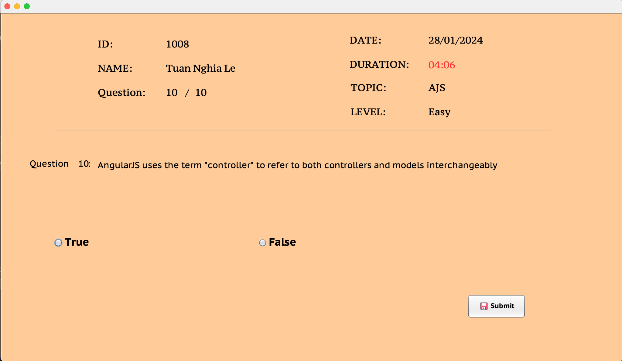

* After completing 10 sentences, the next button will be hidden

*Figure 3 : Easy level*

* All information related to the test results will appear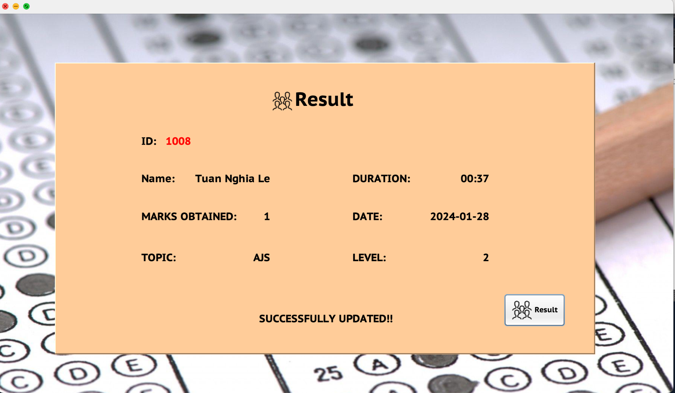

*Figure 4 : Player's result*

* *Players can view all results by clicking the Result button*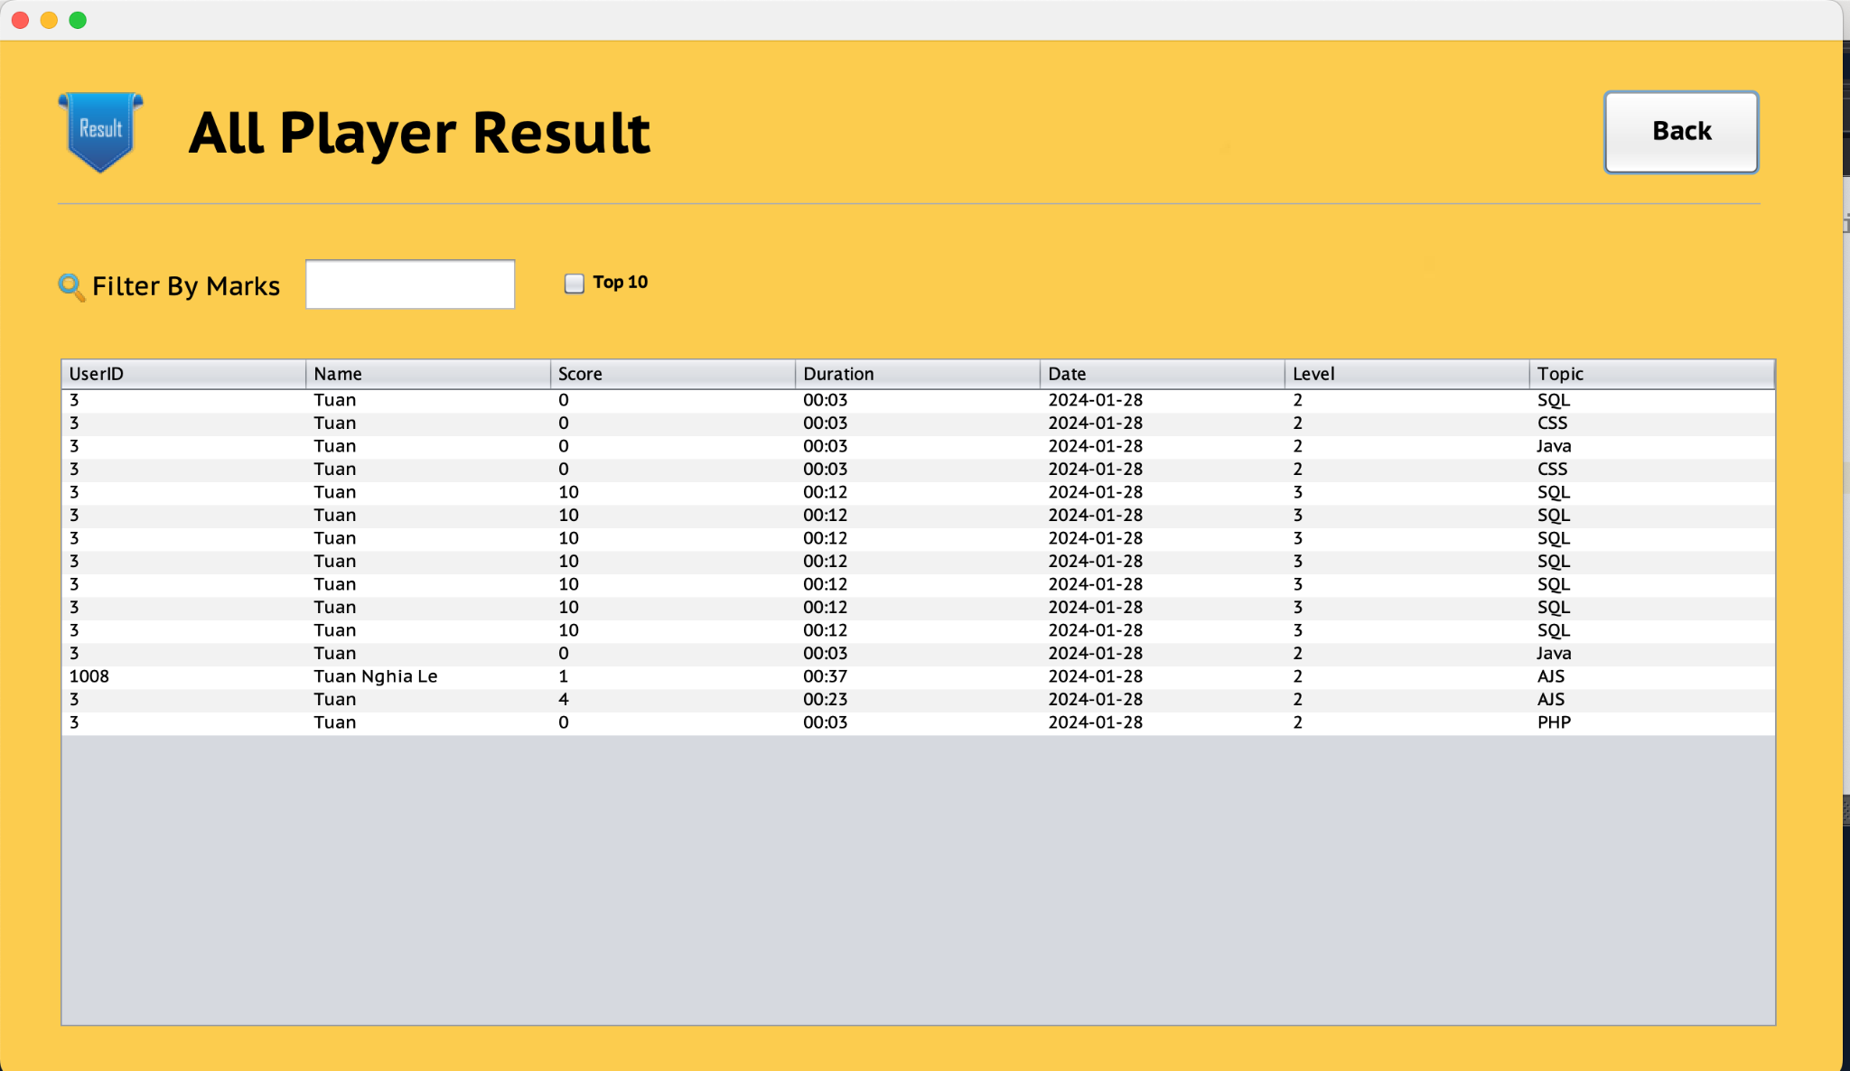

*Figure 5 : All Result*

* *Players can view results filtered by score*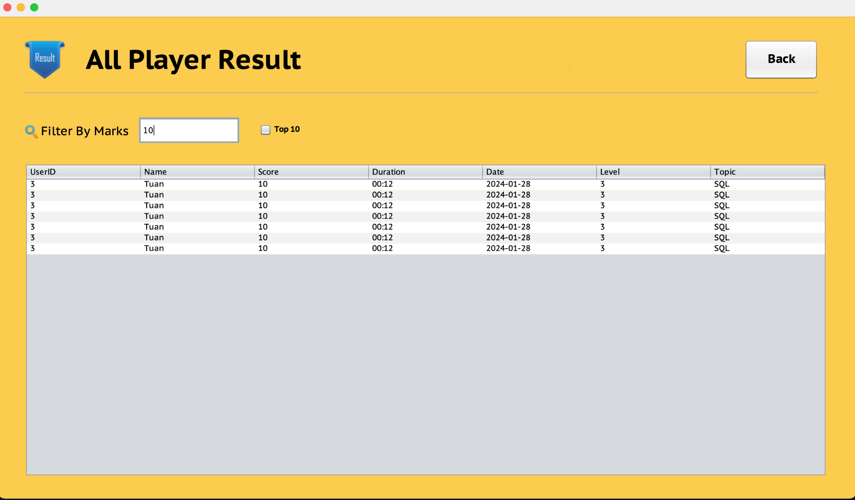

*Figure 6 : All Result*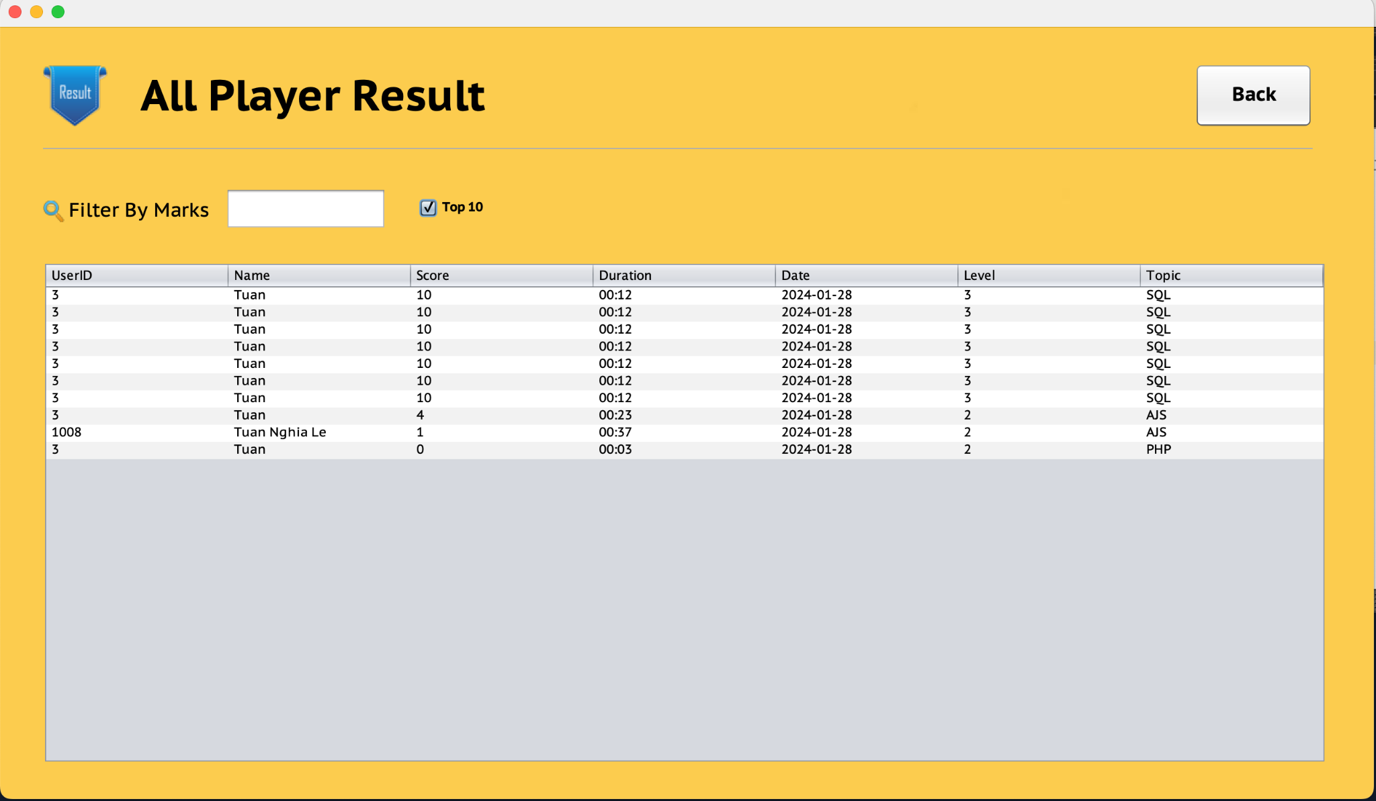

* *View top10 results in descending order when clicking on the top10 checkbox.*
* *Click the back button to return to the player interface.*

*Figure 8 : All Result*

* *Medium(2) and hard(3) difficulty levels are similar to easy(1)*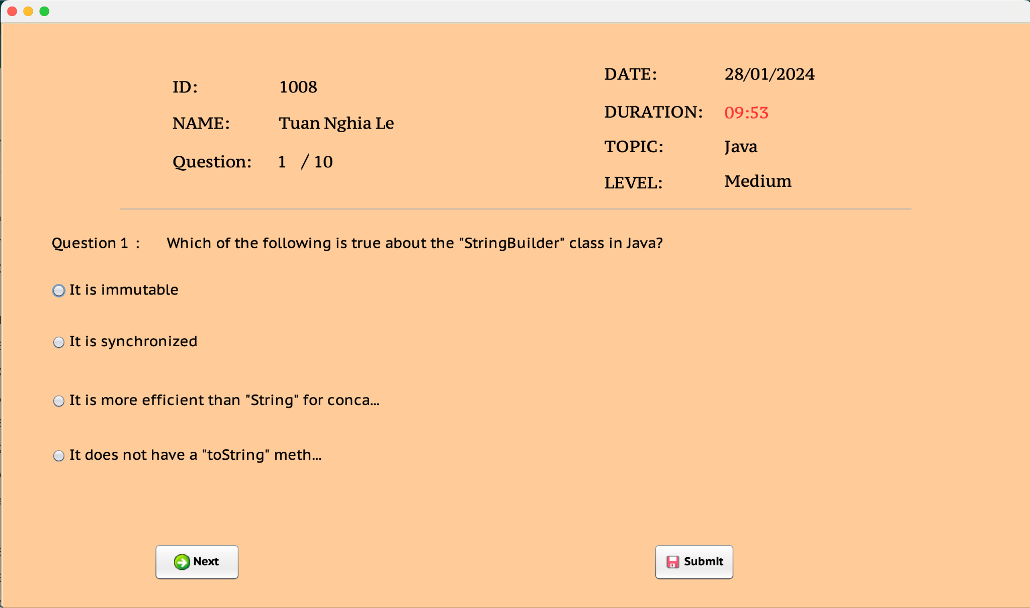

*Figure 9 : Medium level*

*Figure 10 : Medium level*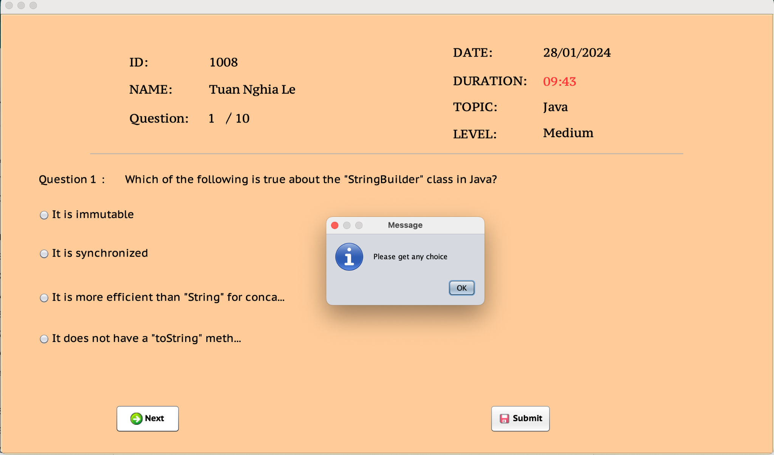

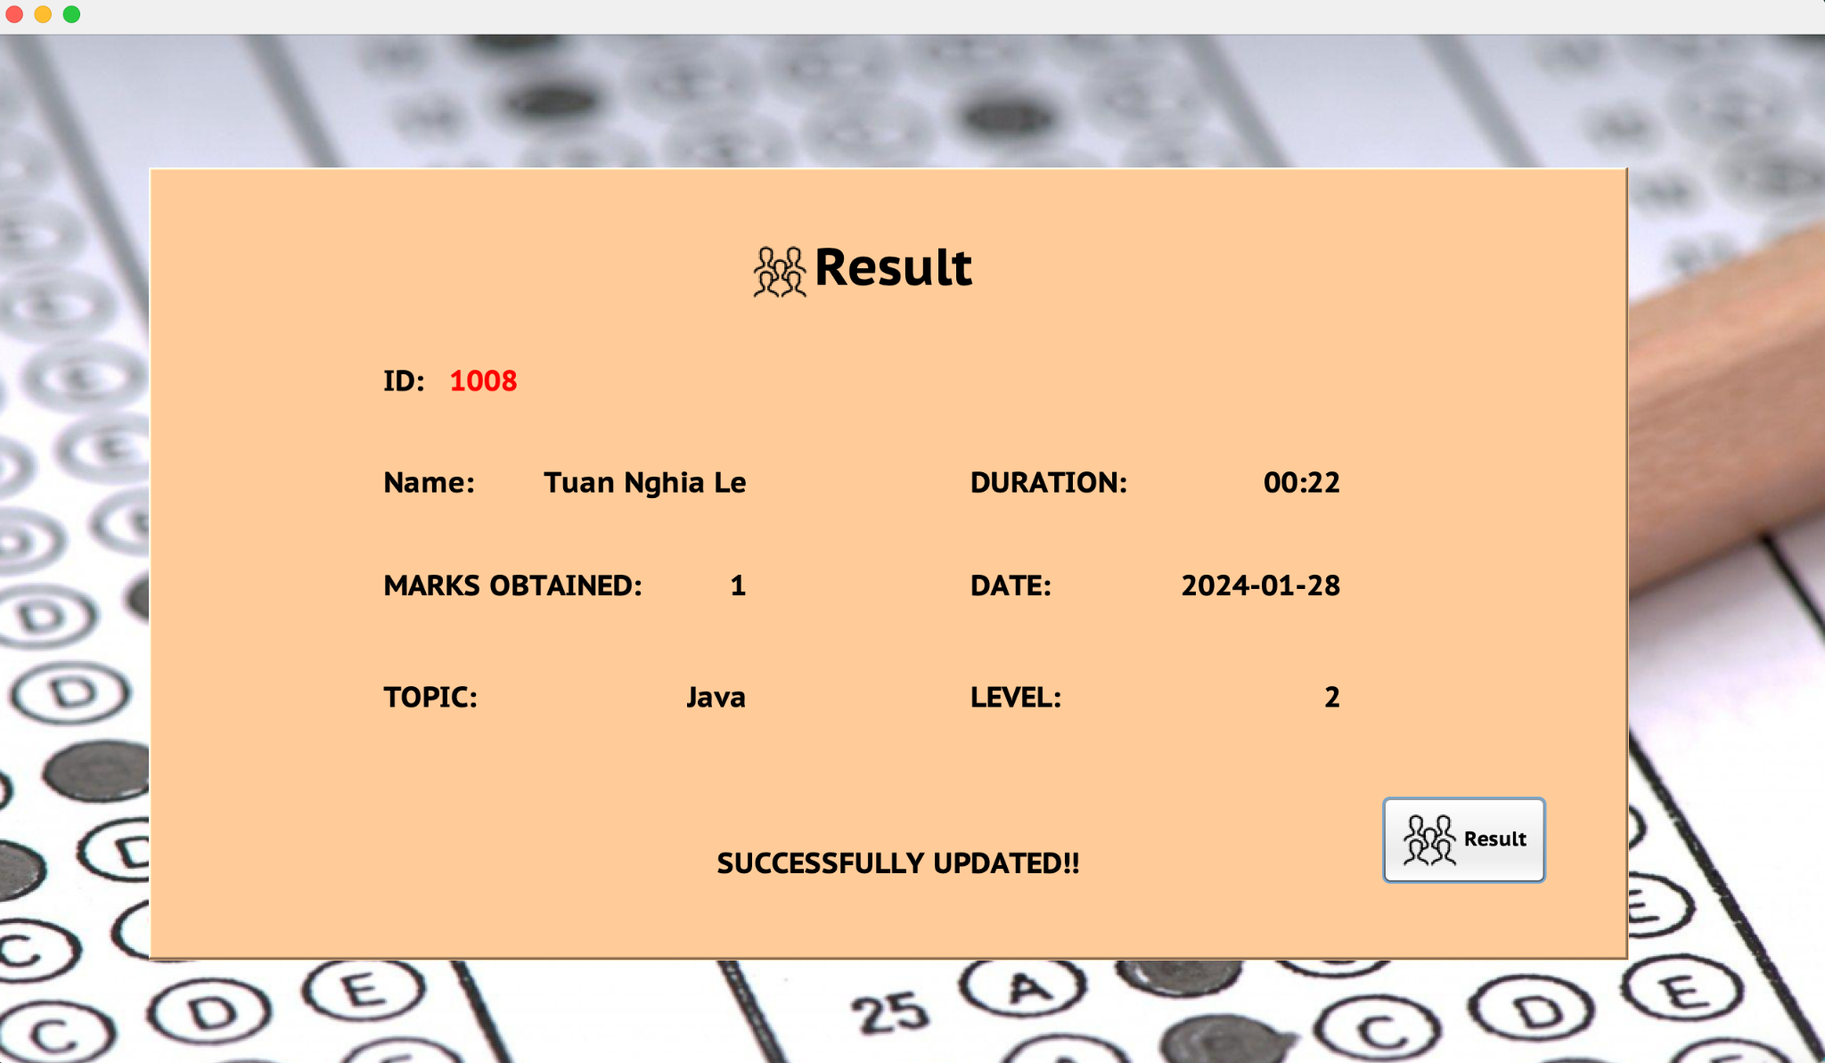

*Figure 11 : Medium level*

*Figure 12: Hard level*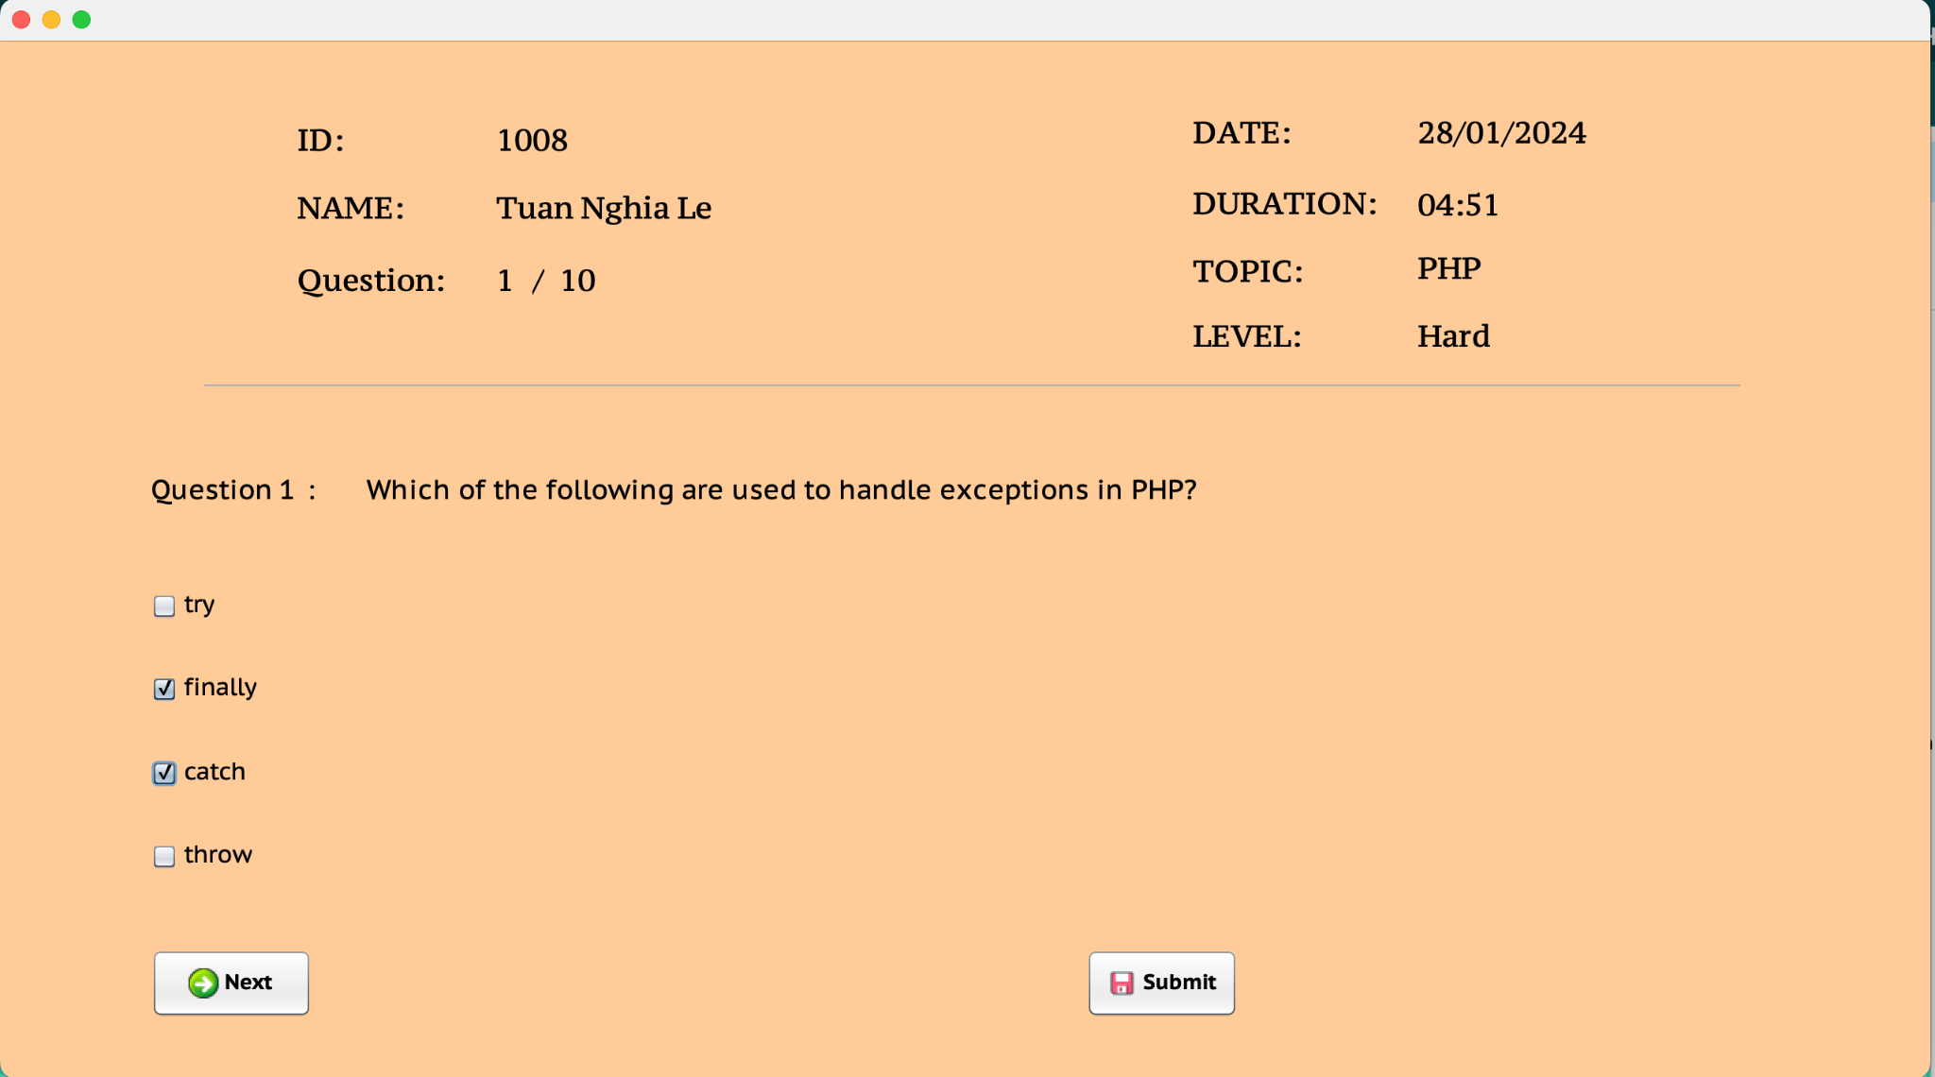

*Figure 13: Hard level*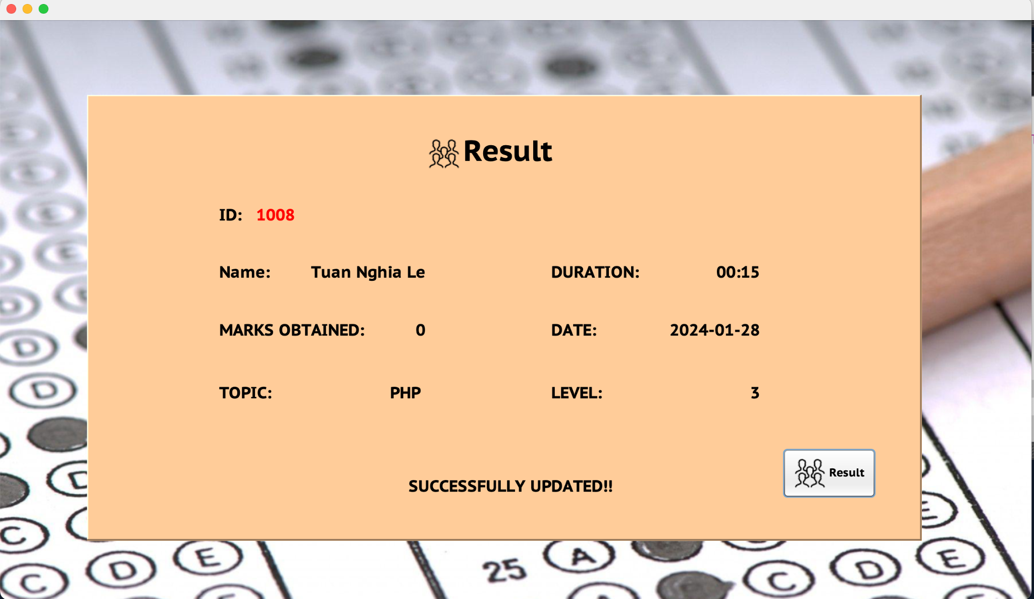

* *Players can logout to log in to another account or exit.*

*Figure 14: Log out* 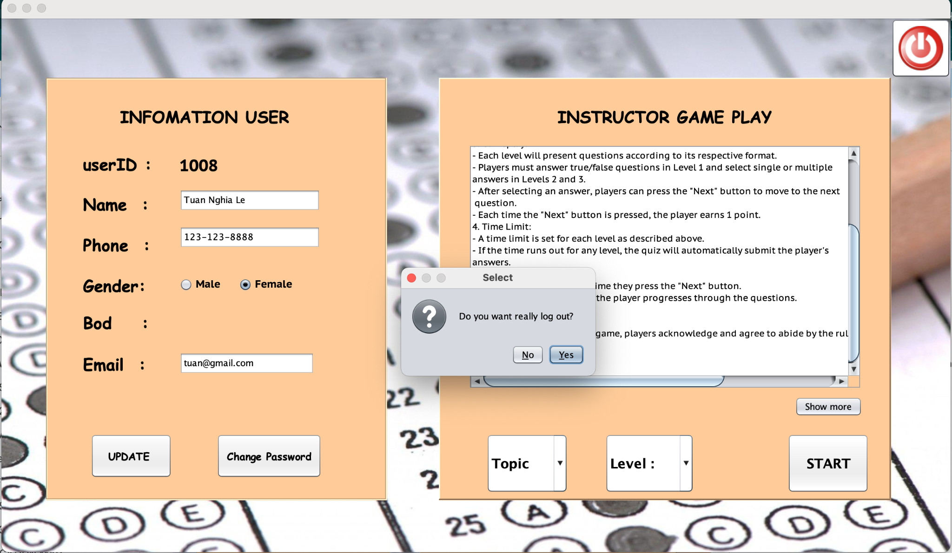

**ADMIN INTERFACE**

*a.Display:*

* To enter the TechQuiz information system managed dashboard must be logged in as an administrator.
* Displays lists of questions for management
* Displays user lists of the QuizTech system
* Displays the player's results

*b. Function:*

* To enter the TechQuiz information system managed dashboard must be logged in as an administrator.
* Administrators can view, edit, add and delete questions
* Administrators can view, edit, add and delete players
* Administrators can view deleted player results

*c. ScreenShot:*

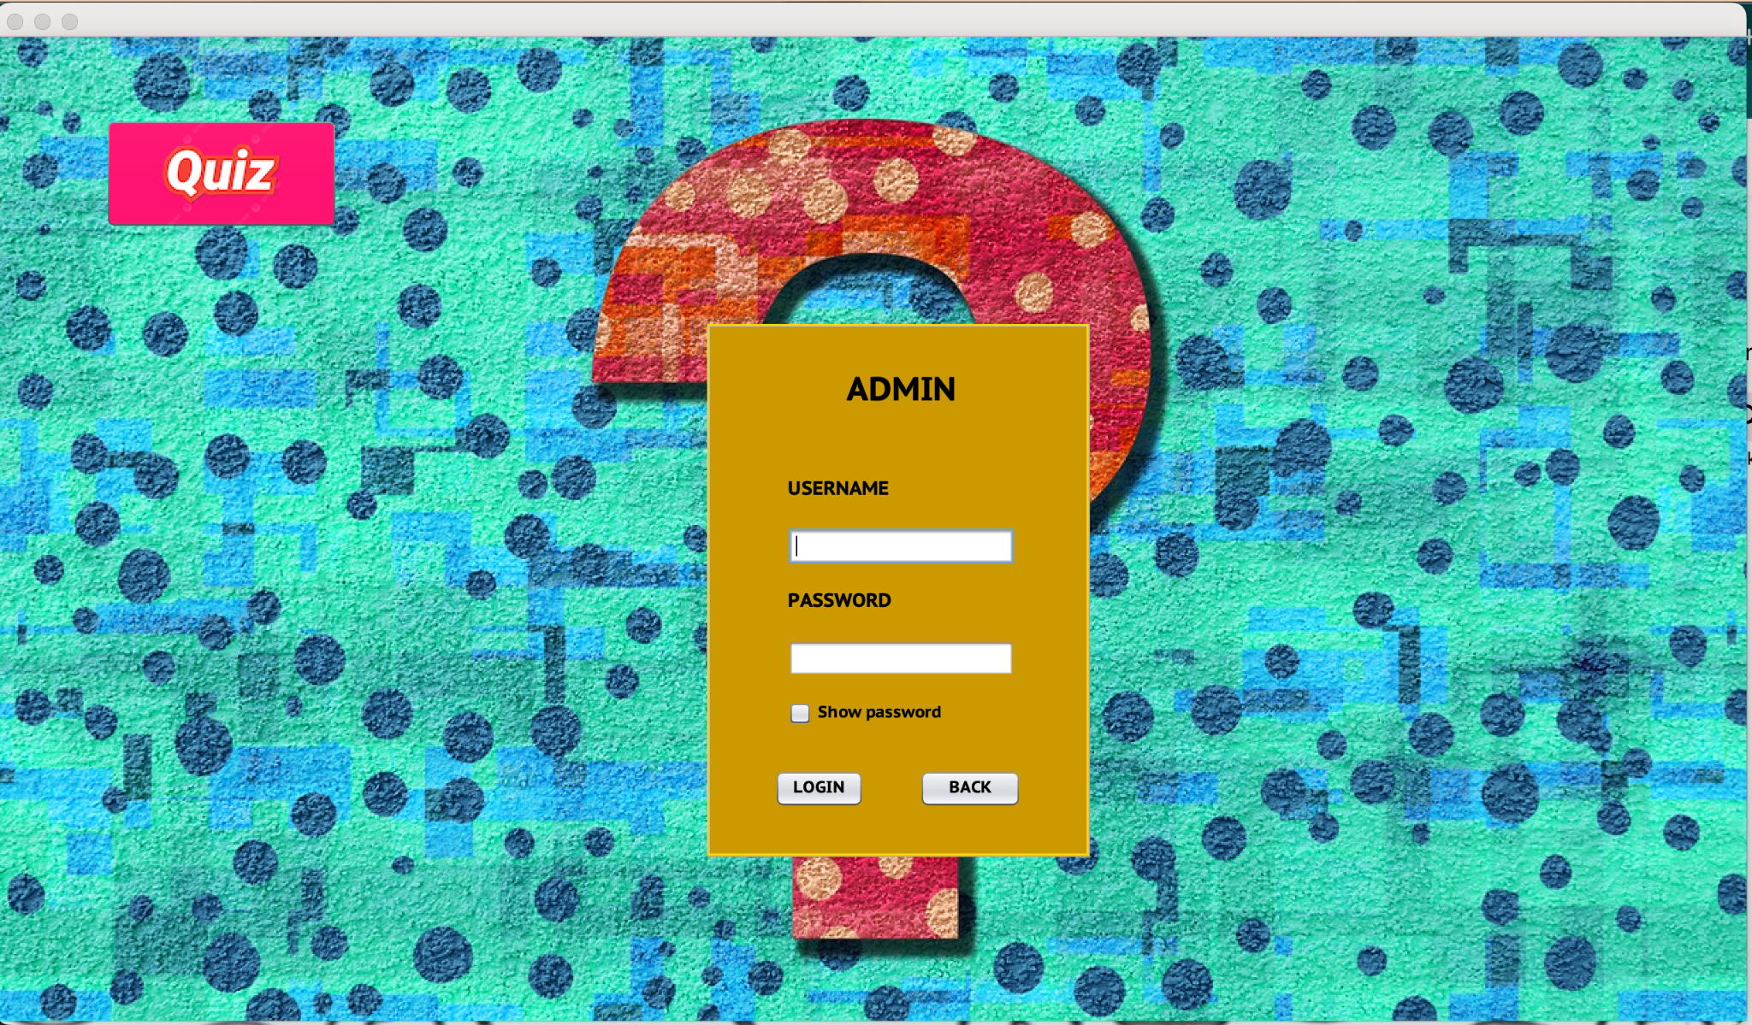

*Figure 1: Login Admin*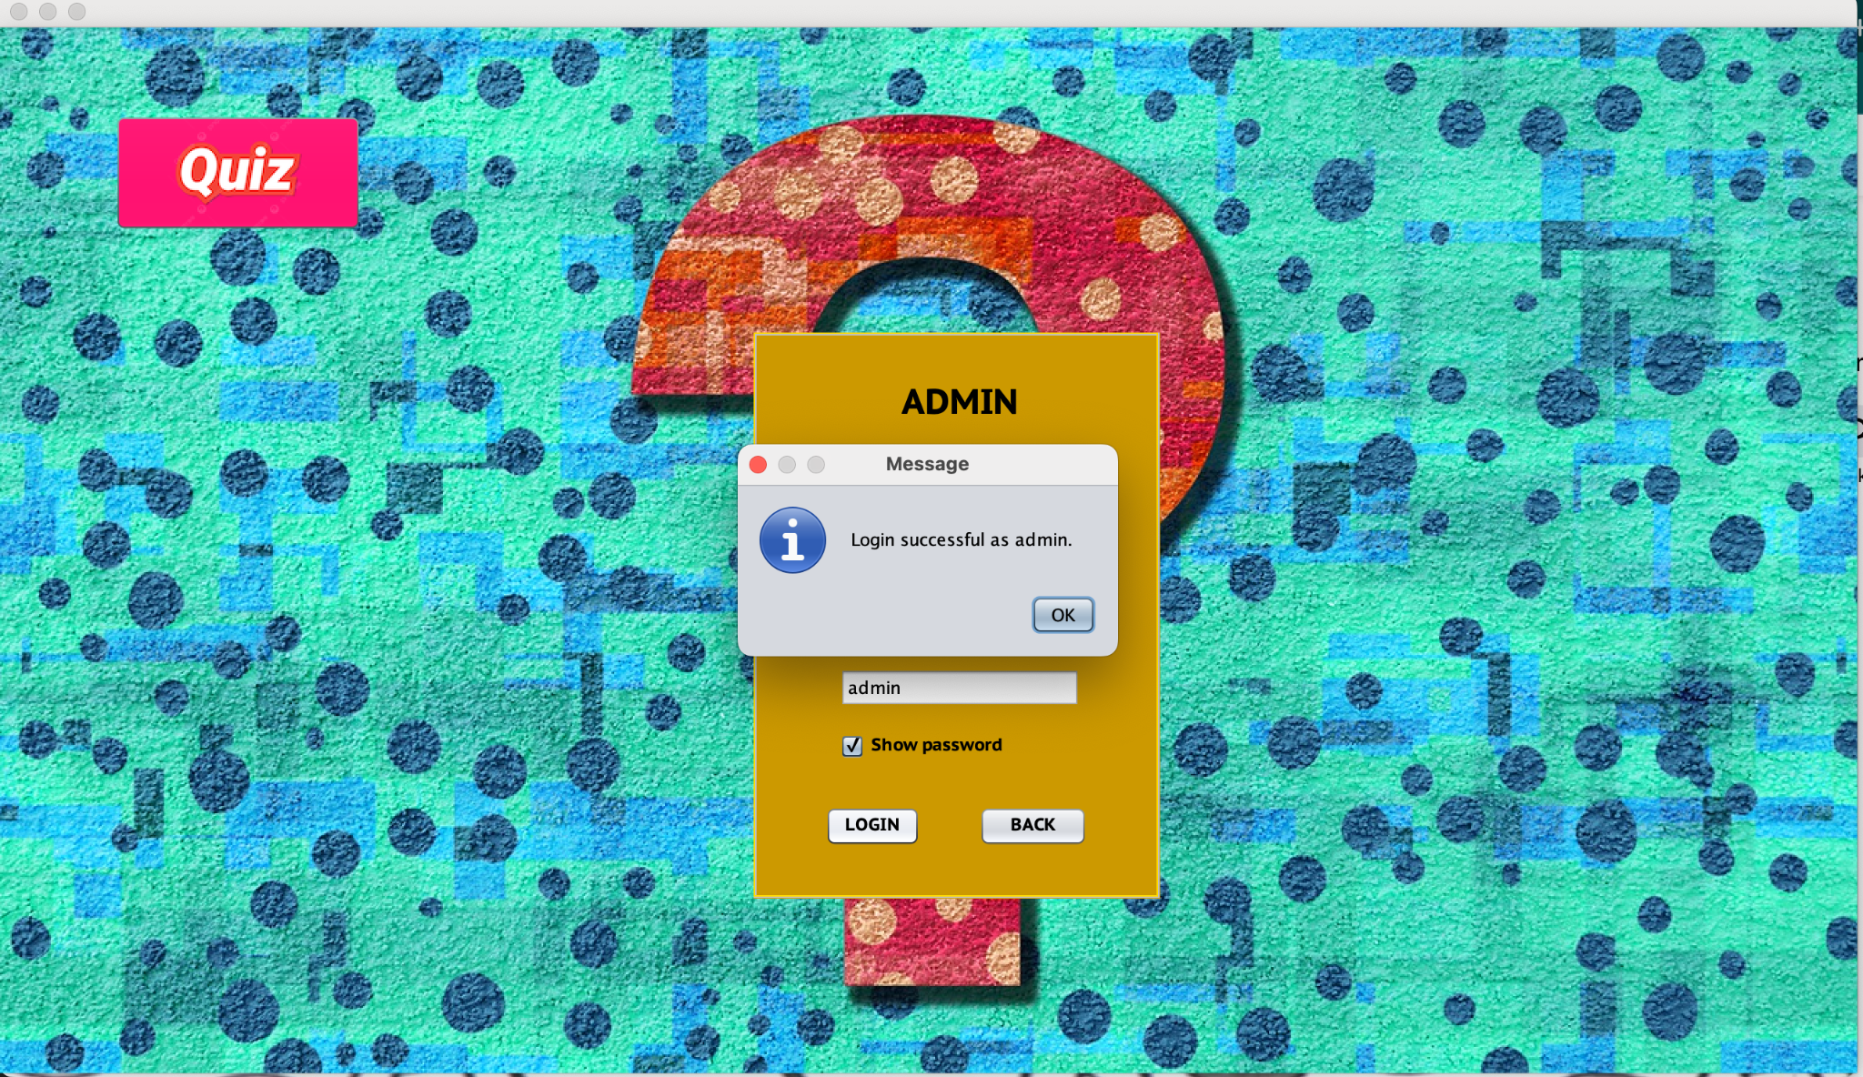

*Figure 2: Login Admin Successfully*

*Figure 3: List Question*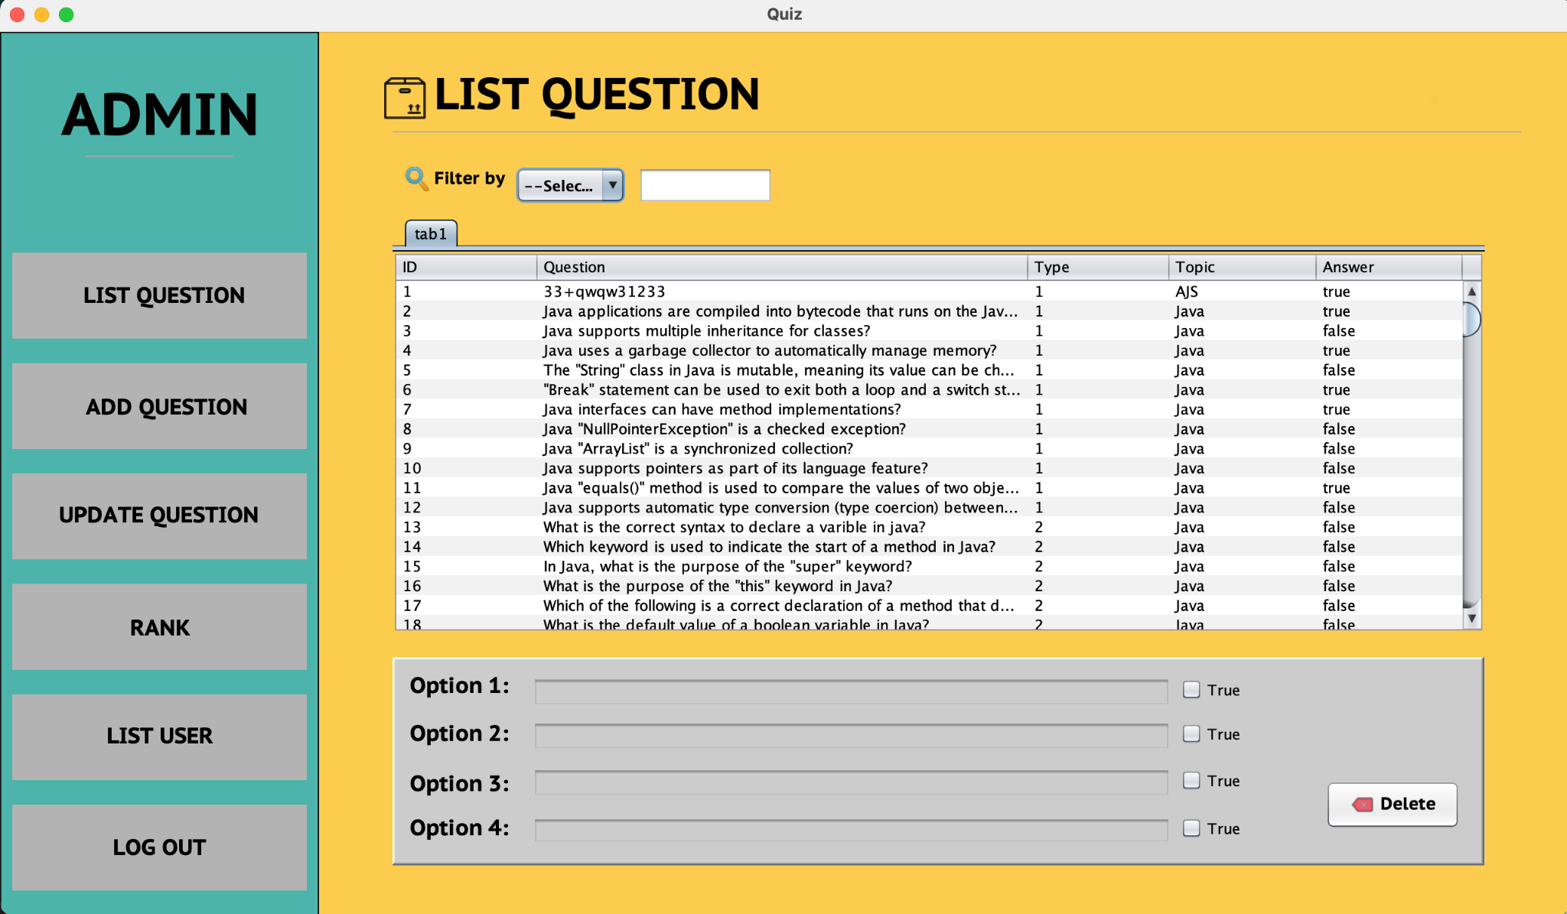

*Admin can search by ID, LEVEL, TOpic*

*Figure 5: Filter by ID*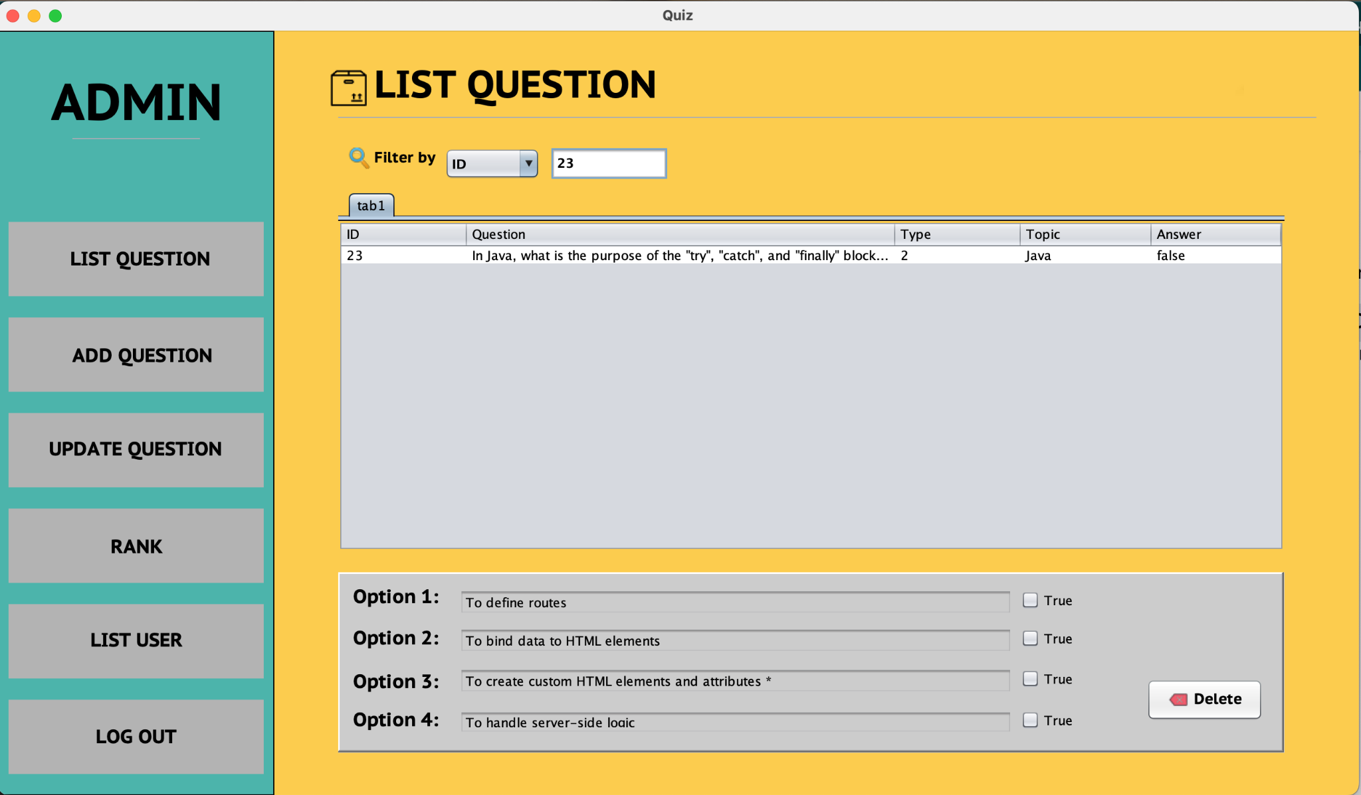

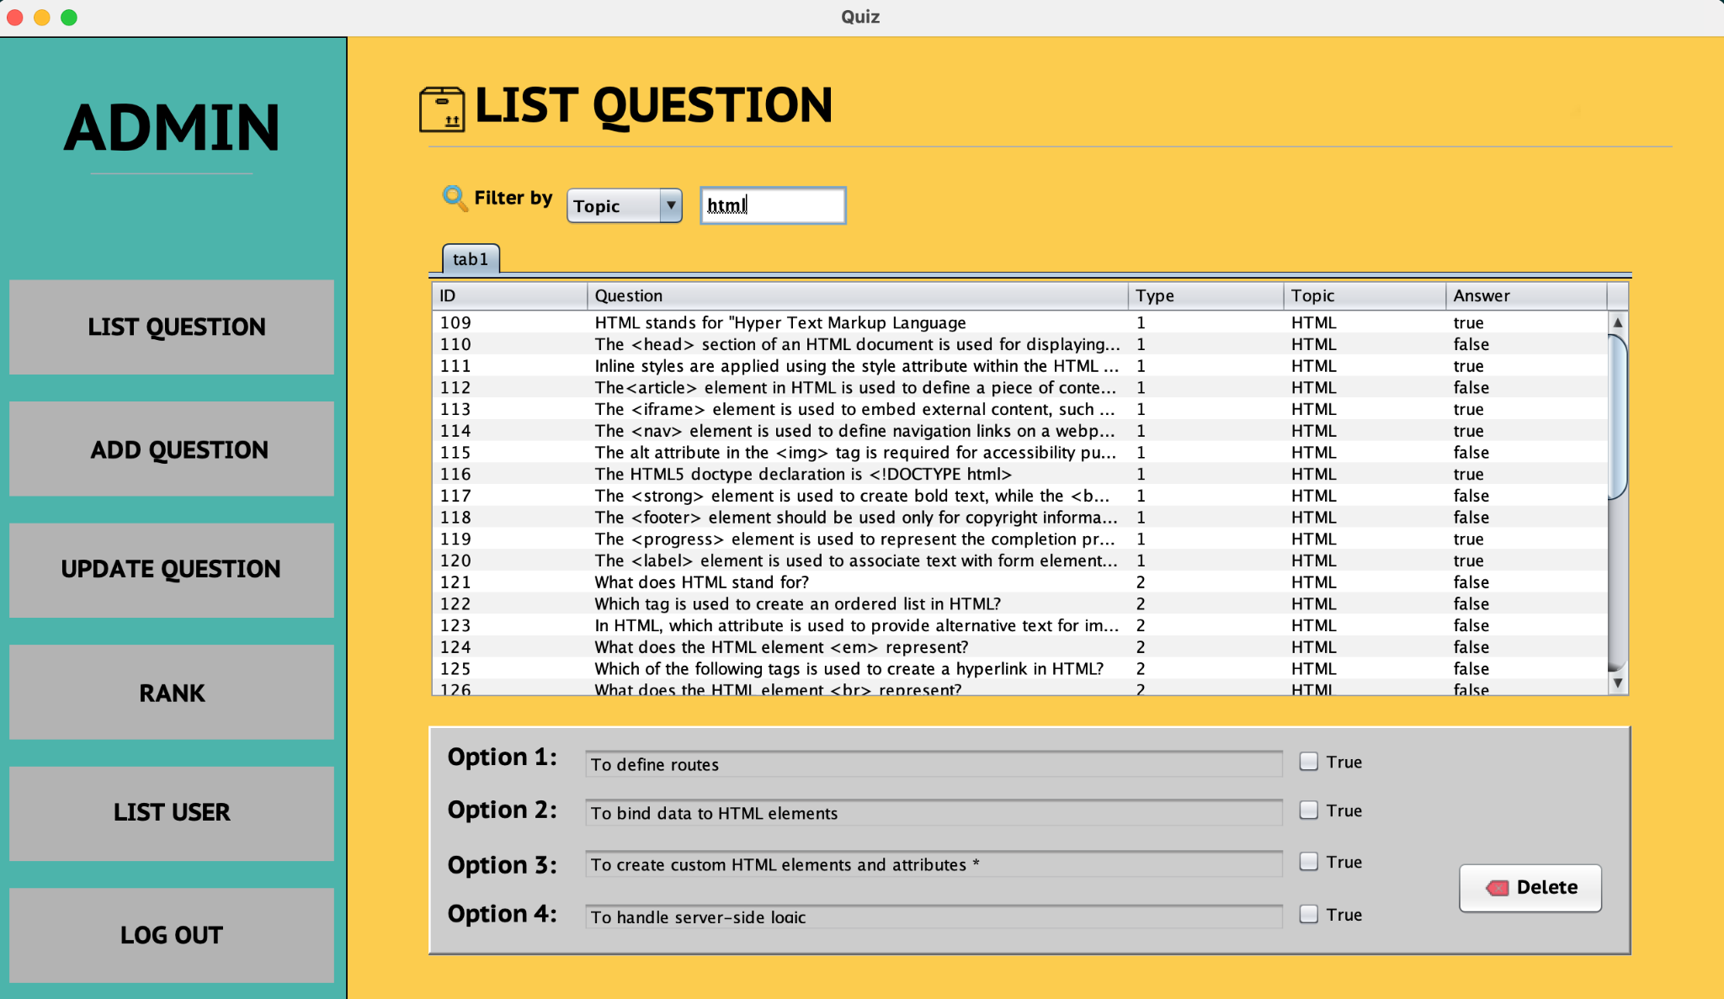

*Figure 6: Filter by topic*

* *When double click on a question, the answers will be displayed and the correct answer will have a check behind it*
* *If the question is Medium(2) and hard(3), the answer will be displayed with a checkbox containing the correct answer*

*Figure 7: Medium(2) question*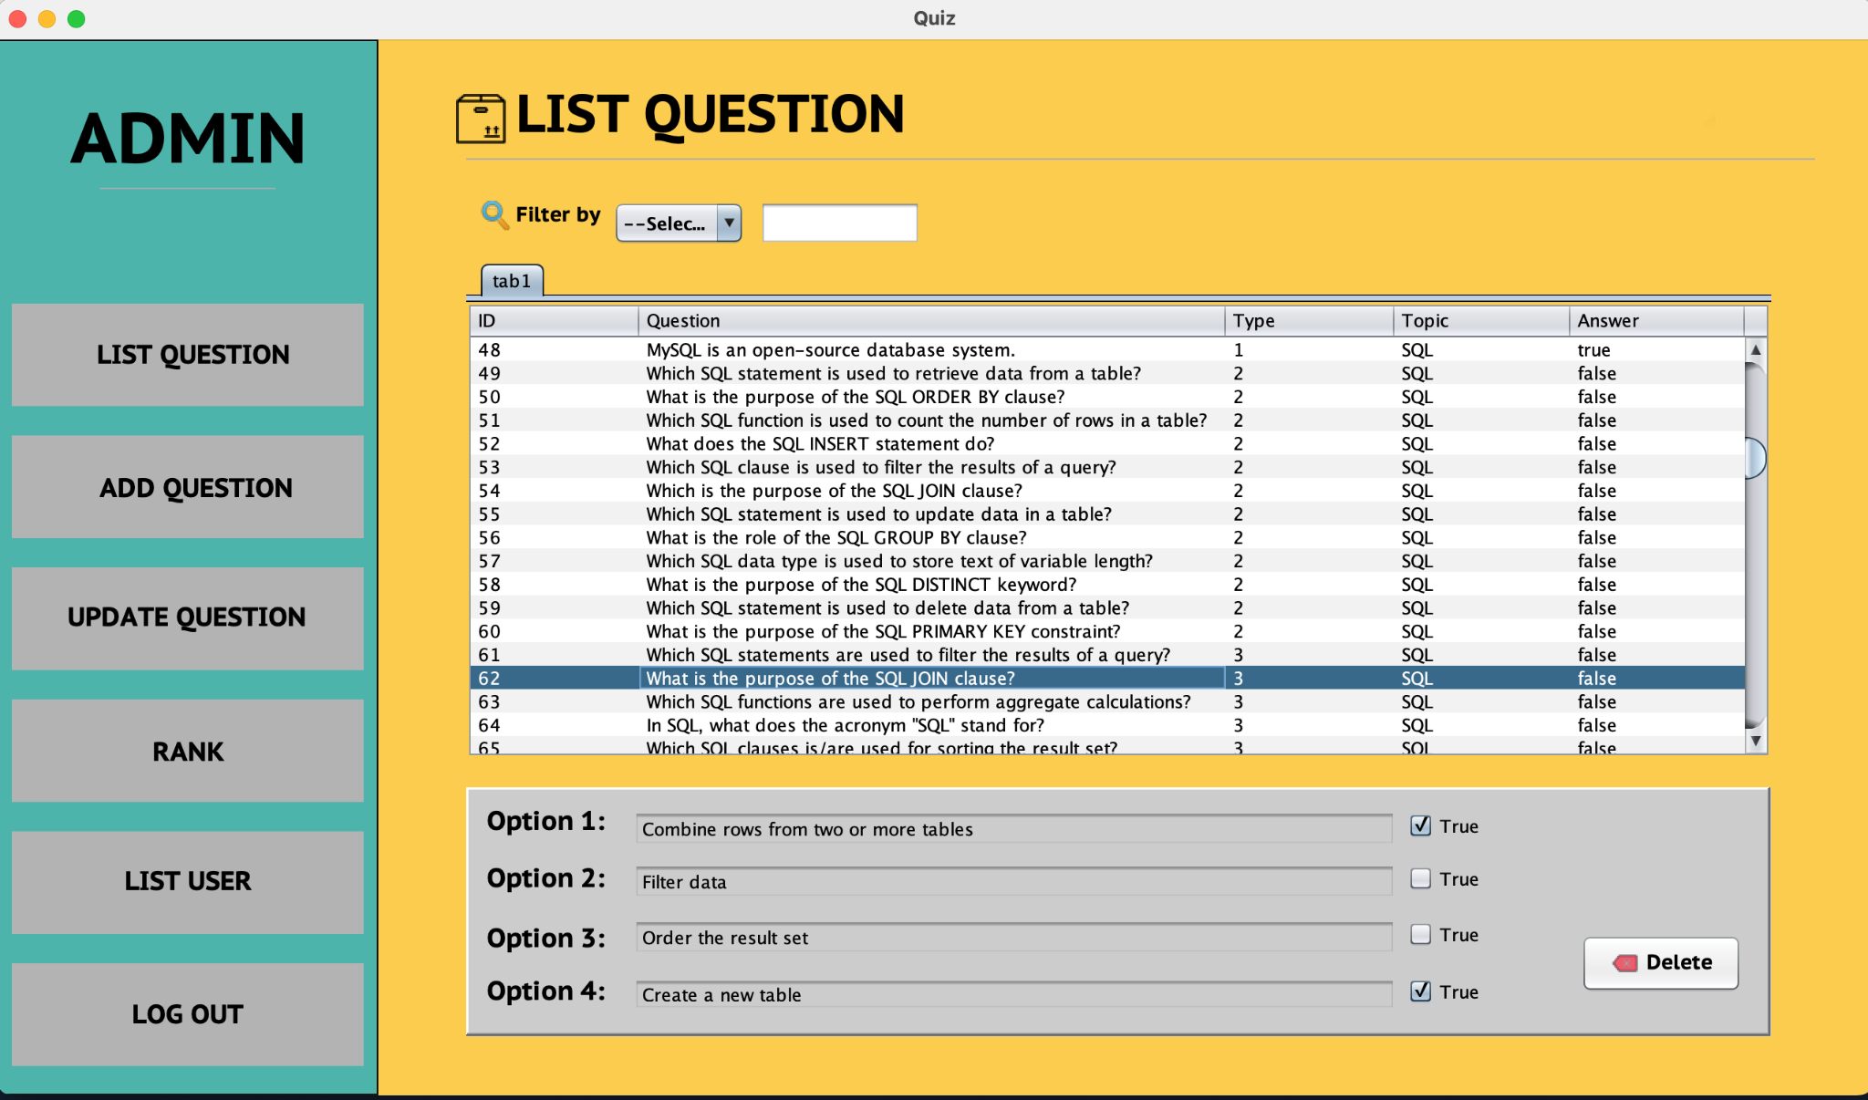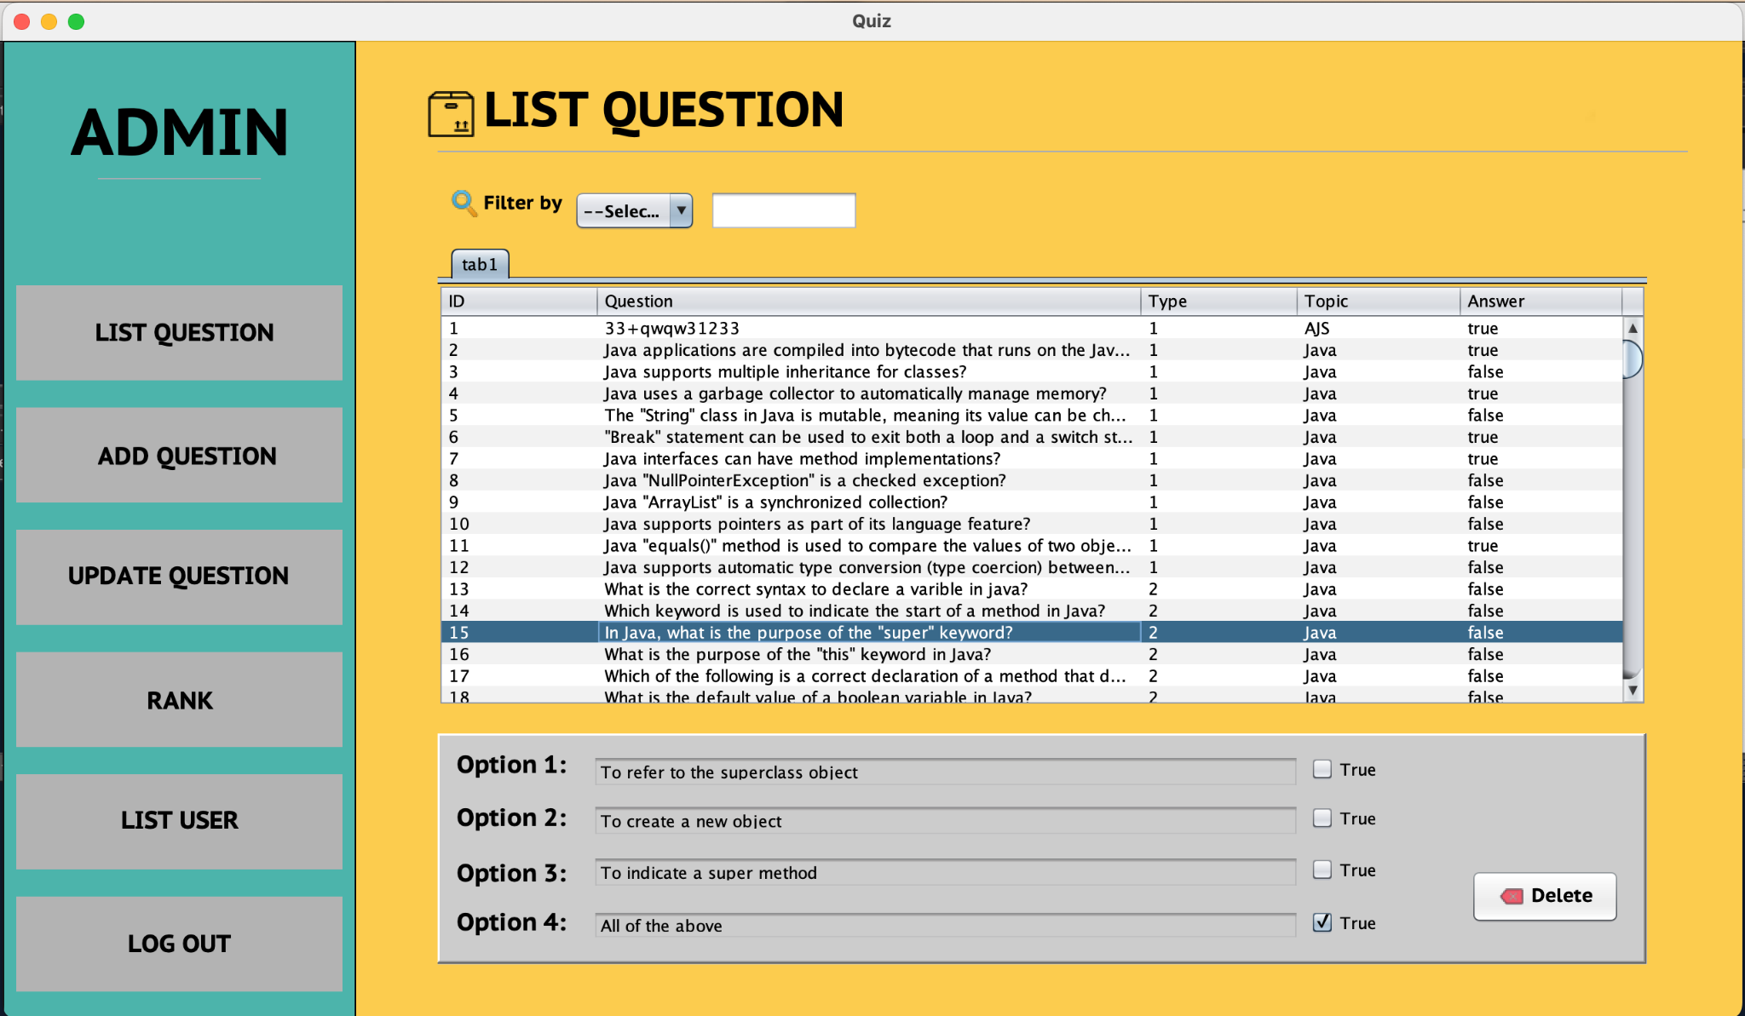

*Figure 8: Hard(3) question*

* *If the answer is easy (1), the answer will not be displayed below*

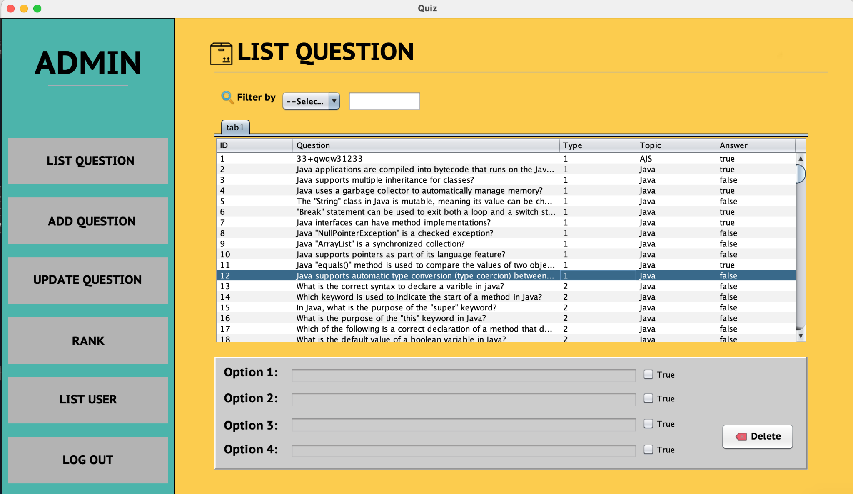

*Figure 9: Easy(1) question*

* *To delete a question, double click and press the delete button on the right corner of the screen*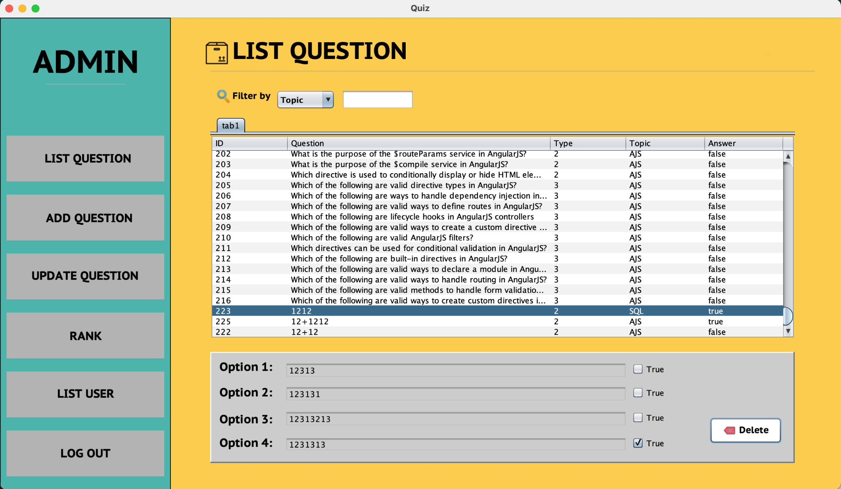

*Figure 10: Delete question ID = 223*

* *A notification will appear when the question is successfully deleted*

*Figure 11: After delete*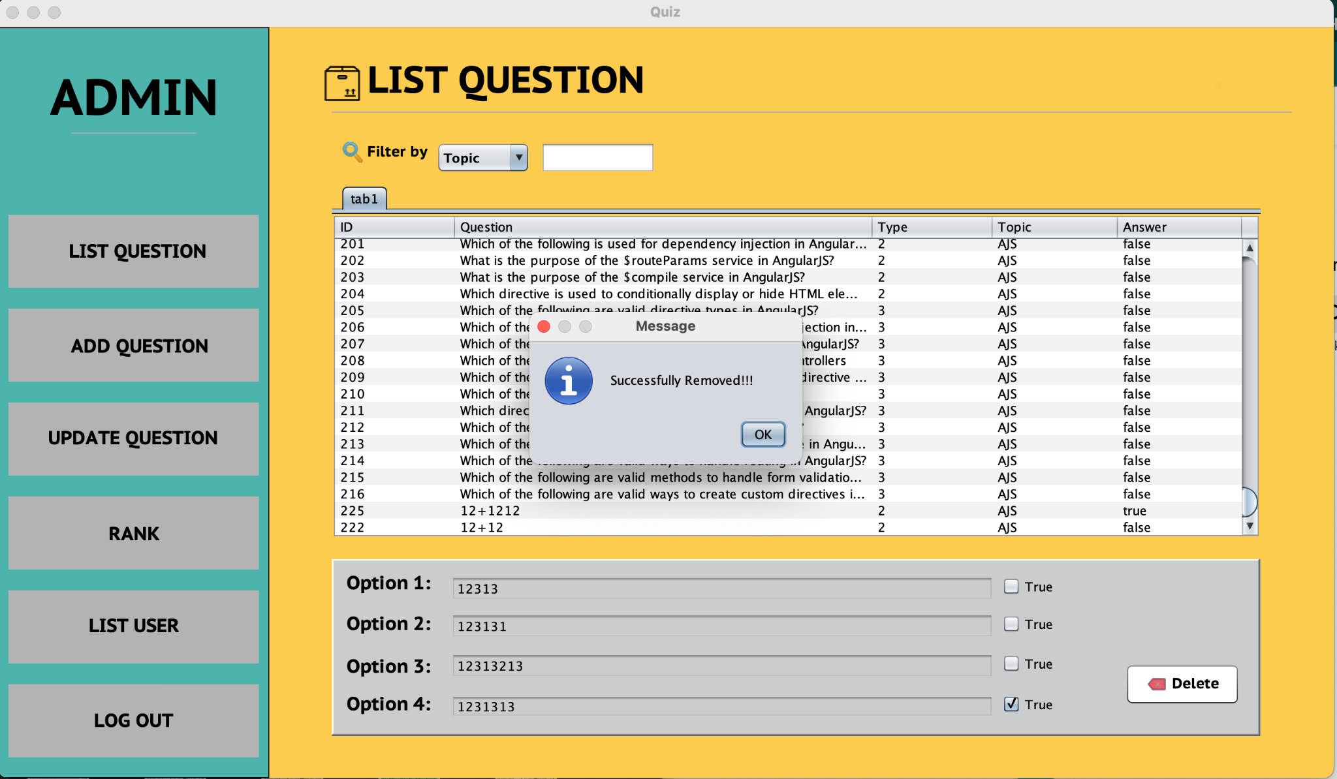

* *Required input fields must be entered to add a question.*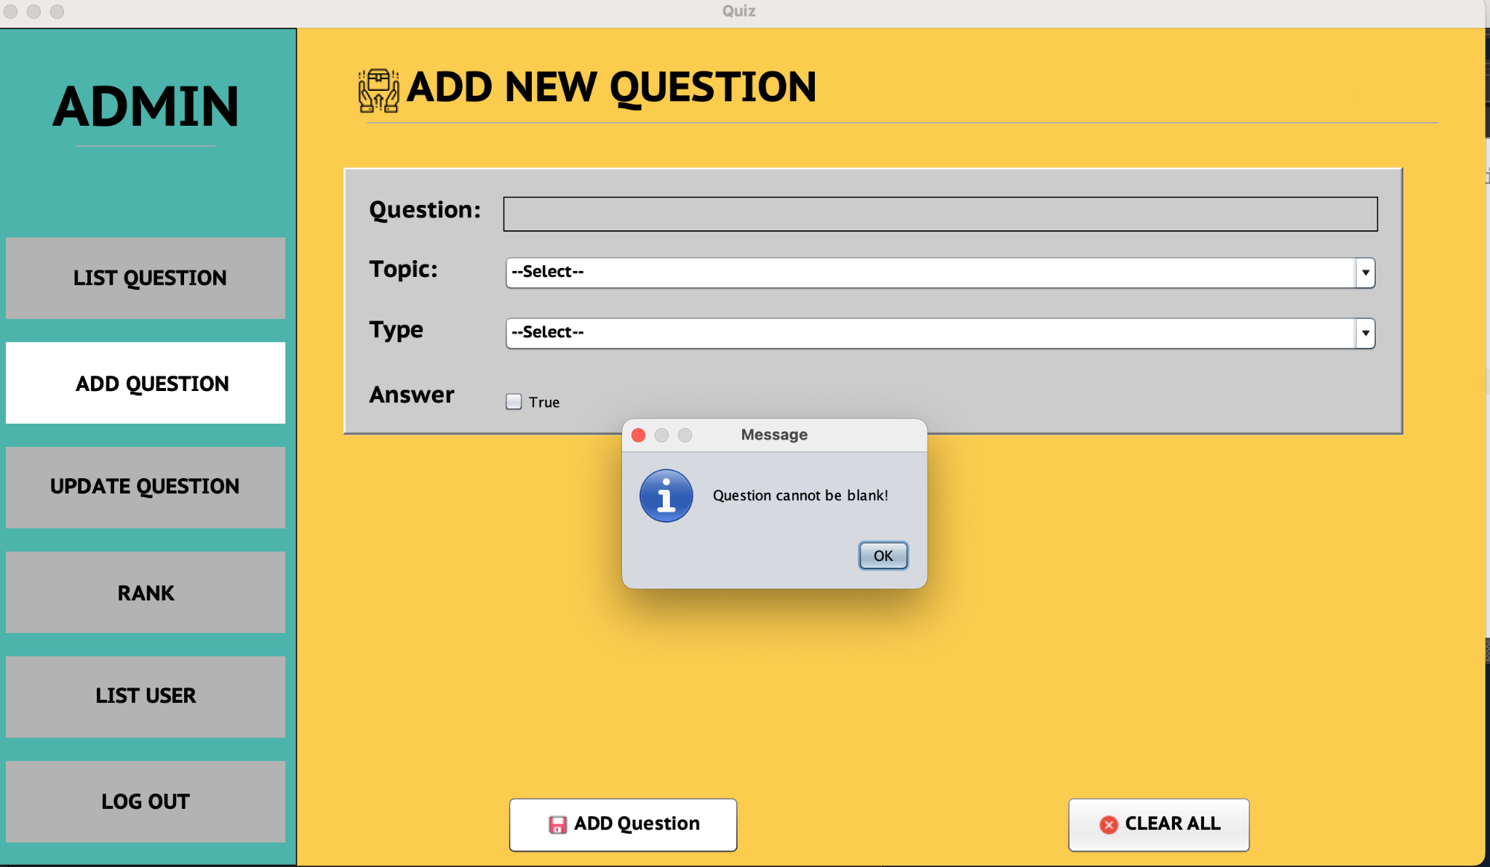

*Figure 12: Required input fields*

*Figure 13: Required input fields*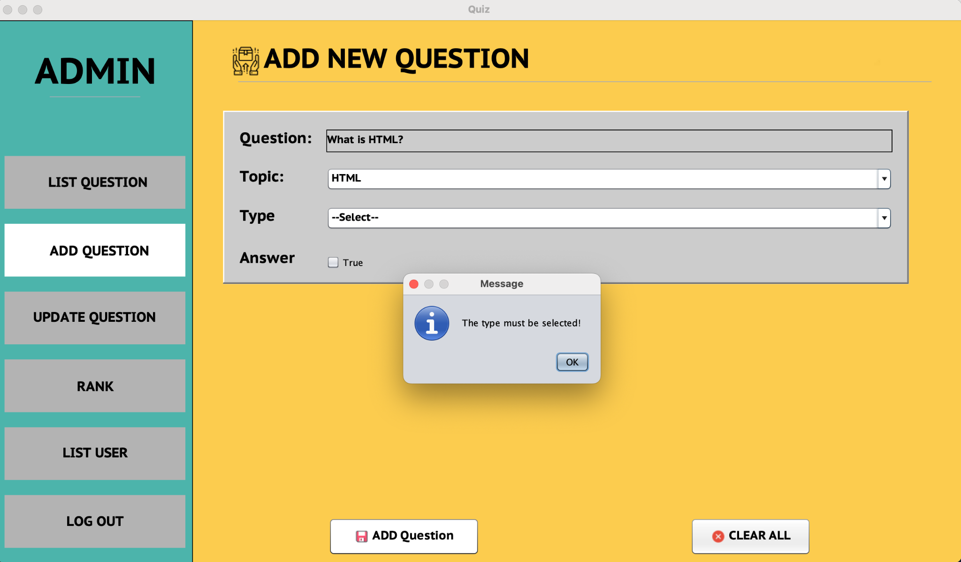

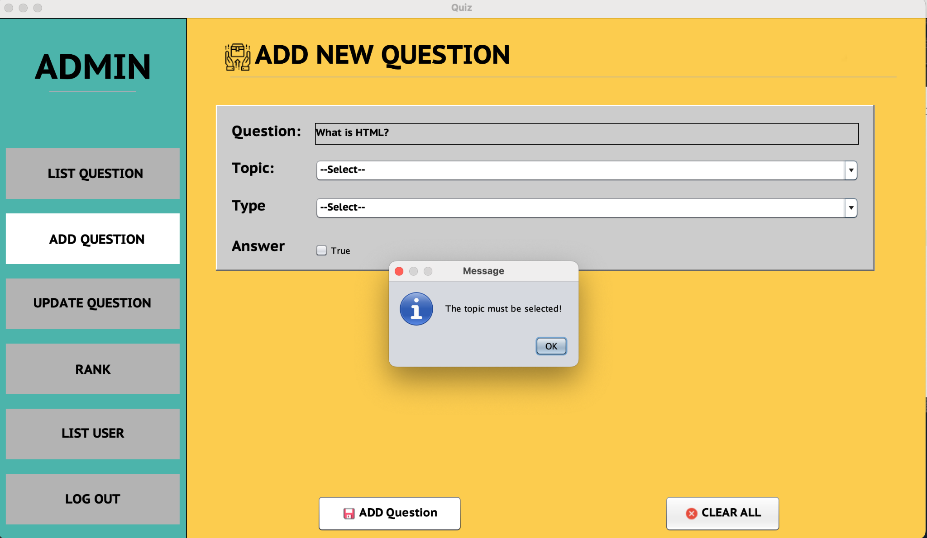

*Figure 14: Required input fields*

* *If the question is type 1, after entering the data, it will be updated in the question list.*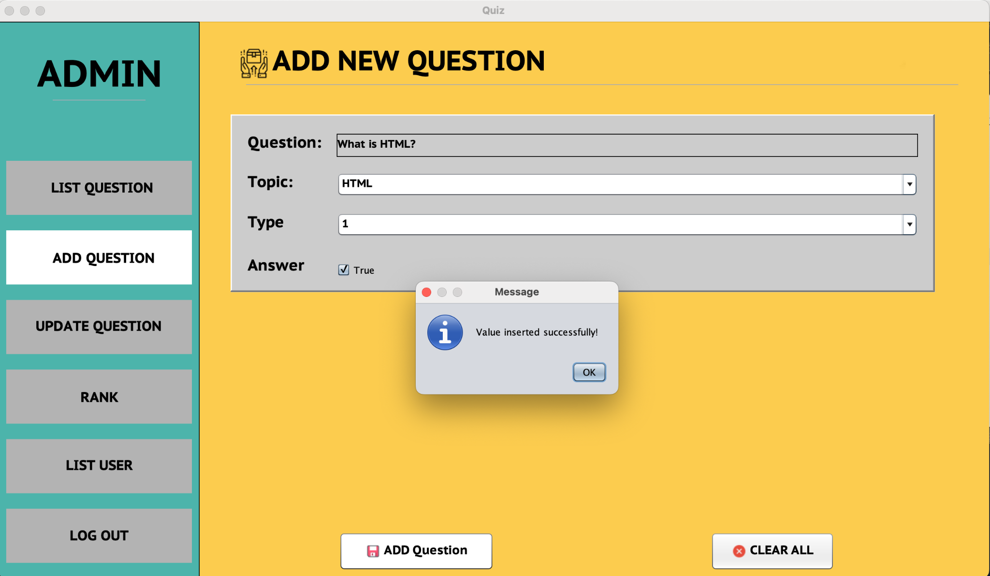

*Figure 15: Inserted Successfully Easy (1) Question*

*-If the question is type 2 and 3, a panel containing options and answers will be displayed.*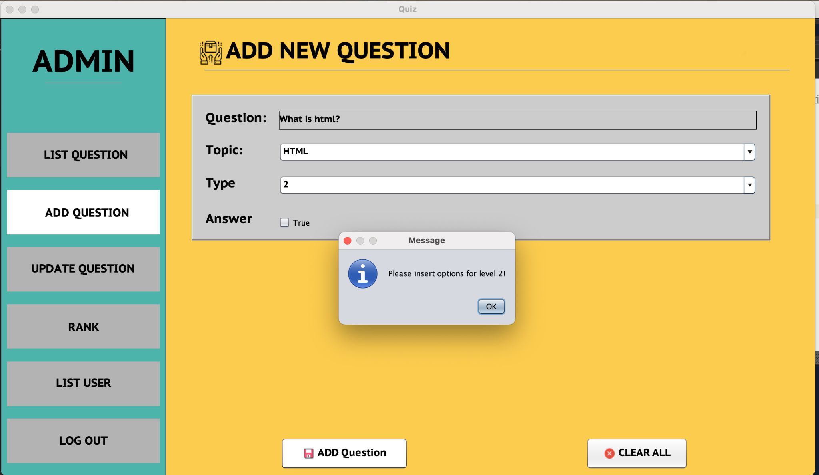

*Figure 16: Insert Medium (2) Question*

*Figure 17: Insert Medium (2) Question*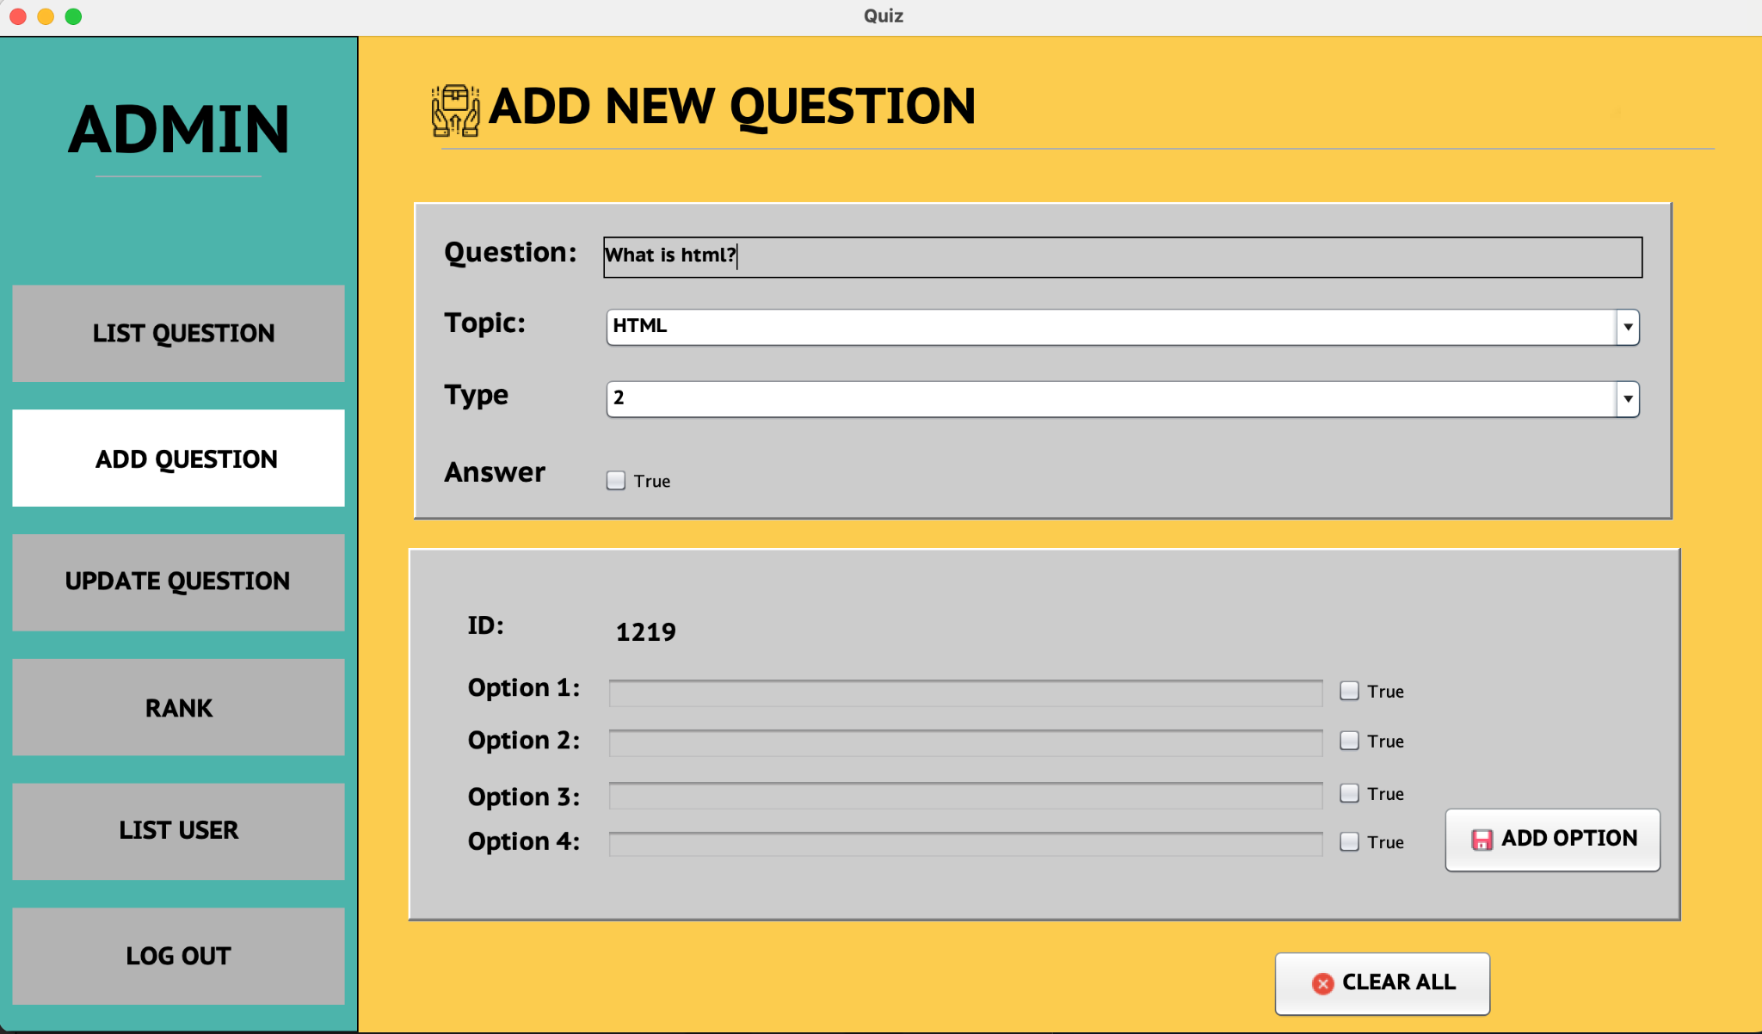

* *When finished entering data for the option boxes, click add options to add to the question list.*

*Figure 18: Insert Option for ID =1219*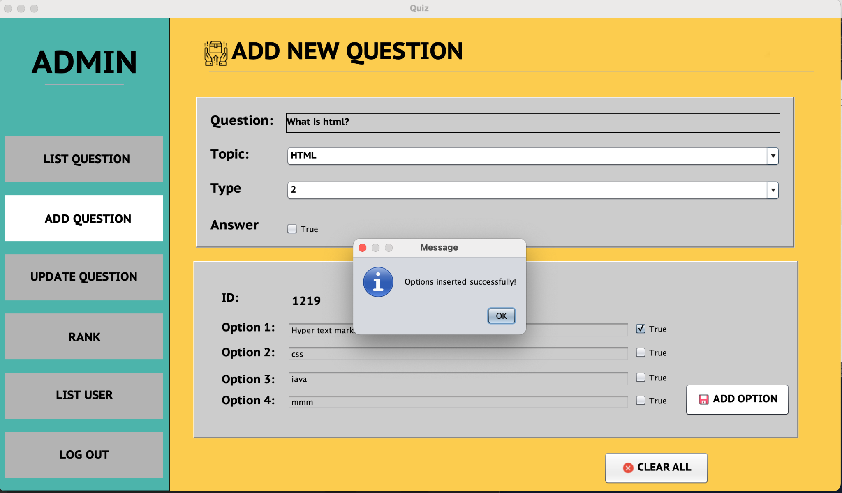

* *Question data has been added successfully.*

*Figure 19: Inserted Successfully ID = 1219*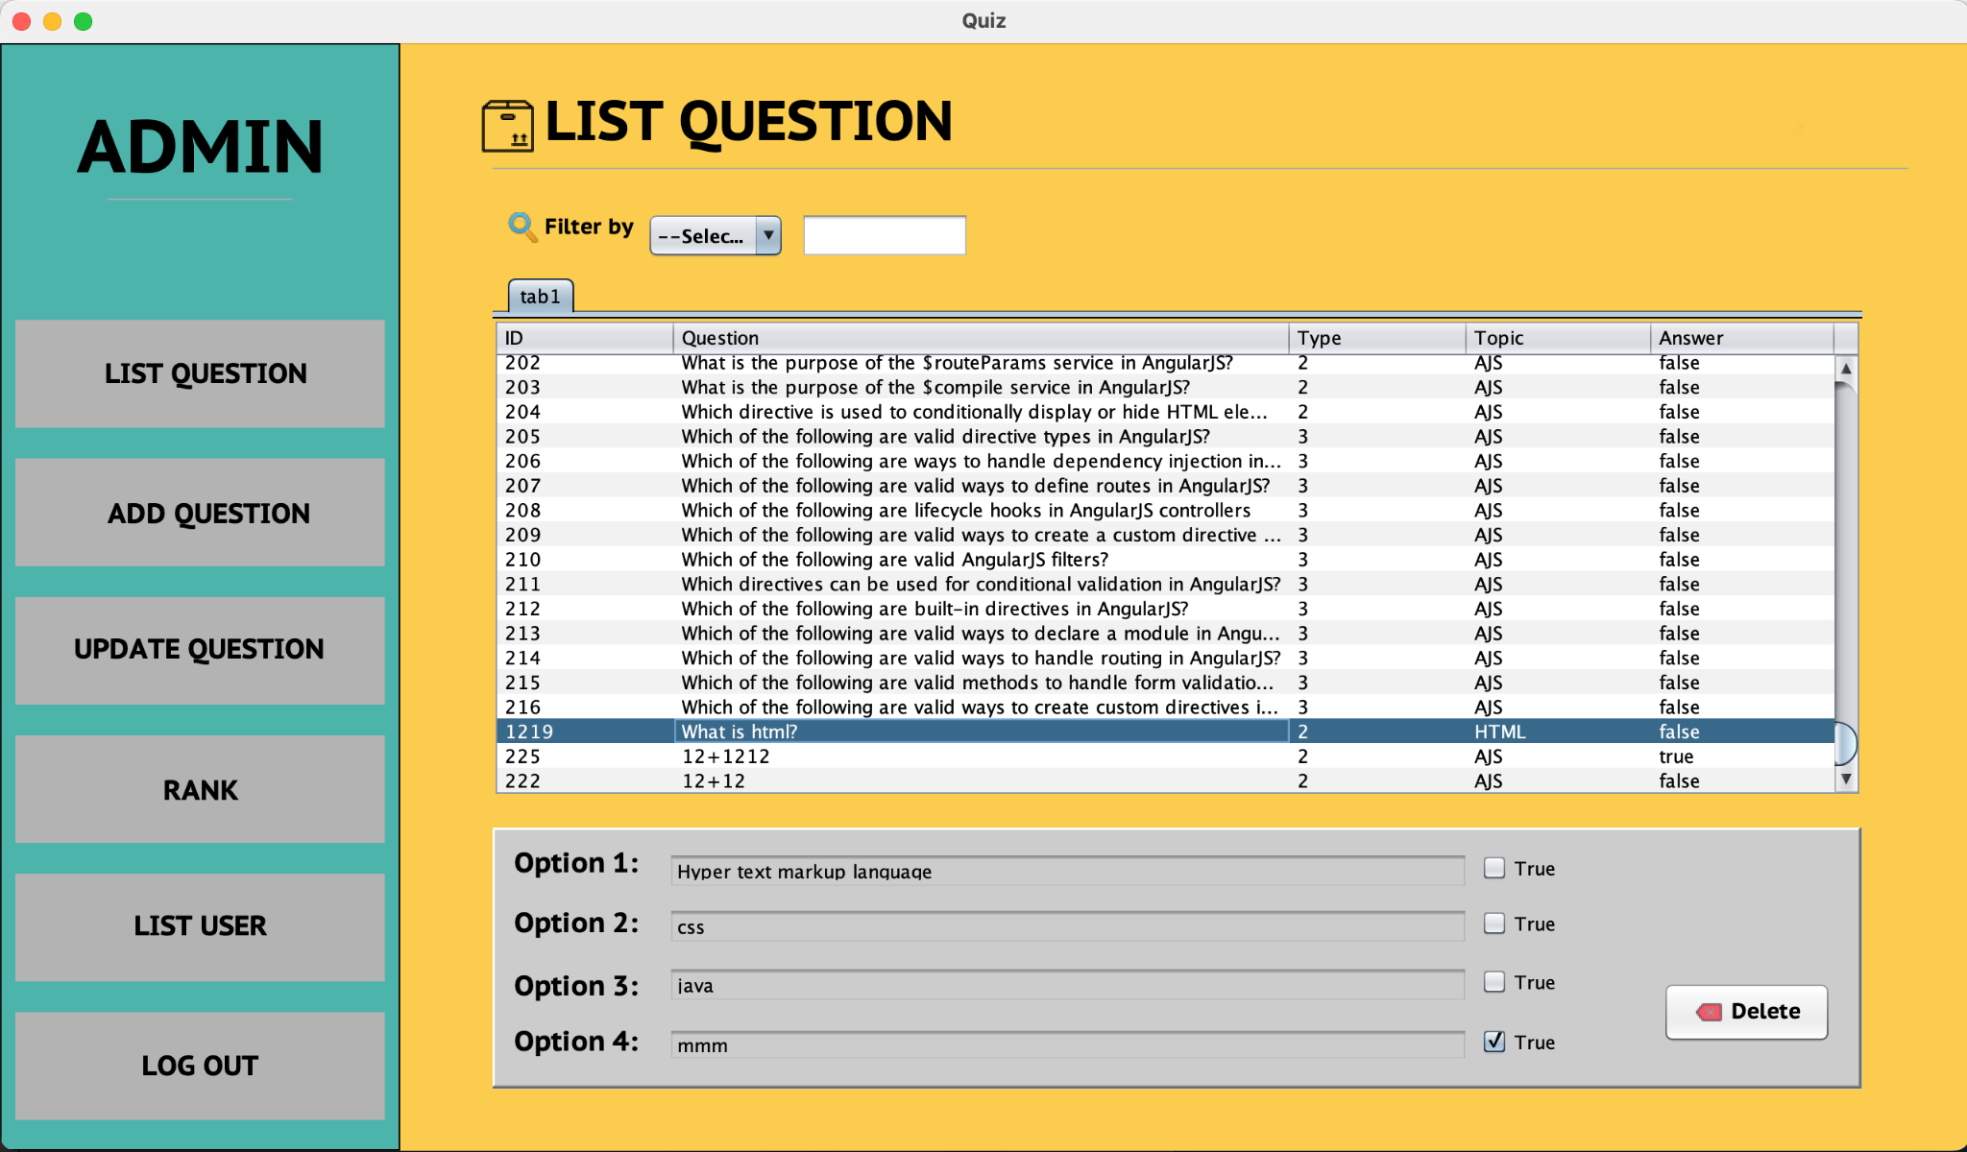

* *To update, you need to search for the id of the question that needs to be edited in the question list. When the id is not there, a notification will be displayed*

*Figure 20: Show notification*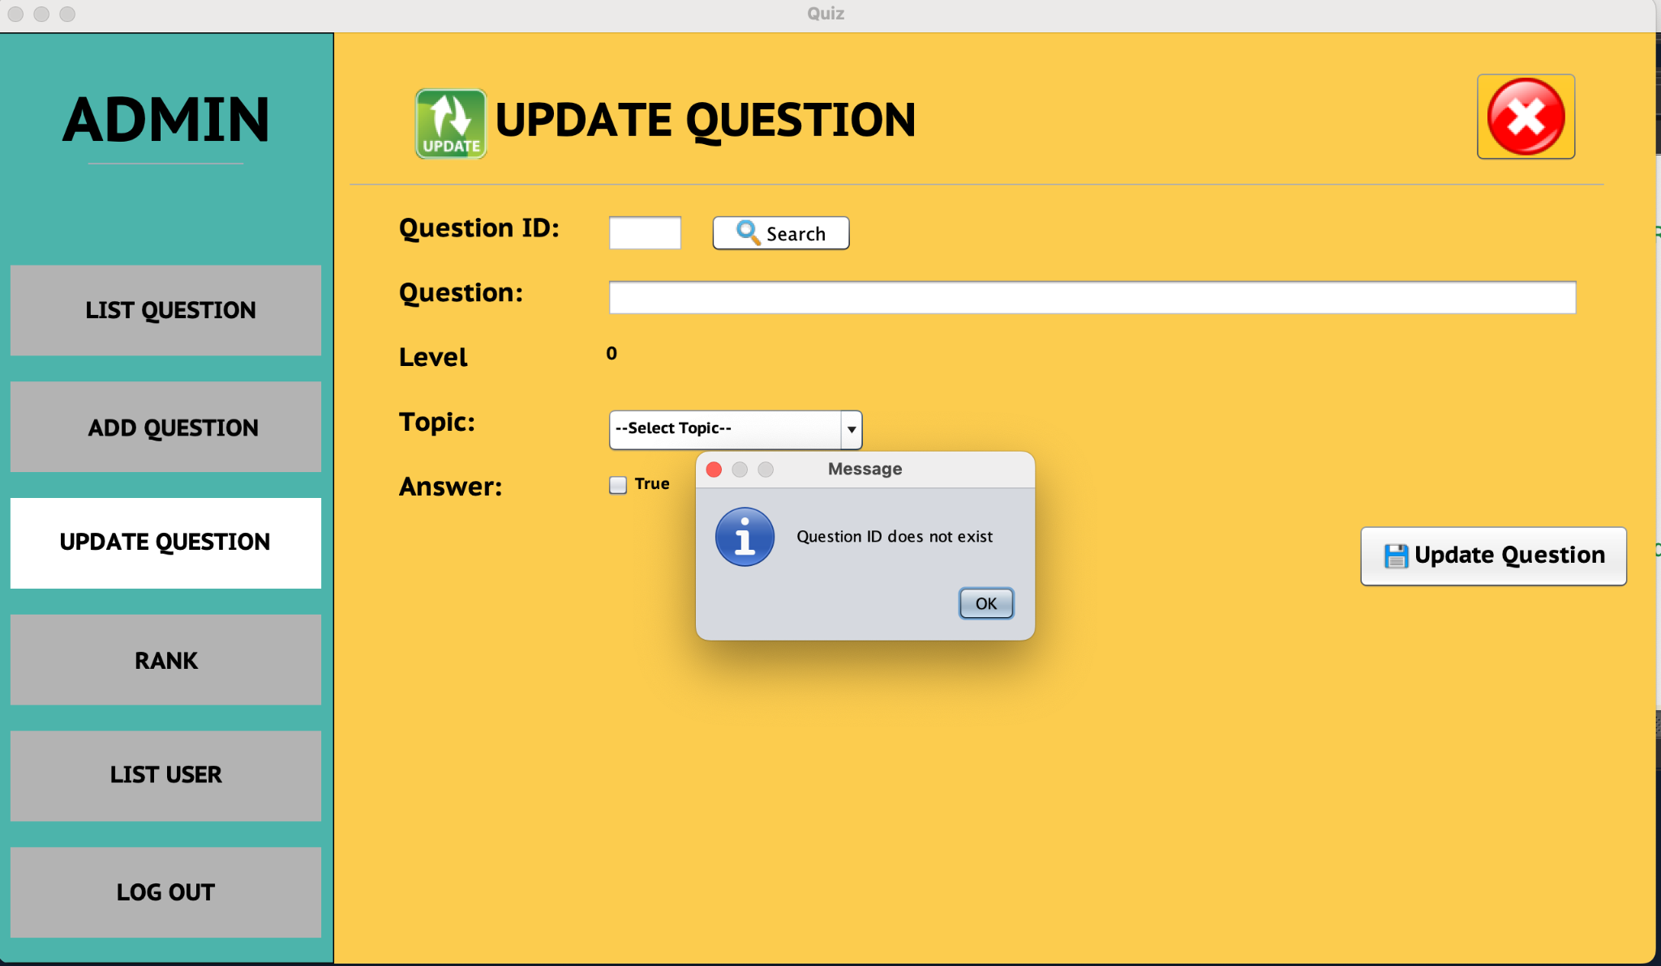

* *When searching for the id, the question will be displayed*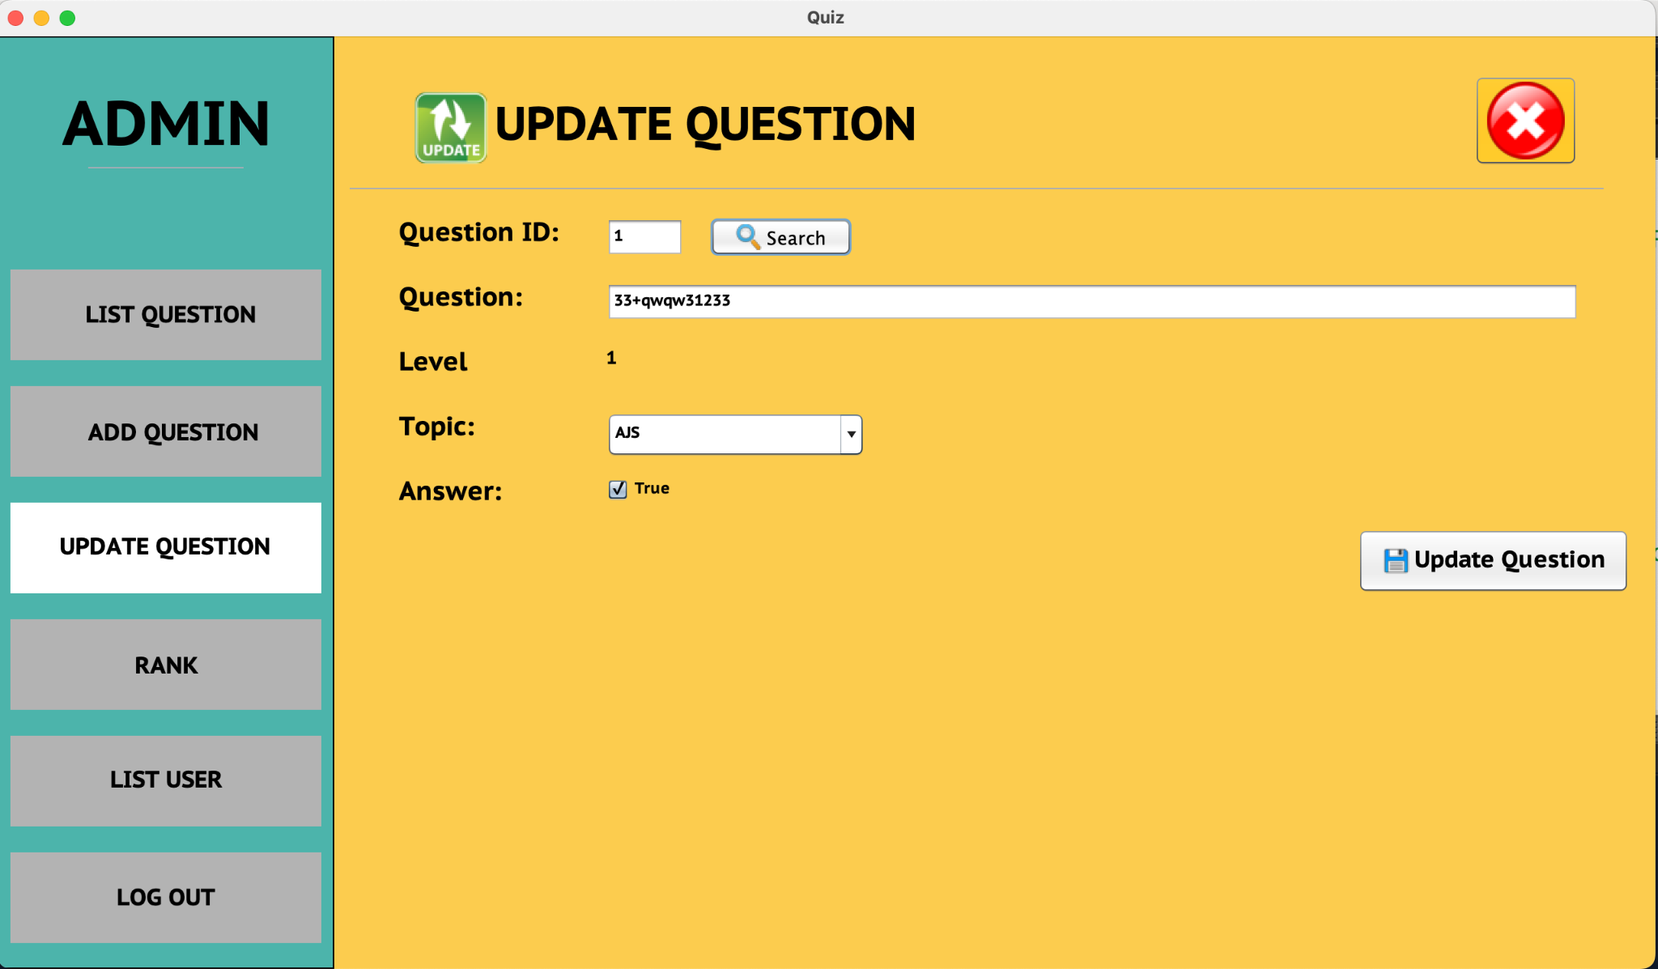

*Figure 21: Update by ID*

* *If the level is easy (1), a successful update message will be displayed.*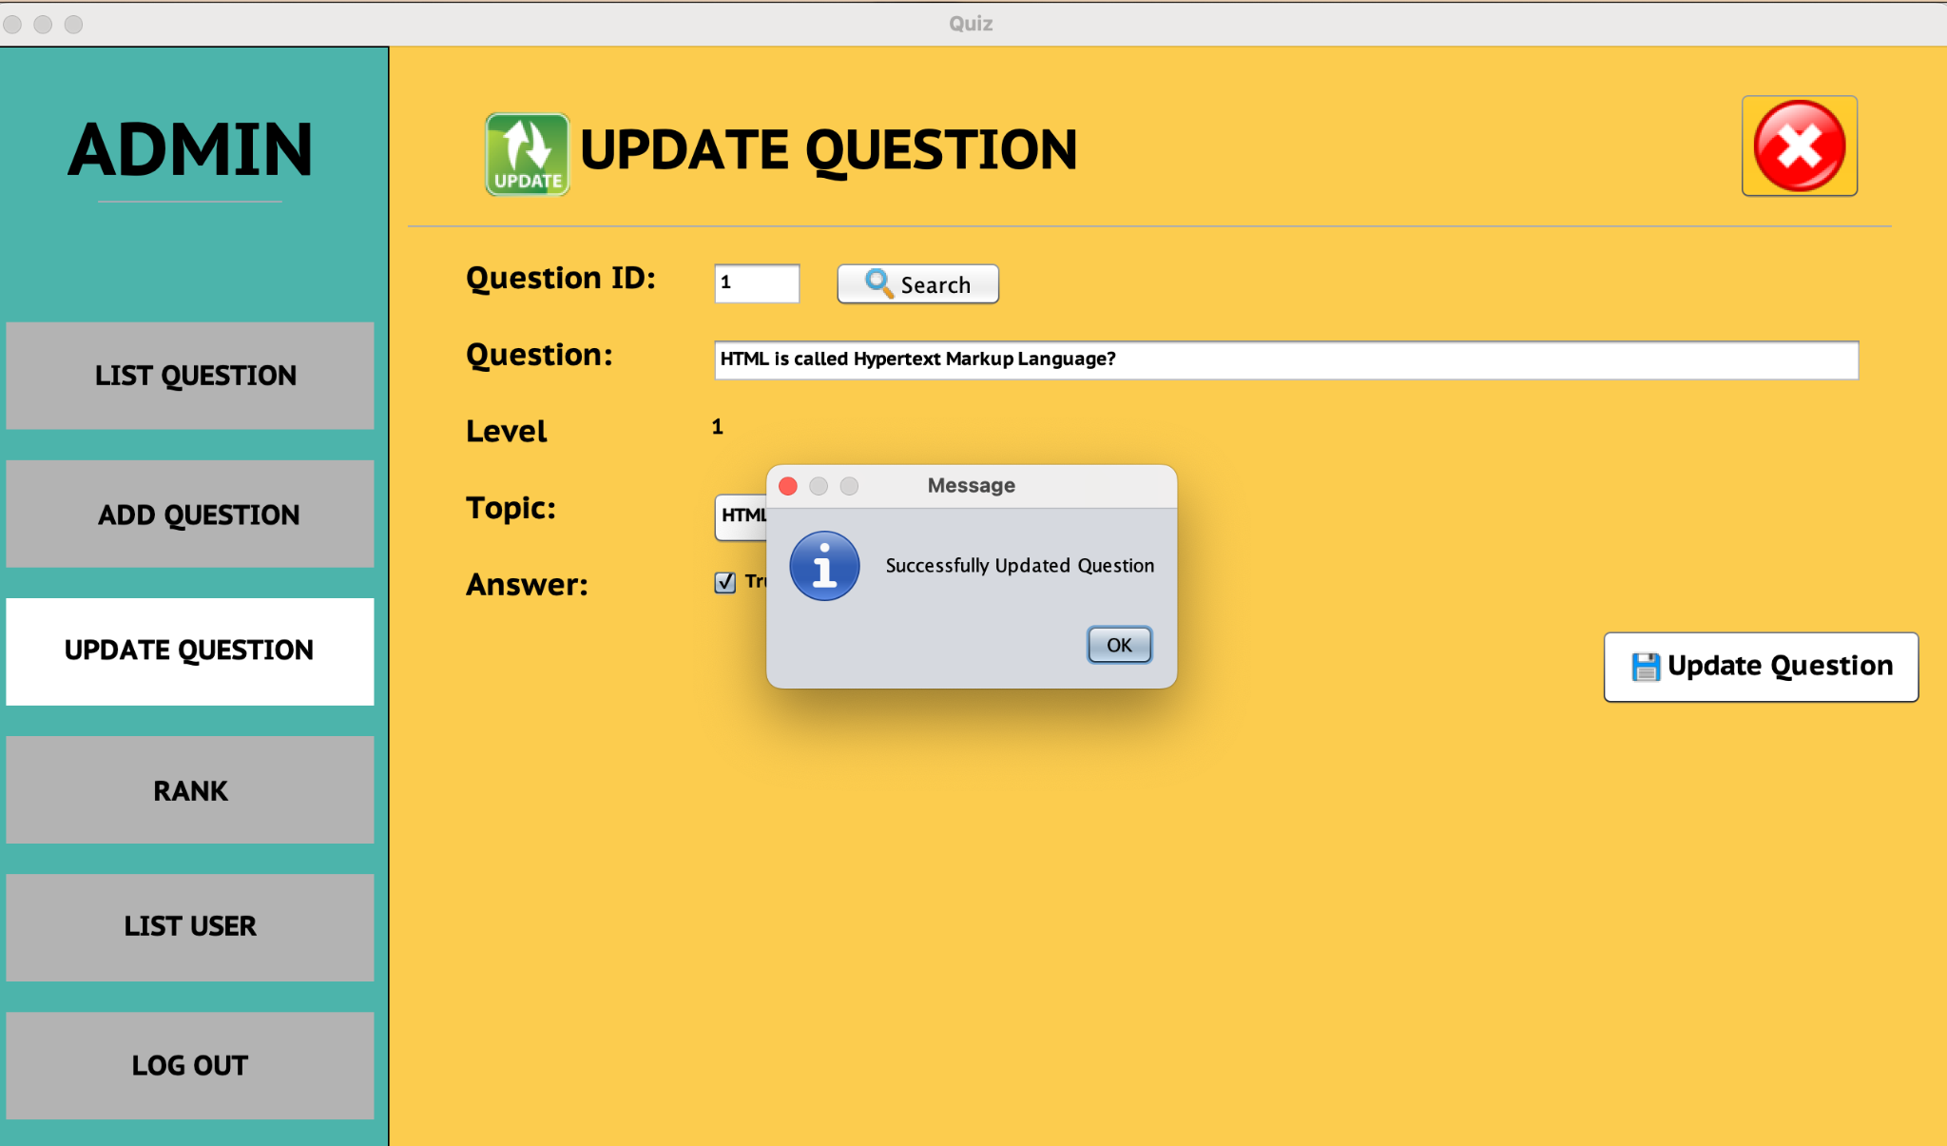

*Figure 22: Update Successful*

*Figure 23: Update Successful*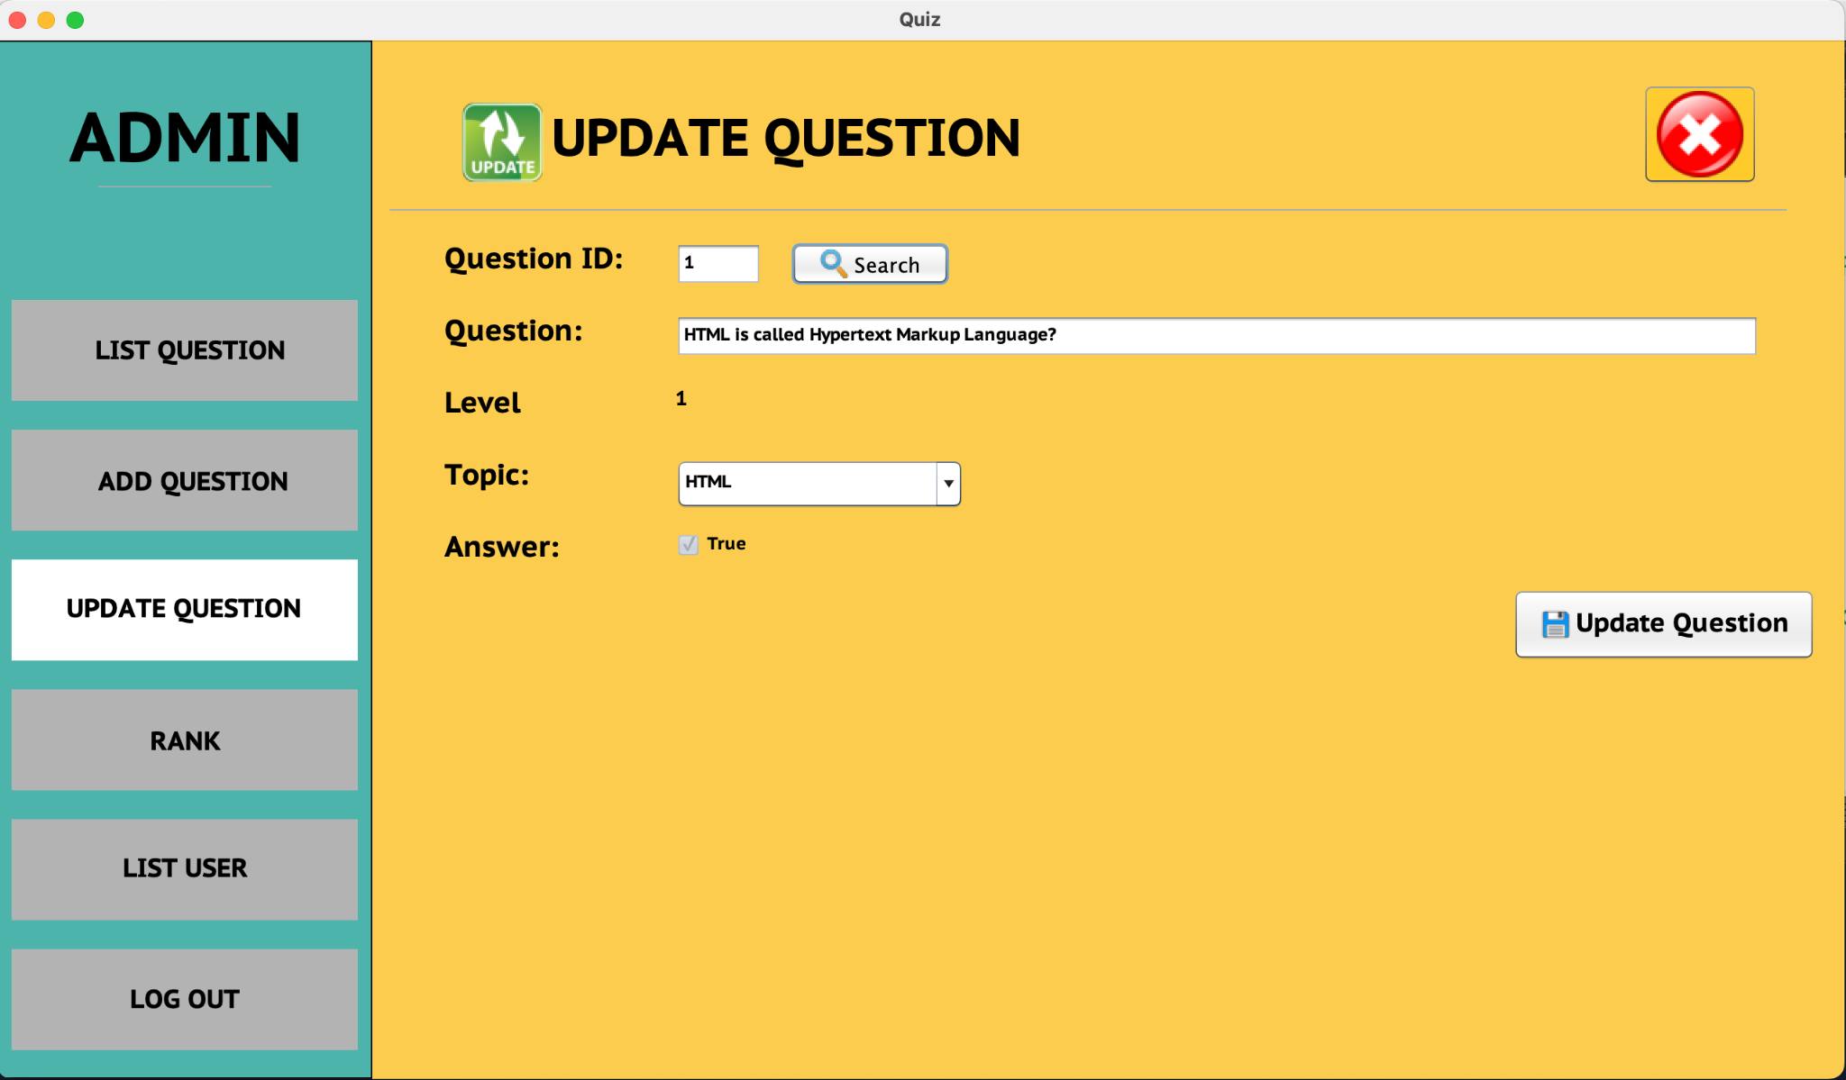

* *If type 2 and type 3 are available, the update option will be displayed*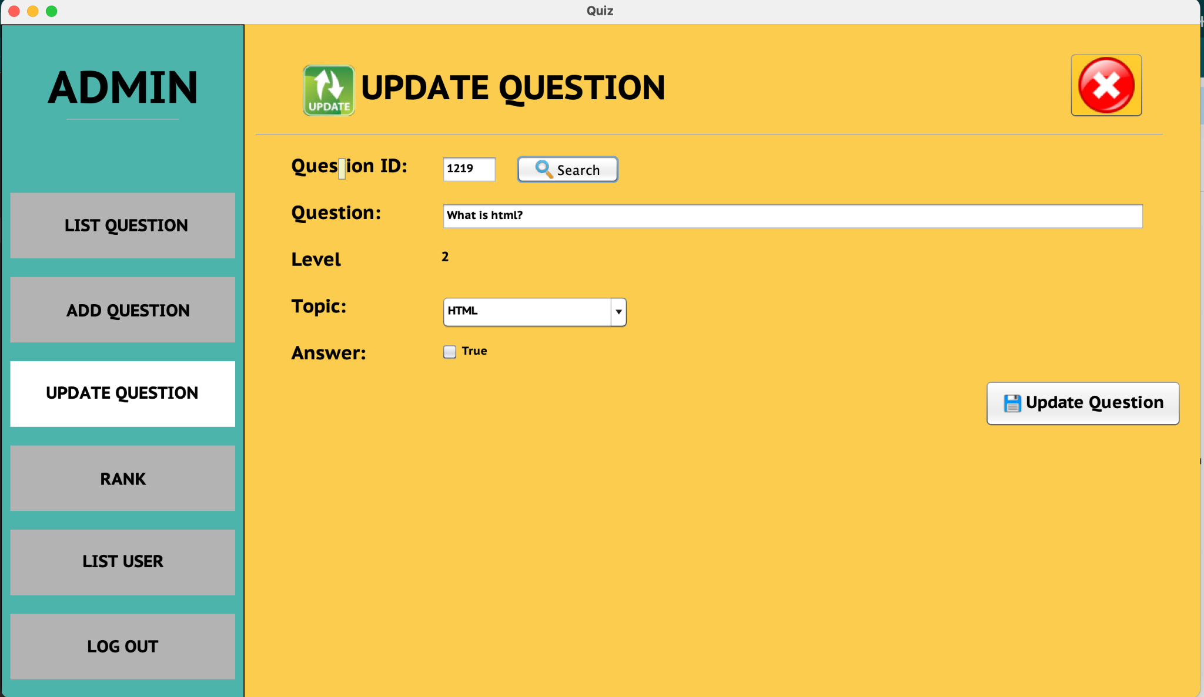

*Figure 24: Update Level 2 Or 3*

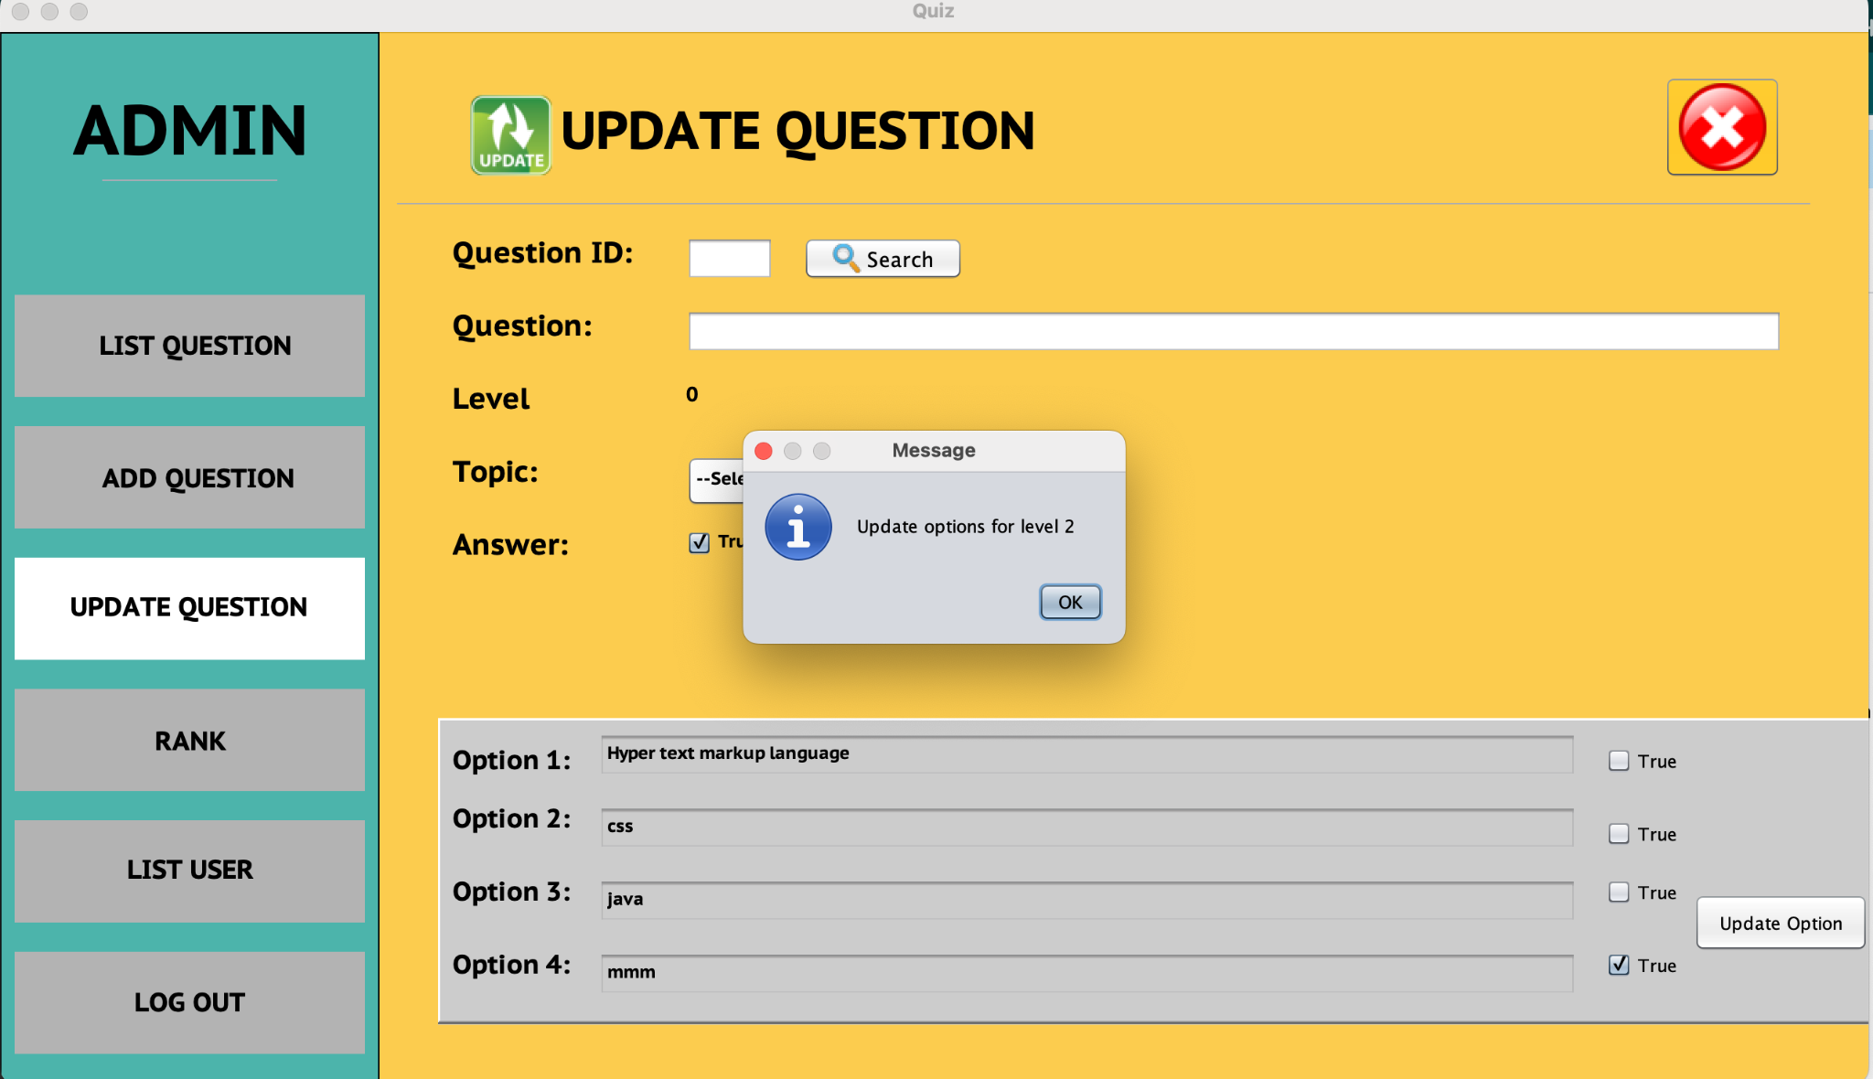

*Figure 25: Update Level 2 Or 3*

* *Administrators can delete and view player results.*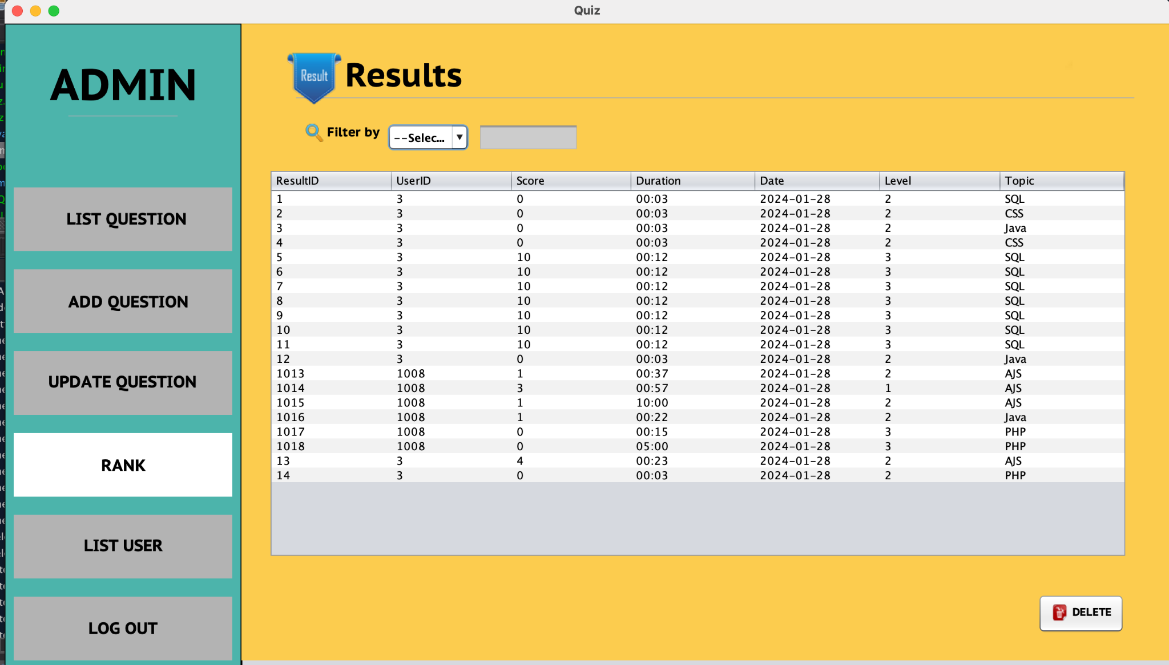

*Figure 26: Player Result*

*Figure 27: Filter by userID*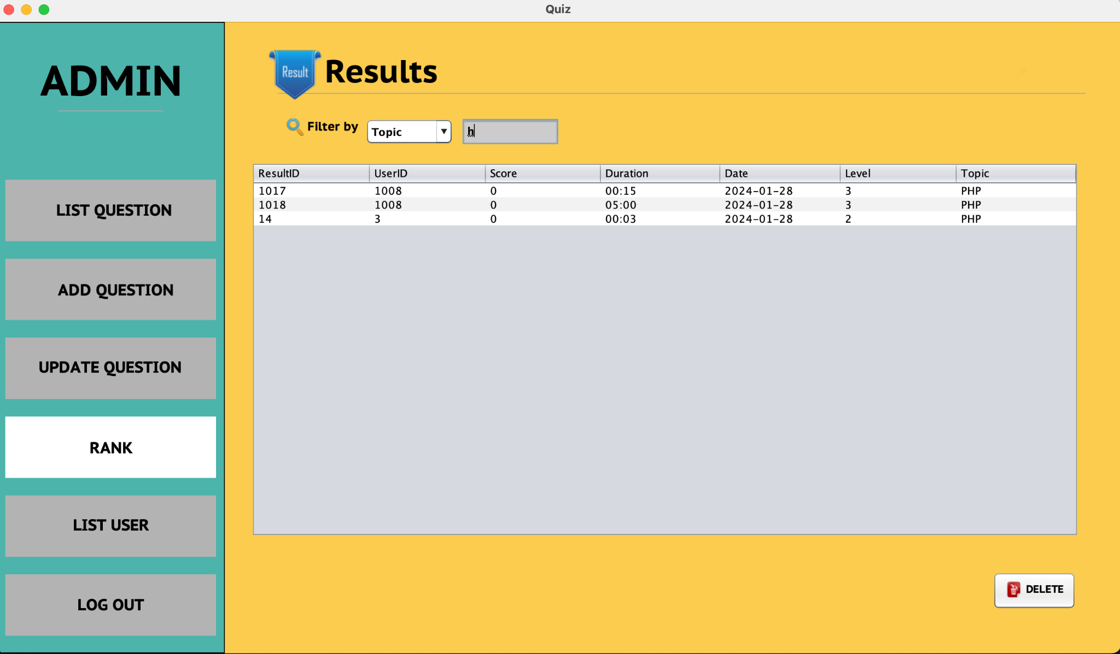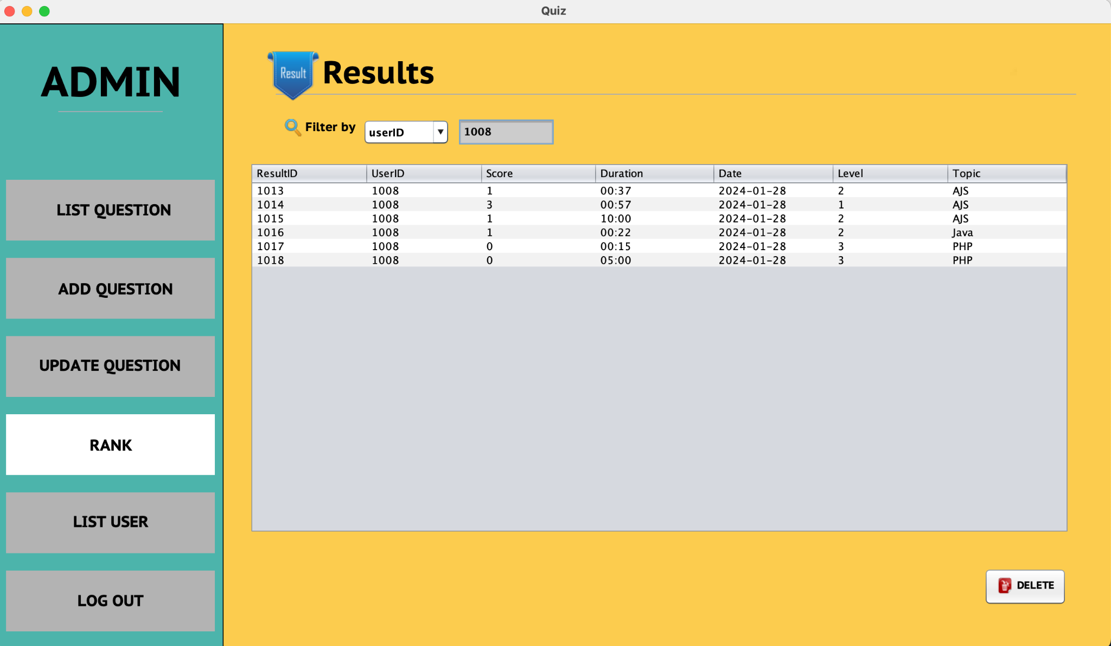

*Figure 27: Filter by Topic*

*Figure 27: Filter by Level*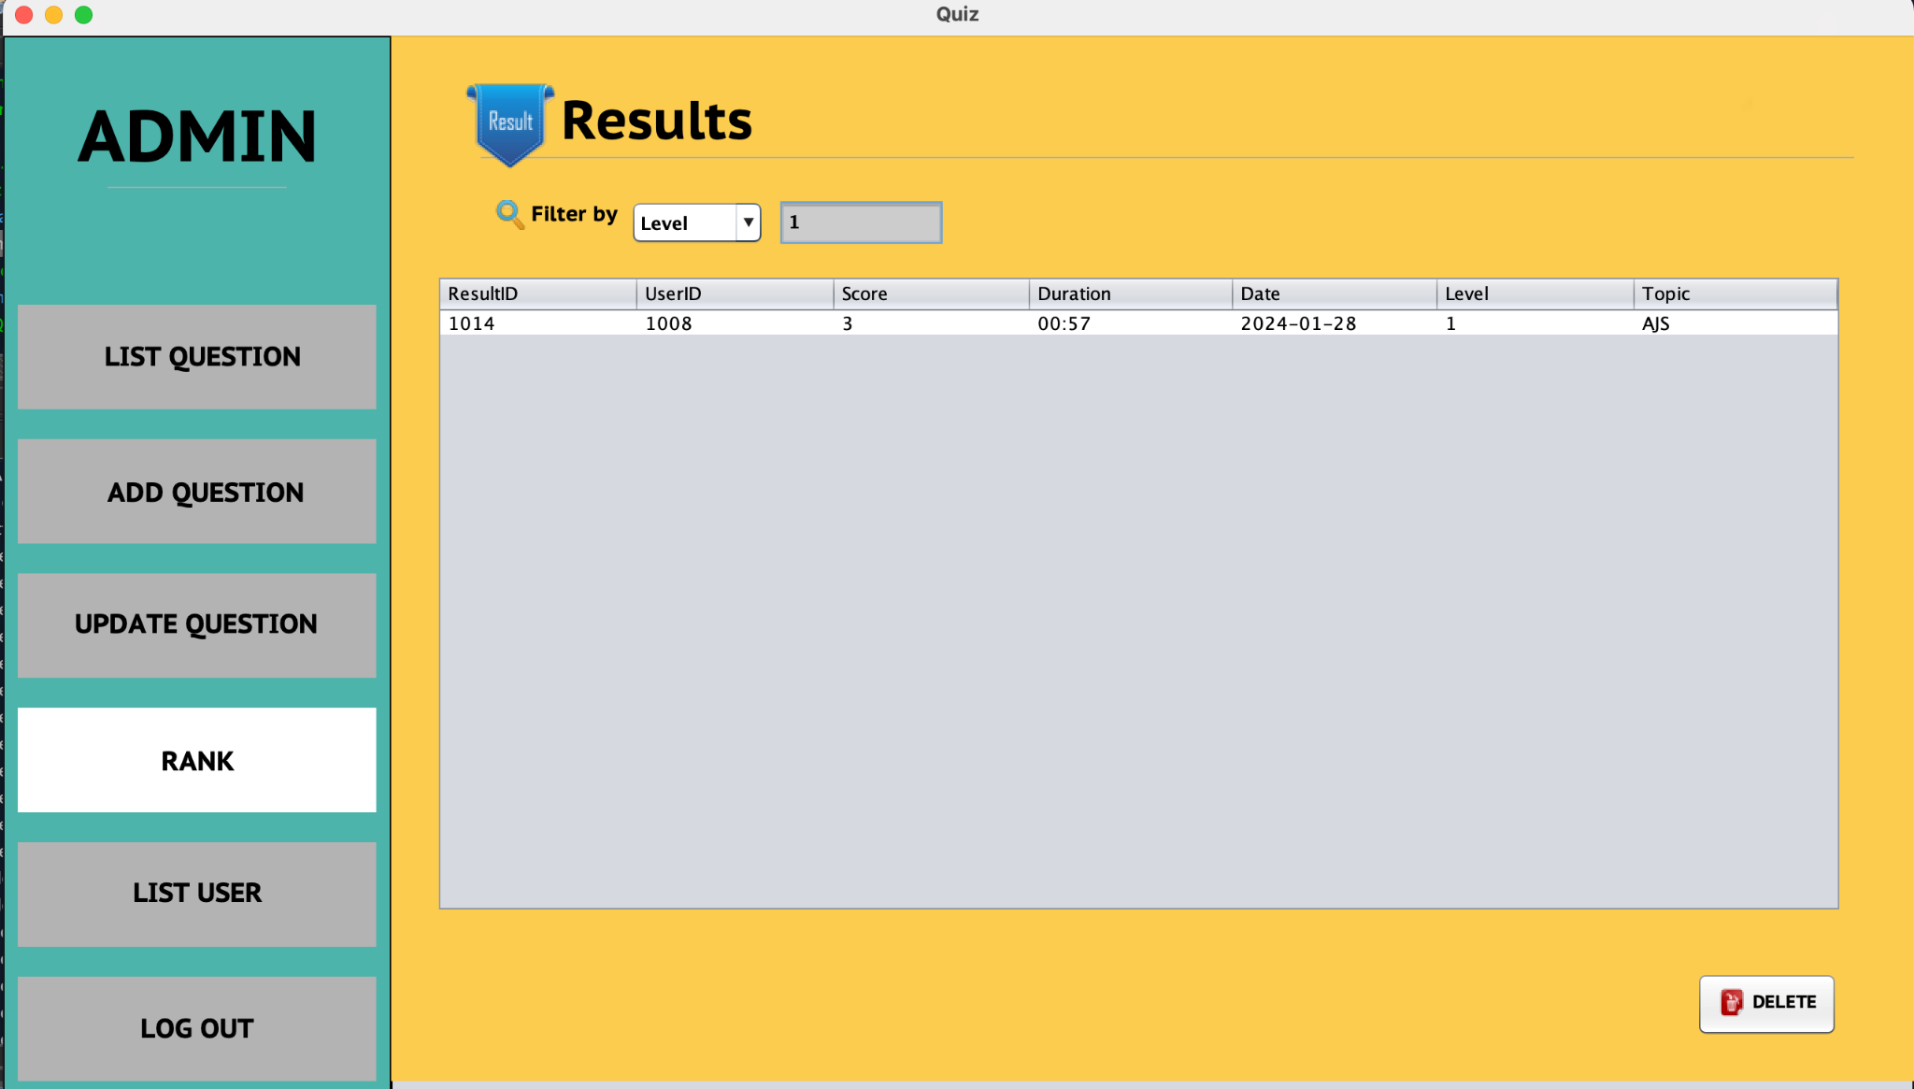

* *Administrators can delete by clicking on the line and pressing the delete button*

*Figure 28: Delete Result*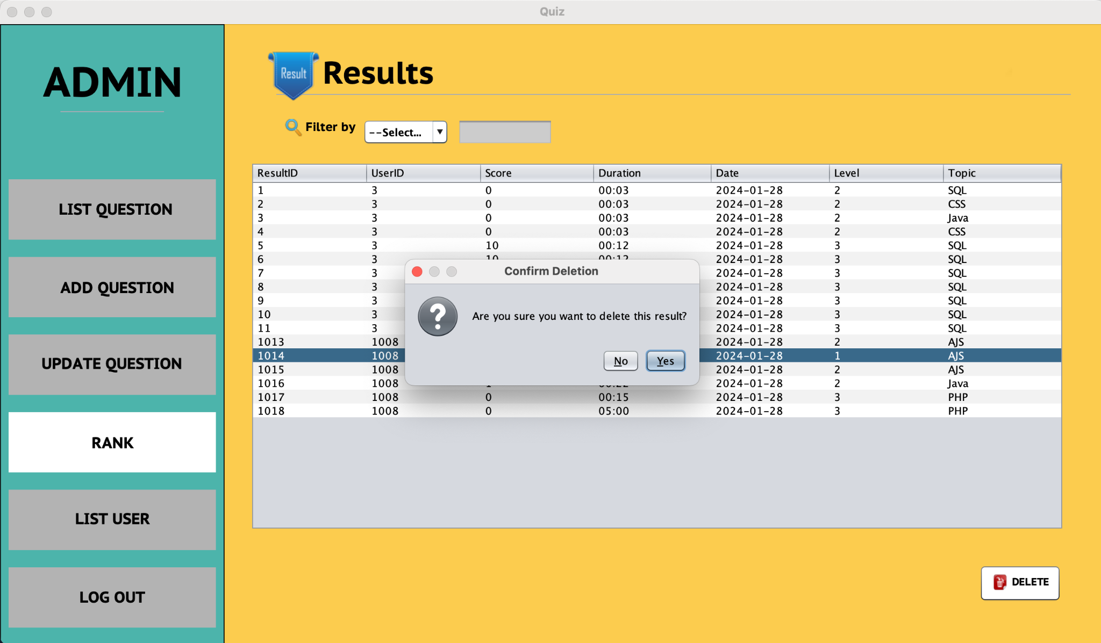

*Figure 29: Deleted Successful ResultID = 1014*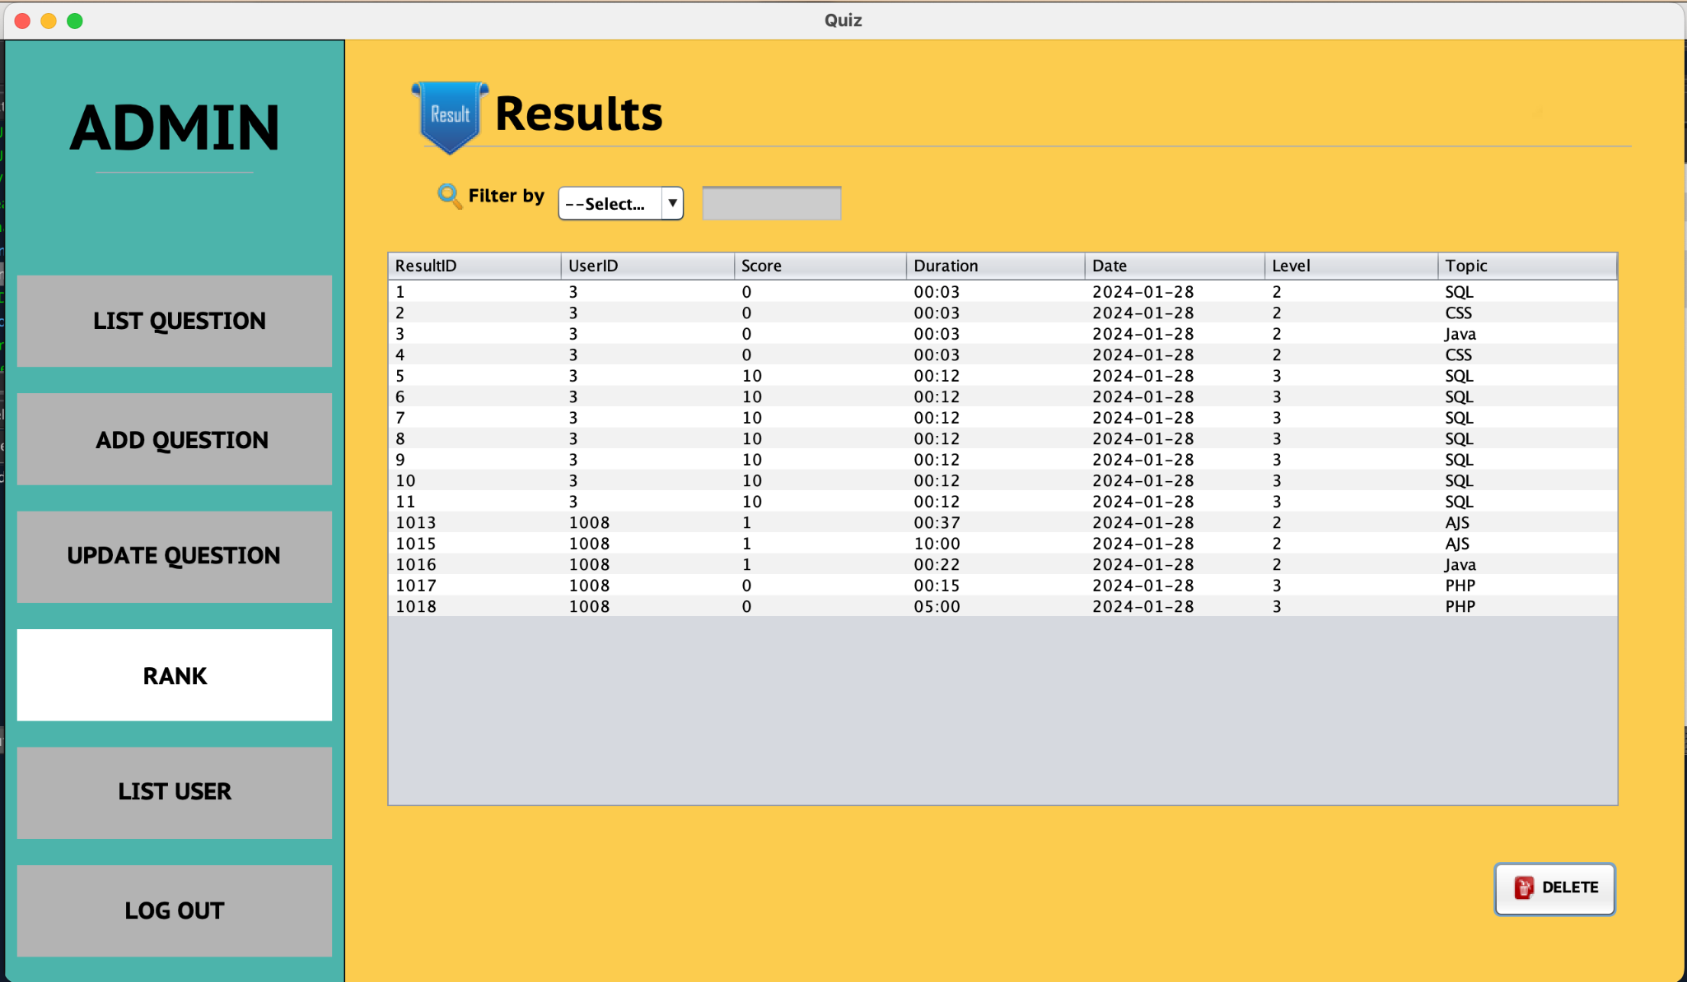

* *Administrators can view, edit, and delete additional users*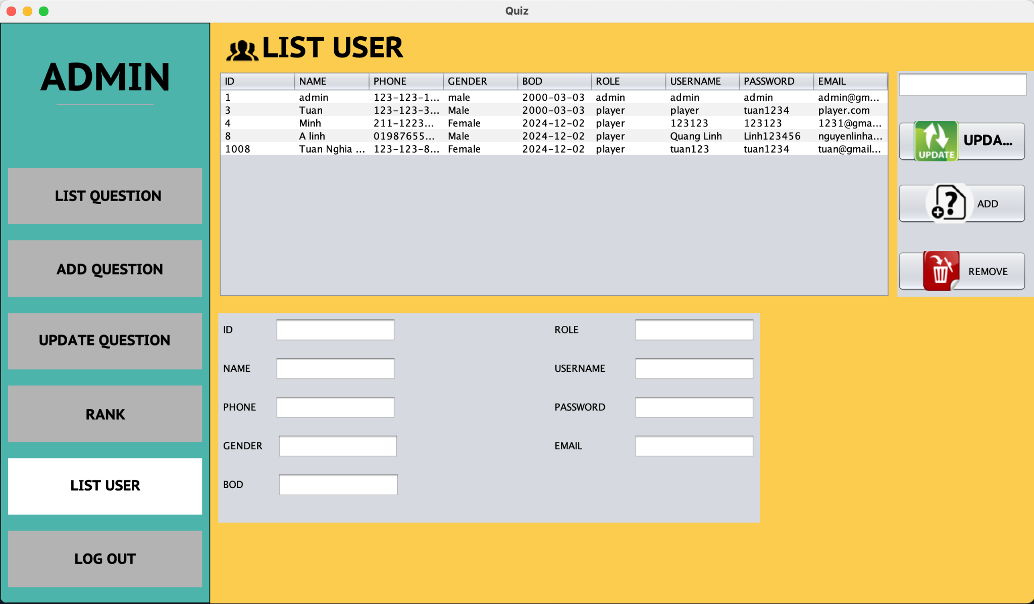

*Figure 30: View List User*

* *When clicking any line in the User table, the information will be displayed below.*

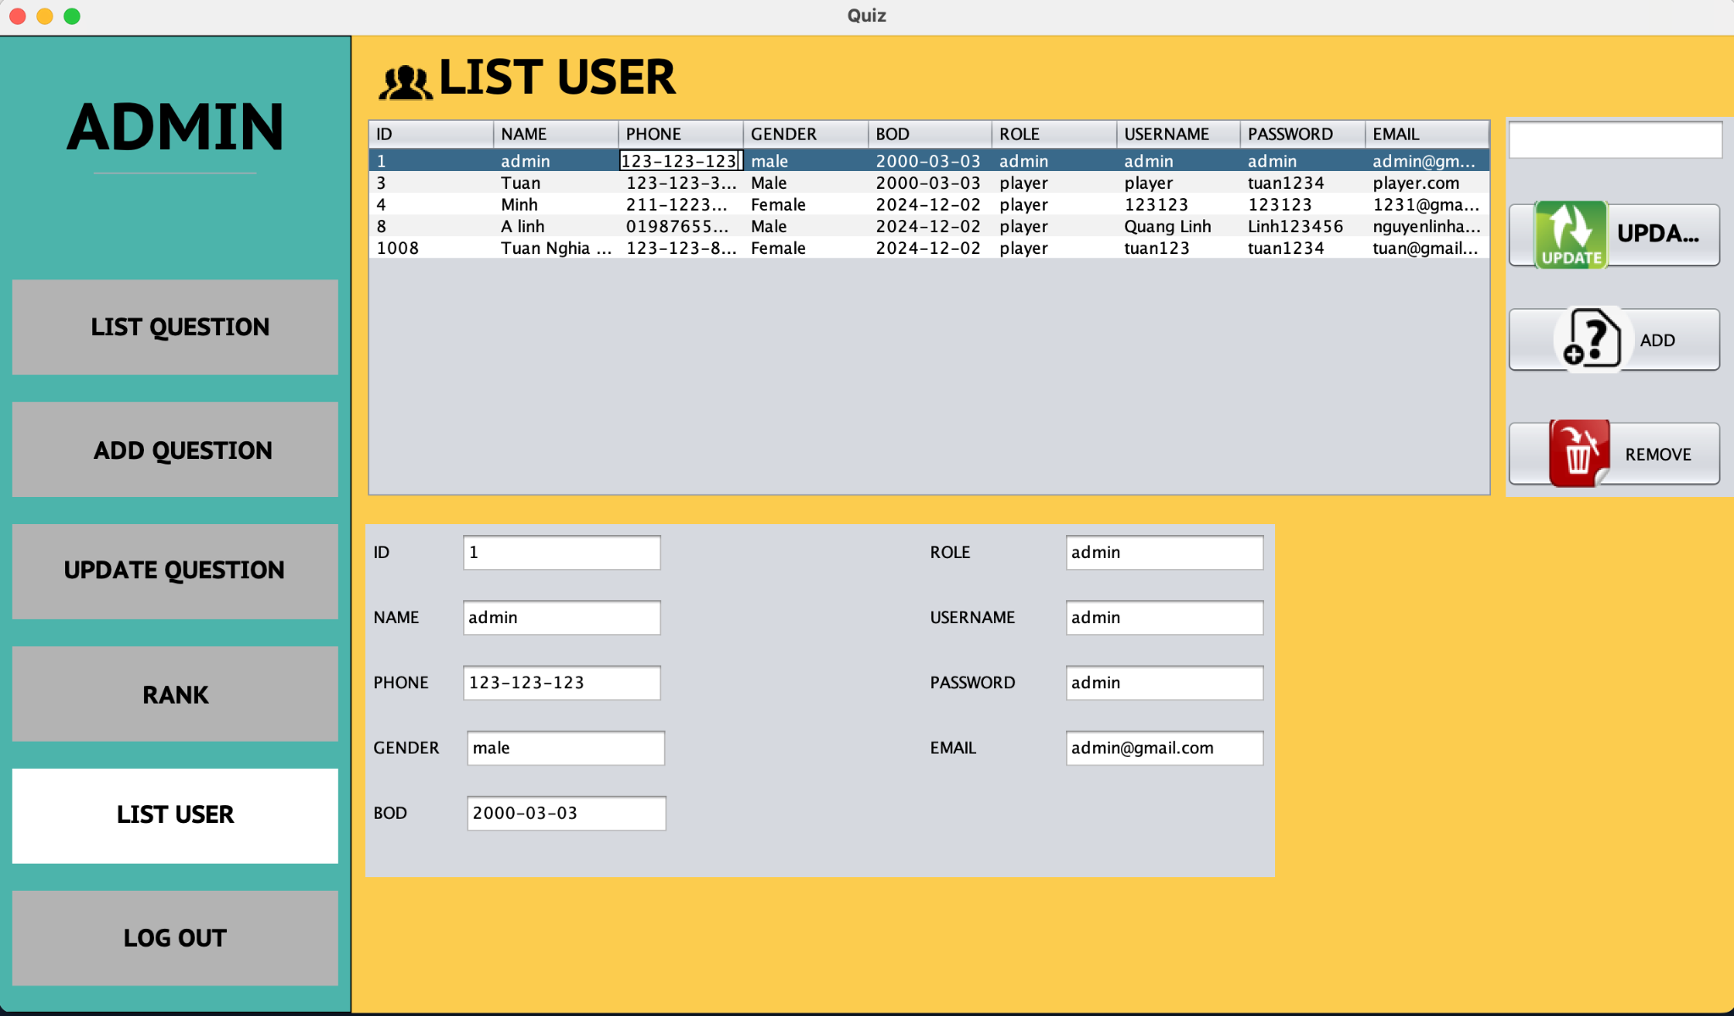

*Figure 30: View List User*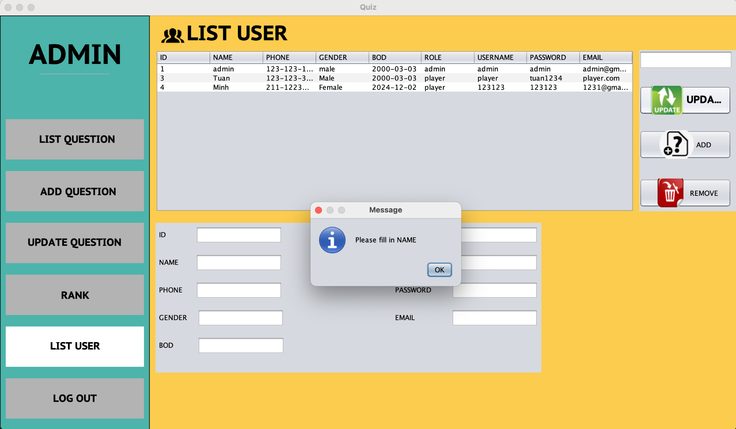

*–To add and update, it is necessary to enter the correct data as required*

*Figure 31: Request input*

*Figure 32: Request input*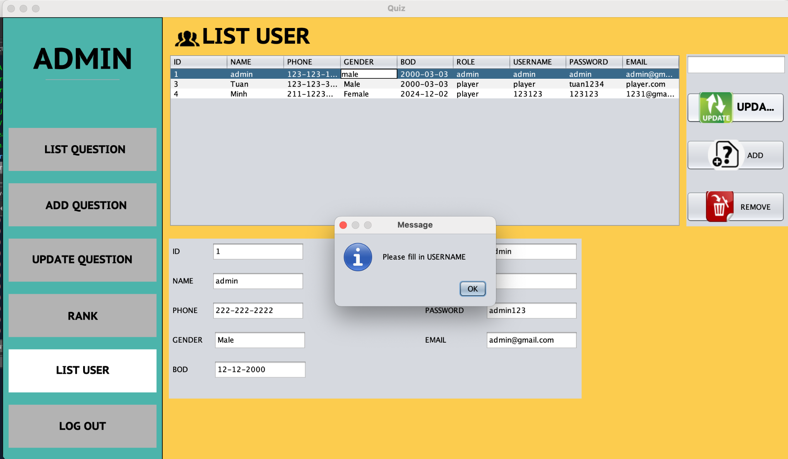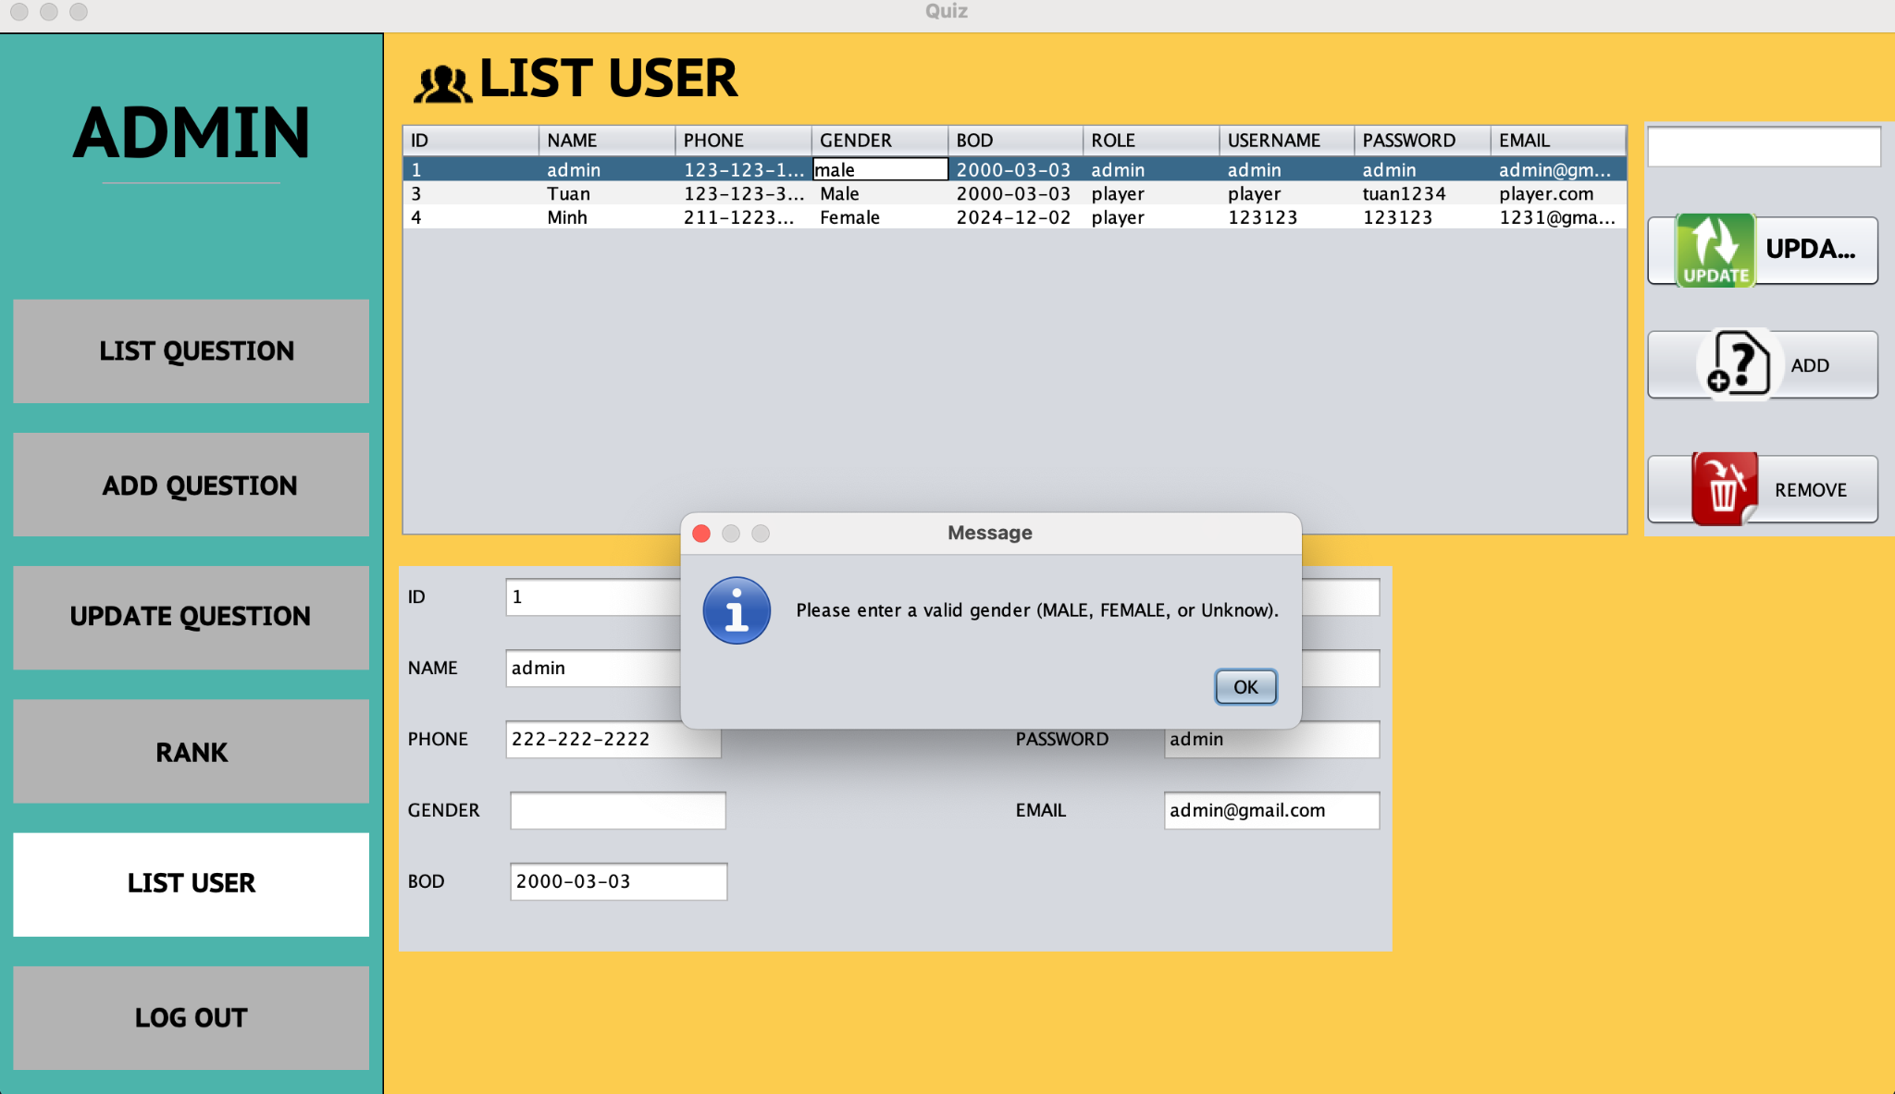

*Figure 33: Request input*

*Figure 34: Request input*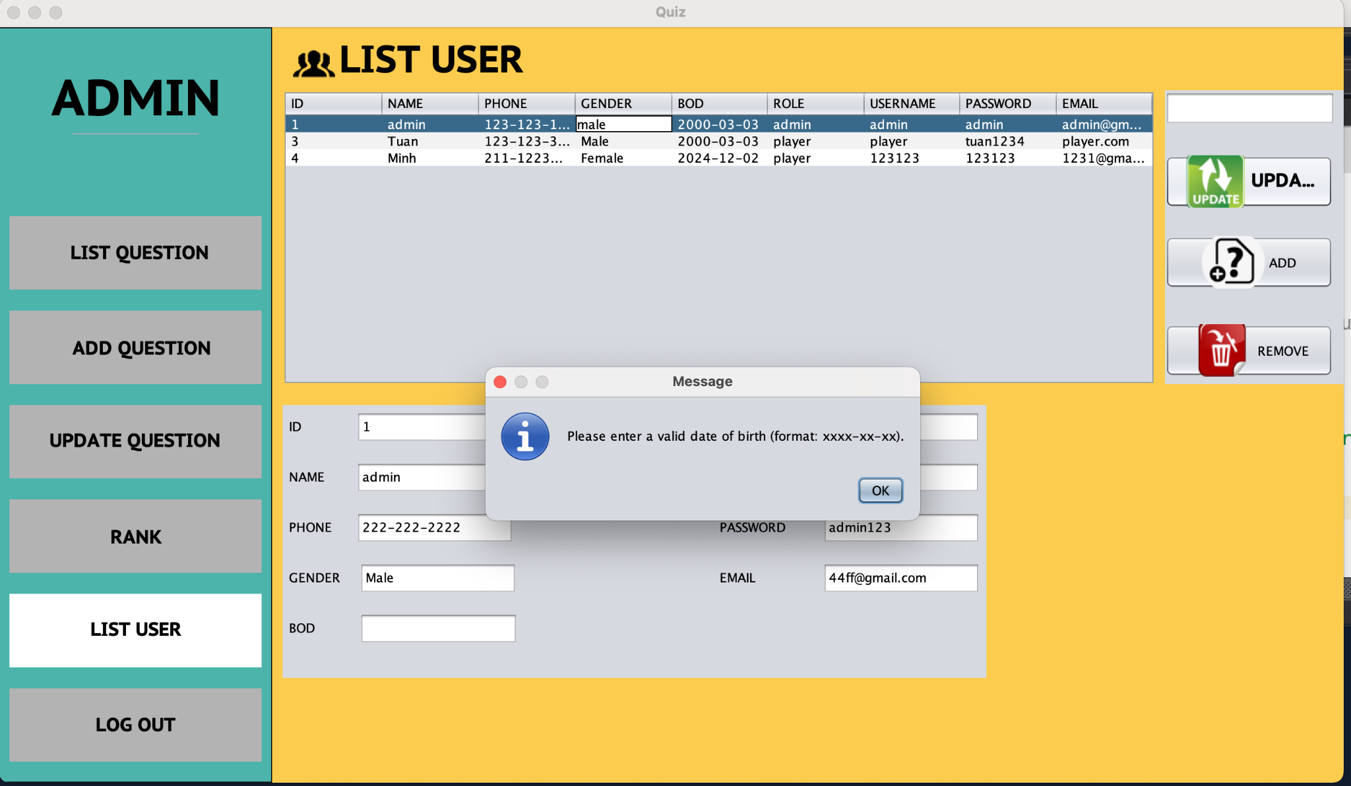

*Figure 35: Update Successful*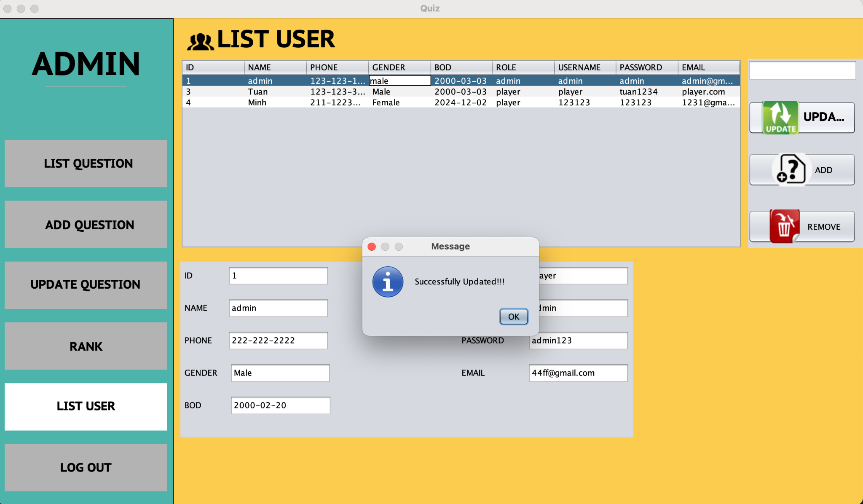

*Figure 36: Removed Successful*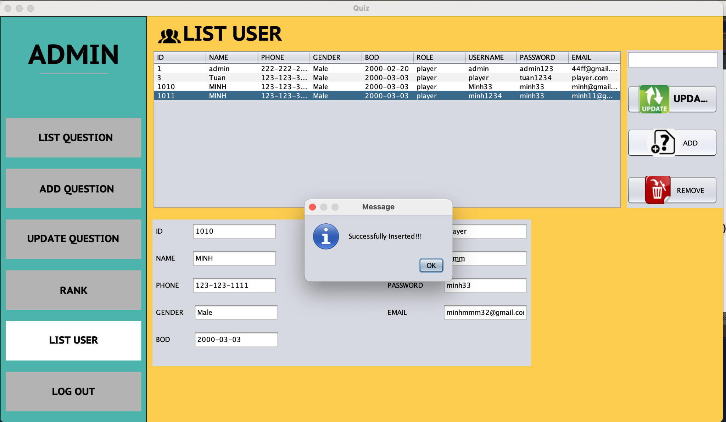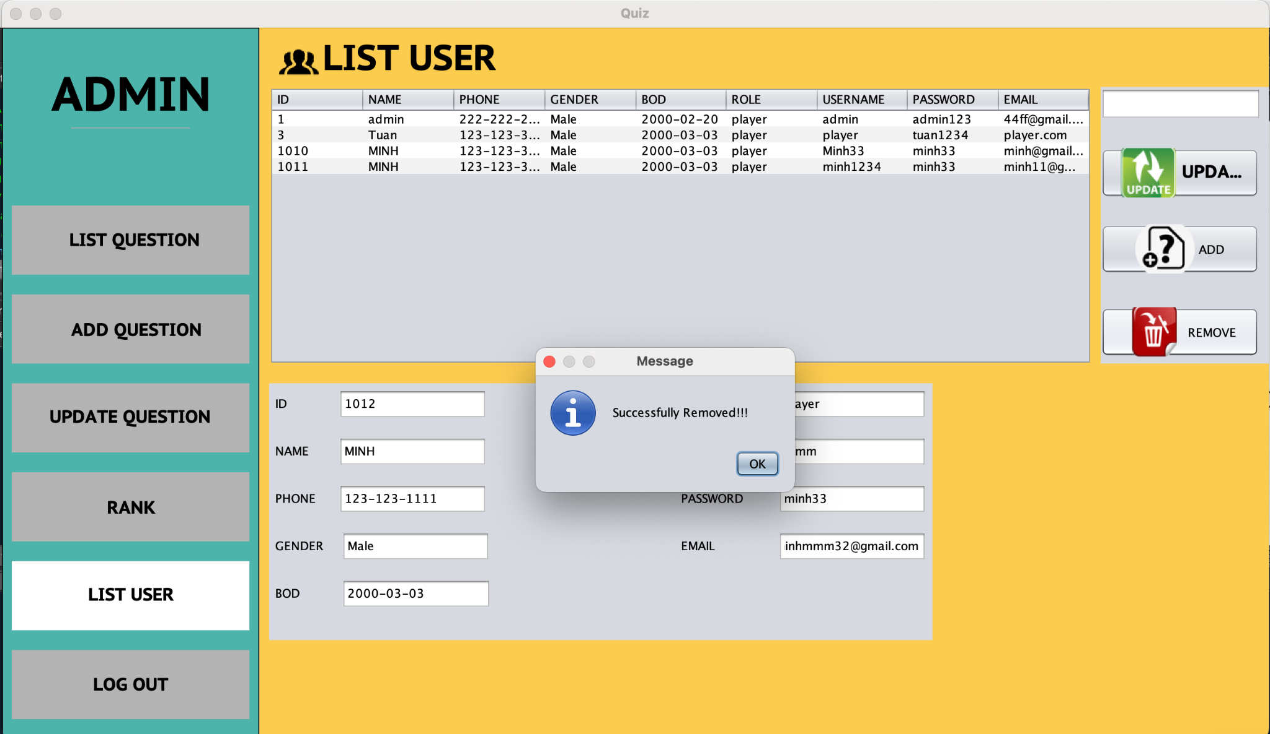

*Figure 37: Inserted Successful*

## TASK SHEET REVIEW 3

| **Project: QuizTech** | | **Project Name** | **Activity**  **Plan Prepared**  **By** | | **Date of Preparation of Activity Plan:** | | | |
| --- | --- | --- | --- | --- | --- | --- | --- | --- |
| **Sr./No.** | **Task** | **Actual Start Date** | **Actual Days** | **Team member name** | **Status** |
| **1** | **Application Map** | **QuizTech** | * Minh   - Thành  - Doanh | | 25/Jan/2024 | 1 | - Minh  - Thành  - Doanh | Completed |
| **2** | **QuizTech** | 30/Jan/2024 | 3 | - Minh  - Thành  - Doanh | Completed |
| **3** | **Task Sheet** | 31/Jan/2024 | 1 | -Minh  - Thành  - Doanh | Completed |
| **Date: 31 – January - 2024** | | | | | | | | |
| **Signature of Instructor:**  **Ms. LÊ MỘNG THÚY** | | | | **Signature of Team Leader:**  **Lê Đức Minh** | | | | |

**THANK YOU FOR YOUR READING**

We would like to sincerely thank you for taking the time to review and evaluate my report on the QuizTech Java Program project. Your interest and feedback are not only appreciated, but also invaluable in helping me understand how to improve and advance my work.

Once again I would like to express my deep appreciation and respect for your support and guidance. We look forward to having the opportunity to learn and share knowledge with you in the future.

**Sincerely grateful,**

**GROUP 3**